

Global 3000
Enhancement Note

Tax Analysis in Cash Manager

Enhancement to Cash Manager to capture tax analysis and supply it to the VAT Reconciliation Report.

This service pack provides an enhancement to Cash Manager to record tax on cash sales & purchases and make that information available to the VAT reconciliation report.
This has been done by modifying the dialogue in Transaction Entry to include the entry of taxable transactions and tax codes and to provide a tax analysis window similar to that in Debtors and Creditors Ledger.
Note that Cash Manager uses three-character codes to identify transaction type and two character codes to identify different types of analysis. These analysis codes comprise user defined codes for the non-taxable portion of a transaction (cashbook analysis or dissection codes), separate user defined codes for the taxable portion (tax analysis codes) and system defined codes for fund transfers and exchange gain/loss.
The service pack also extends Transaction Code Maintenance to cover this enhancement and to provide a more flexible approach to interfacing Global 3000 Cash Manager to Global 3000 Debtors Ledger, Global 3000 Creditors Ledger and Global Payroll.
This enhancement does not cover foreign currency or intra-EC transactions.
After the service pack is applied, program CMSET1 is run automatically done the first time you enter Cash Manager. This program will:-
- set default values for the new fields on your transaction code records,
- set up standard transaction codes for interfaces with other Global modules,
- set up standard tax analysis codes,
- ask you to confirm or amend these codes.
The fact that the program has been run is recorded on the dataset and the program will not be repeated on subsequent entry to Cash Manager.
This program does not enable tax analysis in your Cash Manager, but merely sets up the system for the changes in interfacing to Debtors Ledger, Creditors Ledger and Payroll and prepares the data for tax analysis implementation.
If you wish to use tax analysis in Cash Manager you must enable it in the new Tax Analysis window in System Parameters and set up the codes you want to use for tax postings.

Documentation Changes

Cash Books
<Replace the section on Cash Books in the overview with the following.>
 | Cash Manager can operate multiple cash books. Each cash book is identified by a two character alphanumeric code, has a description of up to thirty characters, and operates in a specified currency and for a specific company. Multiple cash books can be operated for any company/currency combination. A cash book can have a General Ledger profit centre and control account associated with it, and bank details (account number, bank name, branch, sort code) recorded. The ability to print cheques is allowed or disallowed on an individual cash book basis. Cash books can be revalued at the house exchange rates in force on a specified date.
 | Each transaction recorded in a cash book can be analysed across any number of user defined two-character analysis codes. These are described in more detail below.
 | There are facilities for setting up standing orders for a cash book. Each one may be a payment or a receipt, and is identified by a four digit order number and a reference of up to ten characters. The transaction type, currency, start date, frequency, number of repetitions and amount are specified. Cash book analysis across any number of analysis codes can be specified with each order. Standing orders are processed at end of period.
 | Free format notes may be recorded against cash books.
Analysis codes | An individual set of analysis codes can be defined for each cash book. These codes are akin to the columns of a manual cashbook and can be used to analyse the non-tax portion of each transactions across any number of codes.
 | Each analysis code is defined for either payments or receipts, is identified by a two character alphanumeric code and has a description of up to twenty-two characters. Individual codes can optionally be suppressed from the pop-up search which can be invoked whenever the user is prompted for analysis in Cash Manager.
 | Analysis appears on cash book reports. The column headings for each code in the Cash Book Report are defined by the user.
 | Separate two-character analysis codes are defined for the taxable portion of a transaction. These are sometimes referred to as tax analysis codes.
Analysis codes and the General Ledger | If integration with General Ledger is in use, each analysis code has a General Ledger profit centre and account associated with it. Each code has an indicator denoting whether its General Ledger posting codes are fixed or can be changed during transaction entry. In addition, for each analysis code, postings to General Ledger can be either consolidated or detailed.
 | <unchanged text…>
Cash book revaluation | Cash books can be revalued at the house exchange rate in force for a specified date. This involves the following processing:  - A bulk revaluation of all the transactions whose currency information has been confirmed. For these transactions, the program recalculates the base currency values from the values in cash book currency. A new batch is created to account for any exchange gain or loss that arises.
 | - A revaluation of all the transactions whose currency information has not been confirmed. For these transactions, Cash Manager recalculates the base currency value from the value in entry currency. Cash Manager accounts for any exchange gain or loss that arises for a transaction through cashbook analysis codes specifically for exchange gain and loss. If the batch is open, the General Ledger analysis is created when the batch is closed, otherwise a posting is created when the currency information is confirmed.

Cash Manager Parameters

<Add the entry “Tax Analysis” to the Cash Manager System Parameters Menu CM520_M1>

Figure 1: Cash Manager Parameters Menu | 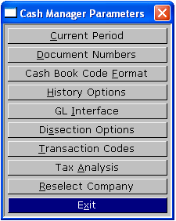

Tax Analysis | Define the cashbook analysis code you wish to use for tax postings. ⇒ Cashbook Analysis Code for Tax Postings window.

Transaction Code Maintenance
<Window has been made full screen and the documentation altered to reflect addition of tax prompts & other parameters.>
Figure 2: Transaction Code Maintenance Window | 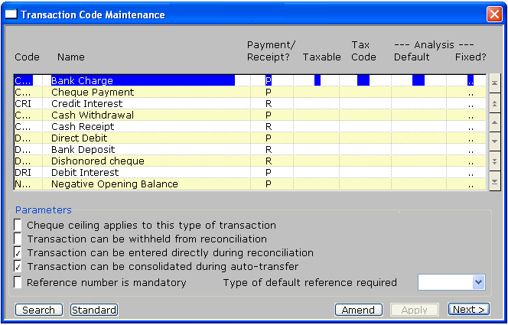
 | This window appears when you select Transaction Codes from the Cash Manager Parameters Menu.
Purpose | This window lists existing Cash Manager transaction codes and enables you to define new ones and to amend and delete existing ones.  Transaction codes identify the different document types that can be used in Cash Manager. Any transaction types can be set up for Cash Manager to help differentiate similar postings and to provide a convenient means of sorting transactions.
Standard codes | If on first entry to this window, your table is empty Cash Manager automatically generates the standard list of transaction codes presented in table 1. Otherwise, clicking on the “Standard” button enables you to add any standard transaction codes that are not present.  Alternatively you can add your own transaction codes as required.
Note | Once one or more transaction codes have been defined, clicking the “Standard” button lists the standard transaction codes with options  - (All) Add all the codes that do not yet feature in your code table,  - (Add) Add the selected code only.
Move through list | You can move through the list using the cursor and <Page Up> and <Page Down> keys in the standard way.
Add | To create a new transaction code, move the cursor to the line below the last entry in the list, or press <F5> to insert a new entry within the list. Alternatively you can press <F4> to go into ‘Add’ mode.
Amend | To amend an existing transaction code, move the cursor to the required line and press <Return> or click “Amend”.
Delete | To delete a transaction code, move the cursor to the unwanted line and press <F7>. Cash Manager asks you for confirmation before it removes the code. If a code is in use as a standard import code (see next page of parameters) you are asked to supply a substitute code to be used in its place in the standard table of import codes before deletion will proceed.
The prompts are:
Code | A code of up to three alphanumeric characters to identify the type of transaction.
Name | Up to 30 characters describing this type of transaction.
Payment/Receipt | Indicate the basic nature of this type of transaction as either of:  - P for payment,  - R for receipt.
Taxable | (Only if Tax Analysis is enabled) Identifies the taxable nature of services or supplies covered by this type of transaction. This is used as a default in transaction entry. Set if the transaction type gives rise to tax postings.
 | Taxable transactions report to the VAT reconciliation report with tax class NS for receipts and NP for payments.
 | Non-taxable transactions do not report to the VAT reconciliation report.
Note | Not setting “Taxable” indicates that the Cash Manager is not responsible for reporting this kind of transaction to the VAT reconciliation report. This may be because the item has no VAT element or because responsibility for reporting rests with another module in the software.
 | NB: Zero rated and exempt items entered using Cash Manager transaction entry which you wish to report to boxes 6 to 9 of the VAT return must be classed as taxable.
Tax code | (If the previous prompt indicates that the item does not contribute to the VAT report, this is set to spaces and skipped.) Identifies the tax code which applies to this type of transaction. This is used as a default in transaction entry.  Leaving the tax code blank for a transaction defined as subject to tax allows multiple tax codes to be entered during input of tax details for the transaction.
Note | The primary advantage in setting up a transaction code with a specific tax class and code is to indicate that during data entry, the gross total entered for a transaction is chargeable at a single rate.
 | Selecting a specific tax code here does not prevent tax details of this kind of transaction from being amended to involve more than one tax code.
Analysis default | Enter the two character Cashbook analysis code to be offered as default for the non-tax portion of transactions of this type during transaction entry. Leave blank to force the operator to select an analysis code during transaction entry. Press Search to select from the list of available cash book analysis codes.
Note | This code is used by Cash Manager transaction data entry programs other than auto-transfer. Codes used by auto-transfer from Global 3000 Debtors Ledger, Global 3000 Creditors Ledger and Global Payroll are set up in the Auto-transfer Transaction Codes window which is displayed by keying <Next> in this window. The code used by auto-transfer for postings into Cash Manager from other modules that supply incomplete analysis is defined in the posting interface for the module.
Fixed | Set if this is to be the only analysis code associated with the transaction code. Leave blank to be able to vary the analysis code at transaction entry. The default is blank.
Reference number mandatory | Set if a reference of up to 10 characters must be entered for transactions of this type. Leave blank if the reference can be left blank.
Type of default reference required | Choose from  - None – this is the default  - Batch - to auto-generate a default reference by incrementing the trailing numeric portion of the reference of the previous transaction entered in each batch. The first transaction in each batch offers no default.  - Previous - to default the reference to that of the previous transaction added or amended. The first transaction in each batch offers no default.
Cheque ceiling applies to this kind of transaction | Set if amounts entered for transactions of this type are to be rejected by transaction entry and statement reconciliation if they exceed the cheque ceiling specified for the cash book in which the transaction is being entered. The default is blank.
Transaction can be withheld from reconciliation | Set if transactions of this type can be held; i.e. they can be prevented from being reconciled with the bank statement until specifically authorised. Leave blank if transactions of this type cannot be held. The default is blank.
Transaction can be entered directly during reconciliation | Set if transactions of this type can be entered directly on to a bank reconciliation statement. Leave blank if they cannot be. The default is set.
Transaction can be consolidated during auto-transfer | When items are posted into a cash book through the auto-transfer interface, there is an option on the interface to consolidate incoming transactions by batch or narrative. If transactions of this type are always to be excluded from such consolidations and generate an individual entry in the cash book, e.g. a refund, leave this parameter unset.  Set it if transactions of this type posted through auto-transfer are to be considered for consolidation if that option is enabled on the interface during transfer, e.g. a sales receipt.  The default is set.
On completion | ⇒ Next line in window.
Next | ⇒ Auto-Transfer Interface Transaction Codes Window

P/RChequeHoldDirectConsolReferRef typeCHGBank charge.PNNYYNNCHQCheque payment.PYYYYYNCRICredit interest.RNNYYNNCSHCash withdrawal.PNNNYYNCSRCash receipt.RNNNYYNTable 1 – Standard transaction codes
CTRCodeName | Credit transfer from Payroll | P | N | N | N | Y | Y | N
DDB | Direct debit. | P | N | N | Y | Y | Y | N
DEP | Bank deposit. | R | N | N | Y | Y | Y | N
DRE | Dishonoured cheque. | R | N | N | Y | N | Y | N
DRI | Debit interest. | P | N | N | Y | Y | N | N
NOP | Negative opening balance. | P | N | N | N | Y | N | N
REC | Receipt from Debtors. | R | N | N | N | Y | N | N
REV | Void payment. | P | N | N | N | N | Y | N
STO | Payment by standing order. | P | N | N | Y | Y | Y | N
TFR | Bank transfer. | P | N | N | N | Y | Y | N

Auto-Transfer Interface Transaction Codes
<New window identifying the CM transaction and analysis codes to be used for the different types of transaction posted by Debtors & Creditors Ledgers and the Payroll.>
Figure 4: Interface Transaction Codes Window | 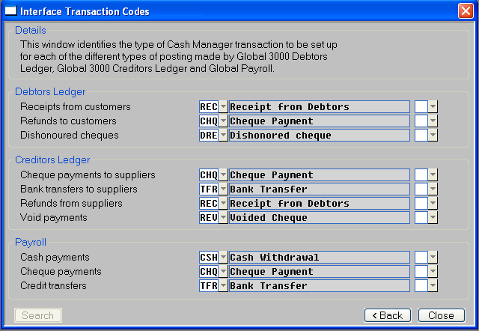
 | This window appears on exit from Transaction Codes Maintenance window in Cash Manager System Parameters.
Purpose | This window identifies the various types of Cash Manager transactions to be generated by the auto-transfer function for postings from Global 3000 Debtors Ledger, Global 3000 Creditors Ledger and Global Payroll.  The codes identifying the different types of transaction to be used must be valid Cash Manager transaction definition codes. Press Search to select from a list of valid transaction codes.
 | As each code is entered, the name of its associated transaction definition is displayed to confirm your selection and you are prompted for the analysis code against which the value of the transaction will be recorded.
The prompts are:
Debtors Ledger payments from customers | (Not required unless there is a Debtors Ledger/Cash Manager interface.) This identifies the type of transaction to be generated when Cash Manager receives details of receipts recorded in a Debtors Ledger payments batch.
Debtors Ledger refunds to customers | (Not required unless there is a Debtors Ledger/Cash Manager interface.) This identifies the type of transaction to be generated when Cash Manager receives details of a refunds batch from Debtors Ledger.
Debtors Ledger dishonoured cheques | (Not required unless there is a Debtors Ledger/Cash Manager interface.) This identifies the type of transaction to be generated when Cash Manager receives details of a batch of dishonoured cheques from Debtors Ledger.
Creditors Ledger cheque payments to suppliers | (Not required unless there is a Creditors Ledger/Cash Manager interface.) This identifies the type of transaction to be generated when Cash Manager receives details of cheque payments made through Creditors Ledger.
Creditors Ledger bank transfers to suppliers | (Not required unless there is a Creditors Ledger/Cash Manager interface.) This identifies the type of transaction to be generated when Cash Manager receives details of bank transfers made from Creditors Ledger.
Note | This transaction type is also used for payments associated with paid invoices.
Creditors Ledger refunds from suppliers | (Not required unless there is a Creditors Ledger/Cash Manager interface.) This identifies the type of transaction to be generated when Cash Manager receives details of a supplier refund from Creditors Ledger.
Creditors Ledger void payments | (Not required unless there is a Creditors Ledger/Cash Manager interface.) This identifies the type of transaction to be generated when Cash Manager receives details of a void payment batch posted in Creditors Ledger.
Payroll cash payments | (Not required unless there is a Payroll/Cash Manager interface.) This identifies the type of transaction to be generated when Cash Manager receives details of cash payments made by Payroll.
Payroll cheque payments | (Not required unless there is a Payroll/Cash Manager interface.) This identifies the type of transaction to be generated when Cash Manager receives details of cheque payments made by Payroll.
Payroll credit transfers | (Not required unless there is a Payroll/Cash Manager interface.) This identifies the type of transaction to be generated when Cash Manager receives details of credit transfers made by Payroll.
Analysis | (Skipped if transaction code is spaces). Enter the two-character analysis code to be used by auto-transfer when transferring transactions of this type. If this is left blank, the analysis code associated with the interface will be used instead.
Note | The codes set up here are used by Cash Manager auto-transfer only. All other Cash Manager transaction data entry programs use the codes established in the previous window.
On completion | ⇒ You are asked to confirm the details in the window.
On exit | ⇒ Cash Manager Parameters Menu.

Tax Analysis
<New window identifying the CM analysis code to be used for Tax Postings.>
Figure 3: Tax Analysis Window | 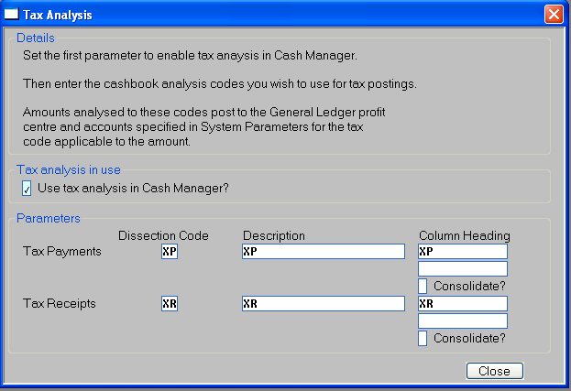
 | This window appears when you select Tax Analysis in the Cash Manager System Parameters Menu.
Purpose | This window allows you to turn on tax analysis in Cash Manager and identifies the cashbook analysis codes to be used for tax postings.
The prompts are:
Use tax analysis in Cash Manager? | Set to enable tax analysis in Cash Manager.
Note | Tax analysis may only be turned off if all Cash Manager batches are closed.
Tax Payments | Enter the two-character analysis code to be used for posting tax on payments. This must not be already set up as an analysis code.
Description | Enter the description for the tax payment code.
Column Heading | Enter the first and second lines of the column heading to be used in reports.
Consolidate | Check to cause postings to General Ledger to be consolidated
Tax Receipts | Enter the two-character analysis code to be used for posting tax on receipts. This must not be already set up as an analysis code.
Description | Enter the description for the tax payment code.
Column Heading | Enter the first and second lines of the column heading to be used in reports.
Consolidate | Check to cause postings to General Ledger to be consolidated
Note | General Ledger profit centre and account codes are not assigned explicitly to these analysis codes. These are determined by the tax code of the posting and are taken from the values set up in System Parameters/Administration/Company Parameters/Cash Book Control Accounts.

Definitions of Auto-Transfer Interfaces
Figure 5: Definitions of Auto-Transfer Interfaces Window | 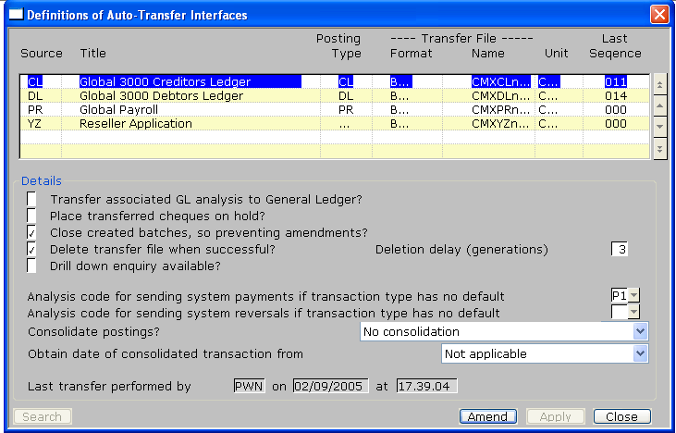
 | This window appears when you select Amend Interface Definitions from the System Maintenance Menu
Purpose | This window enables you to define auto-transfer interfaces so that transaction batches can be transferred automatically from other systems e.g. Global 3000 Debtors Ledger and Creditors Ledger. The window lists any interfaces that have already been defined.
Move through list | You can move through the list using the cursor and <Page Up> and <Page Down> keys in the standard way.
Add | To create a new interface, move the cursor to the line below the last entry in the list, or press <F5> to insert a new entry within the list. Alternatively you can press <F4> to go into ‘Add’ mode. The prompts are described in detail below.
Amend | To amend an existing interface, move the cursor to the required line and press <Return>. The prompts are described in detail below.
Delete | To delete an interface, move the cursor to the unwanted line and press <F7>. Cash Manager asks you for confirmation before it deletes the line.
Warning | The definitions you enter in this window must match the definitions entered for the interface in the other module; for example you must enter the same source id for the interface in both places.
The prompts are:
Source | A two-character code to identify the sub-system, such as ‘CL’ for Global 3000 Creditors Ledger.
Title | A title of up to 30 characters to help you identify the sub-system.
Posting type | A two-character code identifying whether the postings from this source are being made by Global 3000 Creditors Ledger, Global 3000 Debtors Ledger, Global Payroll or some other software module.  This allows Auto-Transfer to identify the set of transaction codes to be used for postings into Cash Manager through the interface. The appropriate codes must be set up using the Auto-transfer Interface Transaction Codes option in Cash Manager System Parameters before attempting to set up an interface posted to by Debtors Ledger, Creditors Ledger or Payroll.  Press Search to select from a menu of valid responses.
Note | For posting type “Other”, please contact your reseller or software supplier for specific details of settings in the interface definition shown here and any transaction codes that must be defined for the interface to operate.
Transfer file format | The format of the interface. This can be one of the following:
 | - BOS. This format can be used for Global 3000 modules version 4.2 or above. This format enables you to consolidate postings, to print a report of postings made via the interface, and to use the on-line posting feature.
 | - ITG. This format is retained for compatibility with pre-version 4.2 Global 3000 modules. It does not provide all the features of the BOS format.
 | The default is BOS.
Note | If you want to use the BOS format interface, you must also define the format of the interface as BOS in the sending system.
Further information | For further information about the on-line posting feature, see Cash Manager Integration in the Global 3000 Installation & Set-up Manual.
Transfer file name | (Display only.) This is a concatenation of ‘CMX’, the source id and the next sequence number. For example, the first file posted from Creditors Ledger would be ‘CMXCL001’, where ‘CL’ is the source id for Creditors Ledger, and 001 is the next sequence number.
Transfer file unit | The unit on which the transfer file will reside. The default is CMD, the Cash Manager database unit.
Last sequence | This is the sequence number of the last file to be transferred via the interface. It is automatically incremented every time a file is transferred, so that earlier cycles of the file can remain on the transfer file unit. The sequence number can be changed but this should only be done with great care.
Transfer associated GL analysis to General Ledger | (For posting types, DL, CL and PR this is automatically unset and skipped.) This specifies whether or not the associated General Ledger analysis is to be posted to General Ledger. If the analysis has already been posted, this should be left blank.
Warning | If posting to General Ledger is in use, the General Ledger analysis is always transferred to General Ledger if transferred batches are left open, and are amended in Cash Manager prior to closing, regardless of the setting of this prompt. This can result in duplicate postings in General Ledger.
Place transferred cheques on hold | Set if transferred payments are to be put on hold, otherwise leave blank.
Note | Held transactions cannot be reconciled with a bank statement until they are manually released via the Release/Hold Cheques option.
Close created batches, so preventing amendments | (For posting types, DL, CL and PR this is set automatically and skipped) Set to cause the imported batches to be closed by the auto-transfer program so they cannot be amended in Cash Manager. Leave blank to leave the imported batches open. They should then be manually closed via the Enter Transactions program.
Delete transfer file after successful transfer | Set if you want Cash Manager to automatically delete a transfer file after a successful transfer. Cash Manager determines which transfer file to delete by the setting of the next prompt. Leave blank if you want to delete the transfer files manually.
Transfer file deletion delay (in generations) | (Only if you set the previous prompt.) Enter the number of transfer files that are to be retained before being deleted. The default is three.
Note | By setting the ‘Delete transfer file’ prompt and specifying three as the deletion delay, you ensure that only the three most recent transfer files are retained.
Drill down enquiry available | Set if the option to drill down from transaction posted through this interface to their details in the source system is available.
Consolidate postings | (BOS format interfaces only.) Postings can be consolidated by:  - Batch number  - Transaction Narrative (excluding blank narratives)  - Transaction Narrative (including blank narratives)  - Or not at all.
 | Select the option you require from the drop-down box.
 | If you select one of the consolidate options you can print the constituent elements of each consolidated posting through the Auto-transfer Report.
Further information | For further information on consolidated postings, see Autotransfer.
Obtain date of consolidated transaction from | (Only if you are consolidating transactions) The date of a consolidated transaction can be taken from:  - The earliest transaction included  - The latest transaction included  - The transfer date  - The period end date
 | Select the option you require from the drop-down box.
 | If you are not consolidating transactions this prompt is set to “Not applicable” and is skipped.
Analysis code for sending system payments when transaction type has no default | (For posting types, DL, CL and PR the analysis code is taken from the relevant entries in the Interface transaction codes window. The value entered here is used for any transaction codes that have no associated analysis code.) Enter the analysis code to use when no analysis information is passed with a transaction.
Analysis code for sending system reversals when transaction type has no default | (For posting types, DL, CL and PR the analysis code is taken from the relevant entries in the Interface transaction codes window. The value entered here is used for any transaction codes that have no associated analysis code.) Enter the analysis code to use when no analysis information is passed with a transaction.
 | When no analysis is provided, the transaction’s narrative is copied to the analysis narrative to provide a reference. If the original narrative was blank, the transaction’s reference is used instead.
 | Provided the batches are not closed immediately following transfer, these details can be amended via Enter Transactions (but see warning below).
On completion | ⇒ Next line in the window.
On exit | ⇒ System Maintenance Menu.

Transaction Details
<Window has been extended to include Taxable &Tax.>
Figure 1: Transaction Details Window | 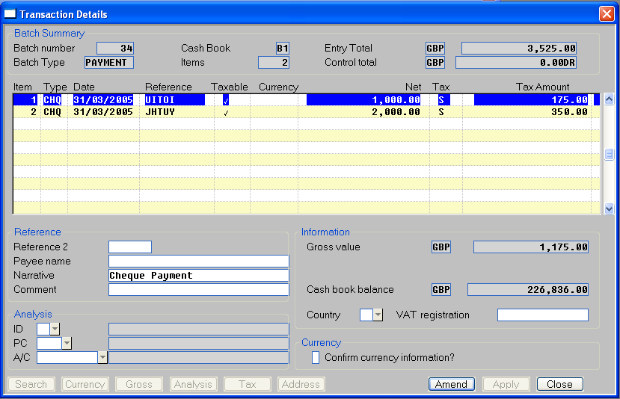
 | This window appears when you select “Lines” in the Cash Book Batches Window.
Purpose | This window displays transactions that already exist in the selected batch, and lets you enter, amend and delete transactions.
Move through list | You can move through the list using the cursor and <Page Up> and <Page Down> keys in the standard way.
Add | To create a new transaction, move the cursor to the line below the last entry in the list, or press <F5> to insert a new entry within the list. Alternatively you can press <F4> to go into ‘Add’ mode. The prompts are described in detail below.
Amend | To amend an existing transaction item line, move the cursor to the required line and press <Return>. The prompts are described in detail below.
Delete | To delete a transaction, move the cursor to the unwanted line and press <F7>. Cash Manager asks you for confirmation before it deletes the line.
The prompts are:
Item | (Display only.) Cash Manager automatically allocates an item number to each transaction as it is added to the batch. This is blank when starting a new transaction. The batch and item number combine to uniquely identify this item in the Cash Manager daybook.
Type | (Only when entering a new transaction.) Enter the transaction code identifying the type of transaction. Press Search for a pop-up enquiry of valid codes.
Note | Transaction codes are set up and maintained in Cash Manager System Parameters/Transaction Codes.
Date | Enter the transaction date. This must not be later than the end of the selected period. The default is either today’s date, or the end of the selected period, whichever is earlier.
Reference | A reference identifying the transaction (up to 10 characters). You must enter this if a reference is specified as mandatory for the transaction code.
Taxable | (Y/N) (The taxable status set when this transaction type was defined is presented as a default) Set to Y if the transaction is to be included in the VAT Reconciliation Report, N otherwise. If it is set to Y, Cash Manager sets the tax class for the transaction to  - NS - for receipts  - NP - for payments.
 | These codes are those used for domestic sales and purchases in the VAT reconciliation report and determine which box or boxes on the report the transaction contributes to. For further information, see General Ledger.
 | If the prompt is set to N the tax class is left blank.
Note | Setting Taxable to N indicates that the Cash Manager is not responsible for reporting this transaction to the VAT reconciliation report. This may either be because the item has no VAT element or because responsibility for reporting lies with another module in the software.
 | For example:- Items posted from Global 3000 Debtors Ledger and Global 3000 Creditors Ledger have Taxable set to N and blank tax class because the ledgers take responsibility for identifying the tax associated with a payment/receipt and for notifying the VAT report.
 | NB: Zero rated and exempt items entered using Cash Manager transaction entry which you wish to report to boxes 6 to 9 of the VAT return must be classed as taxable.
Currency | (Only for non-taxable transactions in multi-currency systems.) When a batch currency has not been specified, you need to enter the currency of the transaction. This is referred to as its ‘entry currency’. The default is the cash book currency. Press Search for a pop-up enquiry.
 | If a batch currency has been specified, it is displayed here.
Note | If the entry currency differs from either the cash book currency, or the company’s base currency, or both, the transaction is referred to in this manual as a ‘foreign currency transaction’. Such transactions cannot be taxable.
Net | Enter the net value of the transaction in entry currency. To enter a tax inclusive value for a taxable transaction, press the “Gross” button to display the ‘Enter Gross Value’ window.  For foreign currency transactions, this value can be changed while the Confirm? Prompt for this transaction is N. After ‘Confirm?’ is set to Y, the value in entry currency cannot be amended.
If the currency operates with a decimal precision of zero or one, you cannot enter a value with more non-zero decimal places than are allowed for the currency; for example if the decimal precision is zero you can enter the amount as ‘1478’ or as ‘1478.00’, but not as ‘1478.5’. For further information about the decimal precision of currencies, see Currency Maintenance in the Global 3000 Installation & Set-up Manual.
Note | Cash Manager converts the value to cash book currency and to base currency if different from the entry currency. Cash Manager uses the house exchange rates in force on the transaction date for any non-tax portions of these calculations.  You can press the Currency button to:  - View exchange details used to calculate the default net value in base currency for cashbook analysis and overall value in book currency.
- Enter a spot rate or specific value for either base or cash book currency to accurately reflect the information on the tax document being recorded.
This option is available for foreign currency transactions until their value in the currency is fixed by setting the confirm flag described below or by running the currency confirmation function. For more details of currency confirmation, see Confirm Currency.
Tax | (If the transaction is not taxable, this is skipped. If a specific tax code was set when this transactions type was defined, it is offered as a default.) If the whole transaction is subject to tax at the same rate, enter that tax code here.  Leaving the tax code blank for a transaction forces the tax details window to be entered once the transaction details have been entered.
Note | Selecting a specific tax code here does not prevent tax details of the transaction from being amended later to involve more than one tax code.
Tax amount | (If the transaction is not taxable, this is set to zero and skipped.) Enter the tax amount. This can be negative if required.
 | If the currency operates with a decimal precision of zero or one, you cannot enter a value with more non-zero decimal places than are allowed for the currency; for example if the decimal precision is zero you can enter the amount as '1478' or as '1478.00', but not as '1478.5'. For further information about the decimal precision of currencies, see Currency Maintenance in the Global 3000 Installation & Set-up Manual.
Note | The first time you enter this prompt for the item line, if a tax code has been established, Cash Manager calculates a default tax amount using the terms defined for the code and displays the value for confirmation or amendment.
Reference 2 | Enter a source reference for the transaction of up to seven characters. For transactions imported from Debtors Ledger, this is the customer’s account code; for transactions imported from Creditors Ledger, this is the supplier’s account code.
Payee/Payer name | Enter the name of the payee/payer in up to 30 characters. For transactions imported from Debtors Ledger, this is the customer’s account name; for transactions imported from Creditors Ledger, this is the supplier’s account name.
Note | If a cheque or other payment document is to be printed, you can enter the payee name to be printed on the cheque here. To enter address and other payment details select the Address button which leads to the Payment Details Window.
Narrative | Enter up to 30 characters of narrative. The default is the transaction code’s description.
Comment | Enter a comment up to 30 characters.
Id | (If a specific analysis code was set when this transaction type was defined, it is offered as a default.) If the non-tax portion of a transaction analyses to a single code in the cash book, enter that code here. The code’s description and associated GL profit centre and account code are displayed.  Press Search to select from the list of valid analysis codes for the currently selected cash book.
Note | If you want to analyse a transaction across multiple columns of your cash book or to a number of General Ledger profit centres or accounts, leave this code blank. The profit centre and account prompts are skipped and you can enter the cashbook analysis window on exit from this window.
Profit centre | (If the profit centre associated with the analysis code is fixed, this item is display only. If no analysis code was selected previously, this is skipped.) If you analyse the non-tax portion of the transaction to a single cashbook code, any profit centre defined for that code is displayed. If the profit centre is blank or not fixed you are prompted for it.  Press Search to select from a list of valid profit centres.  When you select a valid profit centre, its title is displayed.
Note | If your system is configured to validate General Ledger accounts against the off-line chart of accounts, the profit centres listed in the pop-up enquiry are restricted to those defined in the off-line chart of accounts in Company Parameters.
GL account | (If the GL account associated with the analysis code is fixed, this item is display only. If no analysis code was selected previously, this is skipped.) If you analyse the non-tax portion of the transaction to a single cashbook code, any GL account defined for that code is displayed. If the GL account is blank or not fixed, you are prompted for it.  Press Search to select from a list of valid GL accounts.  When you select a valid account, its title is displayed.
Note | If your system is configured to validate General Ledger accounts against the off-line chart of accounts, the accounts listed in this pop-up enquiry are restricted to those defined for the selected profit centre in the off-line chart of accounts in Company Parameters.
Gross value | (Display only.) The transaction total (inclusive of tax) in entry currency. The code of the entry currency is also displayed.
Base value | (Only if entry currency differs from base currency. Display only.) The transaction amount in the company’s base currency.
Book value | (Only if entry currency differs from cash book currency. Display only.) The transaction amount in the cash book currency.
Cash book balance | (Display only). The cash book balance in cash book currency.
Country | (Only if the transaction is taxable) Set to the country of the selected company and skipped.
VAT Registration | (If transaction is not taxable this is set to spaces and skipped.) The tax registration code for this transaction. This is validated according to the mask defined for the entered country. If this is left blank when the transaction is taxable, you are reminded that the VAT Registration information pertaining to the transaction must be retained for audit purposes. Once this reminder has been seen, the operator can choose to suppress it for further transactions.
Confirm currency information | (Foreign currency transactions only.) Enter Y to prevent any further changes to the currency information for the transaction if you are confident that the final rates applying to the transaction are those currently in use for it.  Enter N if the final exchange rates applying to the transaction are not known. You can use the Confirm Currency function to update and fix currency information for a transaction at a later stage, even after the batch containing it has been closed.
 | This prompt is automatically set to Y and is skipped, if all the exchange rates between the currencies involved are fixed on the transaction date.
Warning | After you confirm a foreign currency transaction value is fixed, you cannot un-confirm it, or change its value or currency information.
On completion | If the transaction is subject to tax and the tax code is blank ⇒ Tax Details Window, see page 20,
 | Otherwise, if no single analysis code has been established at this point ⇒ Cashbook Analysis Window, see page21.
On exit | ⇒ Cash Book Batches window

Buttons
Search | Press Search at the appropriate prompt for a look-up window for  - Transaction type  - Currency  - Tax code  - ID (Cashbook analysis)  - PC (GL Profit centre)  - A/C (GL Account)  - VAT registration  - Country
Currency | Press Currency once the transaction currency has been established for foreign currency transactions to view the exchange rate details for the transaction:  - If the cash book and base currency are the same ⇒ Currency Information Window.
 | - Otherwise ⇒ Currency Menu. This gives you access to the Currency Information Window for the conversions to both base and book currencies.
Note | If one of the exchange rates involved in the transaction is variable and the currency information has not been confirmed, the Currency Information Window lets you amend the currency details for the transaction.
Gross | (Only for taxable transactions) Press Gross while at the Net prompt allows you to enter a tax inclusive value for a taxable transaction via the ‘Enter Gross Value’ window.
Analysis | Press Analysis while amending a transaction to go to the Cashbook Analysis window.
Tax | (Only for taxable transactions) Press Tax while amending a transaction to go to the Tax Analysis window.
Address | Press Address while amending a transaction to go to the Payment Details window.

Tax Details
<The following window has been introduced to handle domestic tax detail capture .>
Figure 2: Tax Details Window  . | 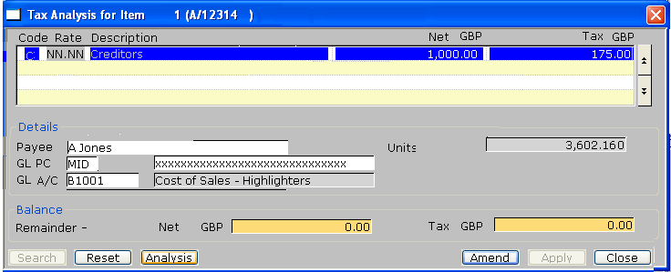
 | This window appears when you specify that the transaction being entered is a taxable payment or receipt.
Purpose | This window displays tax details that already exist for the selected transaction, and lets you add, amend and delete tax analysis lines.
Move through list | You can move through the list using the cursor and <Page Up> and <Page Down> keys in the standard way.
Add | To create a new line, move the cursor to the line below the last entry in the list, or press <F5> to insert a new entry within the list. Alternatively you can press <F4> to go into ‘Add’ mode. The prompts are described in detail below.
Amend | To amend an existing line, move the cursor to the required line and press <Return>. The prompts are described in detail below.
Delete | To delete a line, move the cursor to the unwanted line and press <F7>. Cash Manager asks you for confirmation before it deletes the line.
The prompts are:
Code | Select the two-character tax code to set the rate of tax for the line. Key Search to select from a list of valid tax codes.
Rate | (Display only.) The percentage at which tax is charged on net analysed to the selected tax code.
Description | (Display only.) The description of the selected tax code.
Note | Tax codes are defined in System Parameters/Administration/Tax Codes.
Net | Enter the net value charged to the selected tax code.
Tax | (A default calculated from the tax code & net is offered.) The total tax value for those parts of the transaction charged to the selected code. If the value differs from the default offered by the Cash Manager, you can override the default with the value shown. A warning will be issued if the difference exceeds one minor unit of base currency.
Payer/Payee | (Display only.) For receipts the payer name established in the transaction entry window is displayed for information.  For payments the payee name established in the transaction entry window is displayed for information.
GL Profit Centre and Account Code | (Display only.) The profit centre and account code to which this tax line will be analysed.
Units | (Only if the selected General Ledger account is marked as requiring units.) The number of units.
Remainder – Net and Tax | (Display only.) Remainders for the transaction.
On completion | If no single analysis code has been established at this point ⇒ Cashbook Analysis Window, see page 21.
On exit | ⇒ Transaction entry window.

Buttons
Search | Press Search at the appropriate prompt for a look-up window for tax codes.
Reset | Press Reset to delete all tax analysis for the transaction.
Analysis | Press Analysis to go to the Cashbook Analysis window.

Cashbook Analysis
<This replaces the existing window “Dissection Analysis”. The R-FETCH must filter out CL records with CLSTAT = “T”, they are maintained & viewed through the Tax Analysis window.>

Figure 3: Cashbook Analysis Window | 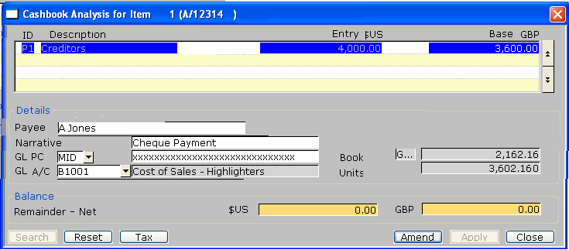
Purpose | This window enables you to distribute the non-tax portion of the transaction across the appropriate analysis codes representing your cash book columns or General Ledger account distribution. If you are amending a transaction, the window lists any existing lines of analysis, and enables you to amend and delete them.
Move through list | You can move through the list using the cursor and <Page Up> and <Page Down> keys in the standard way.
Add | To create a new line of analysis, move the cursor to the line below the last entry in the list, or press <F5> to insert a new entry within the list. Alternatively you can press <F4> to go into ‘Add’ mode. The prompts are described in detail below.
Amend | To amend an existing line, move the cursor to the required line and press <Return>. The prompts are described in detail below.
Delete | To delete an existing line, move the cursor to the unwanted line and press <F7>. Cash Manager asks you for confirmation before it deletes the line.
Note | The balance that remains to be distributed in each currency is displayed at the bottom of the window.
The prompts for each line are:
ID | The code to which this part of the transaction is analysed. The default is taken from the transaction definition of the selected transaction. Press Search for a pop-up enquiry.
Description | (Display only.) The analysis code description.
Entry | Enter the amount in entry currency to analyse to the code.
If the currency operates with a decimal precision of zero or one, you cannot enter a value with more non-zero decimal places than are allowed for the currency; for example if the decimal precision is zero you can enter the amount as ‘1478’ or as ‘1478.00’, but not as ‘1478.5’.
Further information | For further information about the decimal precision of currencies, see Currency Maintenance in the Global 3000 Installation & Set-up Manual.
Base | (Only if the entry currency of the transaction differs from the base currency. Display only.) The base currency value to be posted to the General Ledger. This is calculated by apportioning the base currency equivalent of the overall transaction net calculated using the transaction exchange rates established in the transaction detail entry window.
Payer/Payee | (Display only.) For receipts the payer name established in the transaction entry window is displayed for information.  For payments the payee name established in the transaction entry window is displayed for information.
Narrative | Enter the narrative to be passed to General Ledger in up to 30 characters. This defaults to the transaction narrative.
Note | If the General Ledger profit centre and account code are defined as ‘fixed’ for the analysis code, you cannot change them, and the next two prompts are skipped. For further information, see Cash Book Maintenance.
GL PC | Enter the code of the General Ledger profit centre to which the amount is to be posted. This defaults to the profit centre specified for the currently selected analysis code in Cash Book Maintenance. Press Search for a pop-up enquiry.
Note | If your system is configured to validate General Ledger accounts against the off-line chart of accounts, the pop-up enquiry is restricted to profit centres and account combinations defined in the off-line chart of accounts in Company Parameters.
GL A/C | Enter the code of the General Ledger account to which the amount is to be posted. This defaults to the account specified for the analysis code in Cash Book Maintenance. Press Search for a pop-up enquiry.
Note | If your system is configured to validate General Ledger accounts against the off-line chart of accounts, the accounts listed in this pop-up enquiry are restricted to those defined for the selected profit centre in the off-line chart of accounts in Company Parameters.
Book | (Only if cash book currency differs from both entry and base currencies. Display only.) The equivalent to the entry amount in cash book currency. Cash Manager calculates this by apportioning the overall net value in book currency established in the transaction entry window.
Units | (Only if the selected General Ledger account is marked as requiring units.) The number of units.
On completion | ⇒ Next line in window.

Buttons

Search | Press Search at the appropriate prompt for a look-up window for  - Cashbook analysis codes,  - GL Profit centres,  - GL Account codes.
Reset | Press Reset to delete all cashbook analysis for the transaction.
Tax | Press Analysis to go to the Cashbook Analysis window.

