

Global 3000
Debtors Ledger V6.0

Service Pack 7
Enhancements

All Sites – Enhancement to the allocation of payments.

This service pack improves facilities for initial allocation of payments received in Debtors Ledger.
This enhancement introduces a new “Automatically allocate unallocated payments” parameter.
This parameter enables you to configure Debtors Ledger so that at the start of the allocation of an unallocated payment, its gross value is compared with the cumulative balance of outstanding transactions on the account and if, at any point, it exactly matches that cumulative balance then the transactions up to that point are automatically allocated against the payment prior to entering the allocations window. On entry to the allocations window, the standard facilities for amending allocations and de-allocation are all available.
If the gross payment does not match the cumulative balance of all outstanding transactions at any point, the procedure is repeated checking the cumulative balance of outstanding amounts on invoices.

Debtors Ledger Parameters Menu
Allocation Settings | This option allows you to select automatic allocations for Debtors Ledger payments.

Allocation Settings
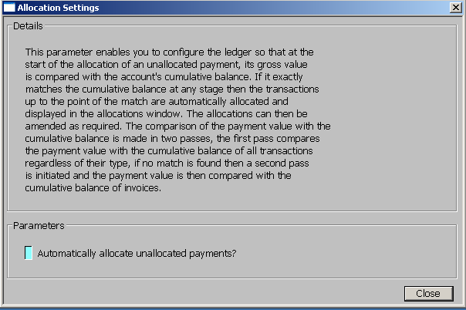 | This window appears when you select Allocation Settings from the Debtors Ledger Parameters menu.
Purpose | This parameter enables you to configure the ledger so that at the start of the allocation of an unallocated payment, its value is compared with the accounts cumulative balance, if it exactly matches the cumulative balance at any stage then the transactions up to the point of the match are automatically allocated and displayed in the allocations window, the allocations can then be amended as required. The comparison of the payment value with the cumulative balance is made in two passes, the first pass compares the payment value with the cumulative balance of all transactions regardless of their type, if no match is found then a second pass is initiated and the payment value is then compared with the cumulative balance of invoices.
The prompt is:
Automatically allocate unallocated payments | Setting this causes the value of unallocated payments to be compared with the cumulative balance of the account, if an exact match is found then the transactions making up the cumulative balance up to the point of the match are automatically allocated.
On completion | You are returned to the Debtors Ledger Parameters menu.

