

Global 3000
Product Maintenance

Service Pack 26 Enhancement Notes

BIC and IBAN

From 1st January 2006 European banks may levy higher bank charges on corporate customers whose cross-border transactions in Euros do not conform to BIC (Bank Identifier Code) and IBAN (International Bank Account Number) data formats. From 1st January 2007 banks can reject such transactions and also charge customers for the return of the transaction less the fee levied. This indicates that the use of BIC and IBAN may become mandatory in the future.
The implication for Global 3000 is that BIC and IBAN should be made available on all documents relating to cross-border transactions.
This is done by holding BIC and IBAN with bank account details for companies, suppliers and customers, and printing them when documentation relating to cross-border transactions is produced.
BIC and IBAN for suppliers are printed on autopayment documents and supplier list in Creditors Ledger.
BIC and IBAN for customers are printed on the session banking report and customer list in Debtors Ledger.
The company’s BIC and IBAN are printed on cross-border invoices by Sales Order Processing so that customers can supply them to their bank with the payment.
BIC and IBAN are printed on the fund transfer document in Cash Manager.
IMPORTANT NOTE: Program DS435 supplied with this service pack MUST be run to set the ISO country codes on existing records.

Company Parameters

Cash Book Control Accounts
<Additional prompt for the cash book default for cross-border invoices:>

Cash Book Control Accounts Window
Figure 1: Cash Book Control Accounts Window | 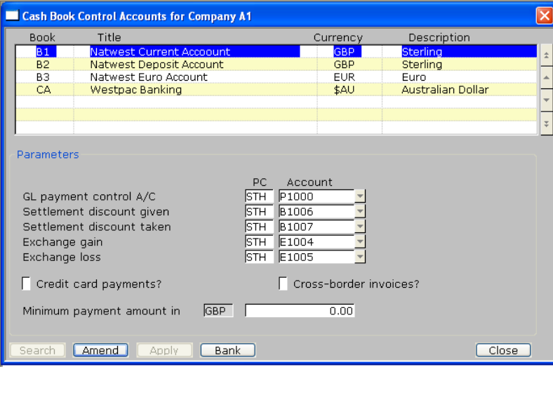

Cross-border invoices? | Tick if the cash book is to be used for cross-border invoices. The BIC and IBAN from the account are printed on the invoice.
Note | You can only select one cash book for Cross-border invoices, but this can be changed for individual customers and invoices at order entry.

<Additional prompt for BIC and IBAN in cash book bank details:>

Bank Details Window
Figure 2: Bank Details Window | 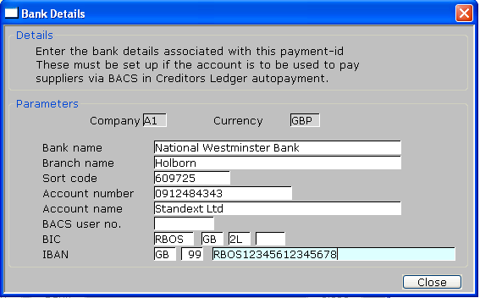

BIC | Bank Identification Code. This has three or four parts:-
 | Enter the four-character bank code. This is required.
 | Enter the required two-character country code. A search is available.
 | Enter the next two characters which identify the city or town.
 | Enter the optional final three characters which identify the branch.
IBAN | International Bank Account Number. This number comprises a country code and a two-digit checksum, followed by a code generated from sort codes and account numbers. Because these vary from country to country within the EC it is not possible to format the final part of the number
 | Enter the two-character country code. A search is available.
 | Enter the two-digit checksum.
 | Enter the remainder of the code.

Creditors Ledger

Supplier Maintenance

<Additional prompts for BIC and IBAN in Supplier Bank details>

Supplier Bank Details Window
Figure 3: Supplier Bank Details Window | 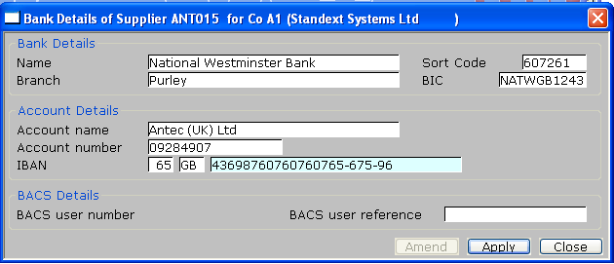

Bank name | Enter the supplier's bank name in up to 30 characters.
Branch | Enter the supplier's bank branch name in up to 30 characters.
Sort code | Enter the supplier's bank sort code in up to 10 characters.
BIC | Bank Identification Code. This has three or four parts:-
 | Enter the four-character bank code. This is required.
 | Enter the required two-character country code. A search is available.
 | Enter the next two characters which identify the city or town.
 | Enter the optional final three characters which identify the branch.
Account number | Enter the supplier's account number in up to 15 characters.
Account name | Enter the supplier's account name in up to 30 characters. The default is the supplier's name.
IBAN | International Bank Account Number. This number comprises a country code and a two-digit checksum, followed by a code generated from sort codes and account numbers. Because these vary from country to country within the EC it is not possible to format the final part of the number.
 | Enter the two-character country code. A search is available.
 | Enter the two-digit checksum.
 | Enter the remainder of the code.
BACS user no | (Only if the supplier's payment method is set to BACS transfers.) Enter the supplier's BACS user number in up to six digits.
BACS user ref | Enter the supplier's BACS user reference in up to 18 characters.

Supplier Bank Details Enquiry
<BIC and IBAN shown in Supplier Bank Details Enquiry>

Figure 4: Supplier Bank Details Window | 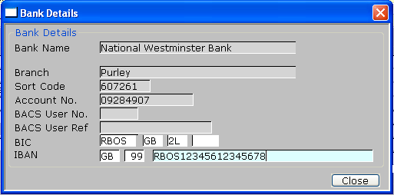

Debtors Ledger

Customer Maintenance

Customer Bank Details window
<As above for Creditors with Supplier⇒ Customer>

Customer SOP Parameters Window
<Additional prompt for Cash Book for cross-border invoices>

Figure 5: Customer SOP Parameters Window | 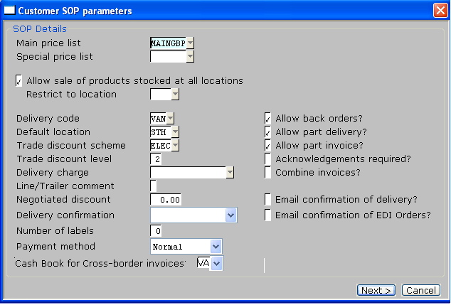

Cross-border cash book | Enter the cash book to be used as a default for cross-border invoices generated for this customer. The BIC and IBAN of this cash book must be printed on the invoice so that the customer can use them for payment. The default is the cash book flagged for this purpose in System Parameters.

Cash Manager

Cash Book Maintenance
<BIC and IBAN added to cash book bank details>

General Details of Cash Books window
Figure 6: General Details of Cash Books Window | 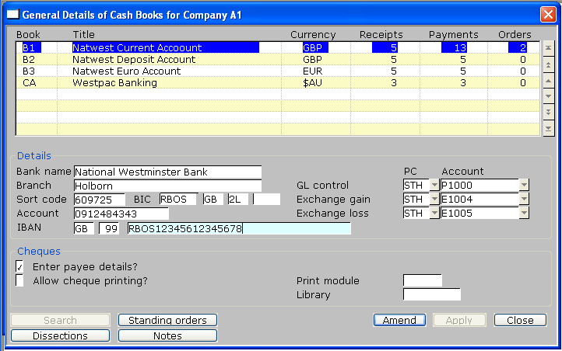

BIC | Bank Identification code. This has three or four parts:-
 | Enter the four-character bank code. This is required.
 | Enter the required two-character country code. A search is available.
 | Enter the next two characters which identify the city or town.
 | Enter the optional final three characters which identify the branch.

IBAN | International Bank Account number. This number comprises a country code and a two-digit checksum, followed by a code generated from sort codes and account numbers. Because these vary from country to country within the EC it is not possible to format the final part of the number.
 | Enter the two-character country code. A search is available.
 | Enter the two-digit checksum.
 | Enter the remainder of the code.

Sales Order Processing

Transaction Entry
<Cash book for cross-border invoices added to account defaults>

Setup Account Defaults Window
Figure 7: Setup Account Defaults Window | 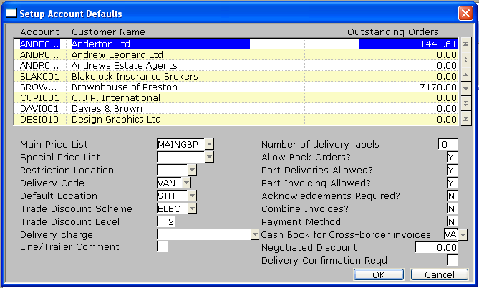

Cross-border invoice cash book | Enter the cash book to be used as a default for cross-border invoices generated for this customer. The BIC and IBAN of this cash book must be printed on the invoice so that the customer can use them for payment. The default is the cash book flagged for this purpose in System Parameters.

Header Details Window
<Cash book for cross-border invoices added to order header details>

Figure 8: Sales Order Header Details Window | 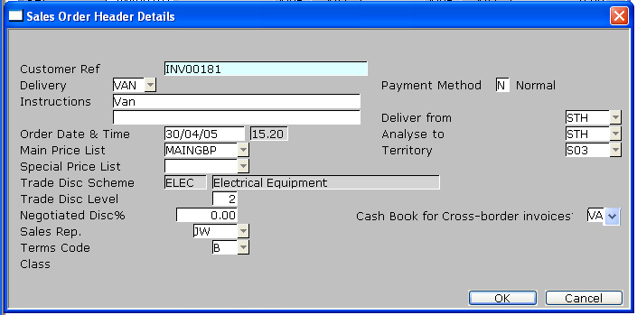

Cross-border cash book | Enter the cash book to be used as a default for Cross-border invoices generated for this customer. The BIC and IBAN of this cash book must be printed on the invoice so that the customer can use them for payment. The default is the cash book Set up for this customer in Customer SOP Details.

REPORT LAYOUT CHANGES

<The following reports have been updated to show IBAN and BIC>

Creditors Ledger

Auto-Payments Final Payments List

Auto-Payments Remittances

Auto-Payments Foreign Payments List

Auto-Payments Remittance List

Supplier List

Debtors Ledger

- Session Banking Report

Customer List

Sales Order Processing

Invoice

Cash Manager

Fund Transfer Report

