

Global 3000
Sales Order Processing V6.0

Service Pack 2
Enhancements

Sites using Sales Order Processing and/or Stock Requisitions – Enhancement to Despatch Confirmation process

This service pack provides an enhancement to Sales Order Processing and Stock Requisitions to allow sales orders or requisitions for all pick runs to be confirmed in one operation.
A new “Bulk” option has been included in Despatch Confirm. This lists all picked orders or requisitions regardless of pick run and gives the user the options which are already available to amend, unpick and confirm or unconfirm, together with a further option to withhold from the bulk process.
When any amendments are completed, the orders or requisitions may be confirmed in one operation. When this is complete, orders or requisitions which have been held during the process are released.

SALES ORDER PROCESSING

Despatch Confirmation
Introduction | Despatch Confirmation enables you to confirm despatch of sales orders and stock requisitions that have been picked, and make amendments as necessary.
The following options are available:
- You can select a pick run and then choose to confirm despatch of all orders and requisitions for the run, or process them one by one.
 | - You can confirm despatch of orders for a specified account.
 | - You can confirm despatch of individual orders and requisitions.
 | - You can confirm all orders in bulk, after listing them and holding any that should not be confirmed.
For each order and requisition:
- You can change the picked quantity.
 | - You can skip problematic lines.
 | - You can return a line to stock leaving it allocated.
 | - For normal pooled lines you can back order items.
 | - You can amend the delivery details and the despatch date.
 | Full batch-tracking and serial number handling facilities are provided.

Despatch Confirmation Menu
Figure 1: Despatch Confirmation Menu | 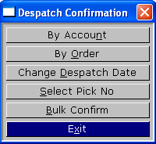
 | This menu appears when you select Despatch Confirmation from the Order Processing menu or the Stock Requisitions menu in Stock Control.
Purpose | This menu enables you to select different groupings of orders or requisitions, which you can then confirm (or amend) in the Confirm Despatch Of Sales Order window.
The options are:
By account | This option enables you to confirm despatch of orders for a specified account. ⇒ By Account window.
By order | This option enables you to confirm despatch of a specific order or requisition. ⇒ By Order.
Change despatch date | This option enables you to change the default despatch date for the deliveries you are confirming. ⇒ Enter the Default Despatch Date Window
Select pick number | This option enables you to select the pick run that you wish to confirm the despatch of. ⇒ Select Picking List Number window.
Bulk confirm | This option enables you to display all picked orders or requisitions, flag any that should not be confirmed and confirm the remainder in bulk ⇒ Bulk Confirmation of Picked Orders window.
Exit | You are returned to the menu from which you came.

Bulk Confirmation of Picked Orders
Figure 2: Bulk Confirmation of Picked Orders Window | 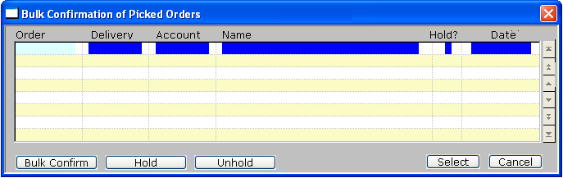
 | This window appears when you choose Bulk Confirm from the Despatch Confirmation menu
Purpose | This window lists all picked orders which have not been confirmed. It enables you to select individual orders to amend or confirm, and to withhold orders from the bulk confirmation process.
Note | Withholding orders from the bulk confirmation process is not the same as holding orders at order entry for reasons related to credit checking. Orders which are held in this window are held for the duration of the bulk confirmation process only. When the process is complete, the held status is removed from any orders which have not been confirmed.
Move through list | You can move through the list using the cursor and <Page Up> and <Page Down> keys in the standard way.

Buttons

Bulk Confirm | Confirm all the orders which have not been held. You are asked to confirm your intention.
Note | Bulk confirmation is an irreversible process. Any changes required after it is complete must be done for the individual orders or requisitions.
Hold | Withhold an order from the bulk process.
Unhold | Remove the hold from an order.
Select | View or amend an individual order ⇒ Confirm Despatch of Sales Order Options menu
Cancel | Cancel the current confirmation process. All orders are returned to “Unheld” status.

Delivery Instructions

When the default delivery instructions for an order are amended the associated delivery code is now retained. In addition the first line of delivery instructions is now shown below the delivery code to make it visually clearer that there are two lines of delivery instructions available.

