|  |
| --- |
| Global 3000  Asset Register  Version 6.0 |



All rights reserved. No part of this publication may be reproduced, stored in a retrieval system or transmitted, in any form or by any means, electrical, mechanical, photocopying, recording or otherwise, without the express permission of TIS Software Ltd.

Published by TIS Software Ltd, Regatta Place, Marlow Rd, Bourne End, Buckinghamshire, SL8 5TD.

Version 6.0 (rev)

Manual reference: ZA60

© TIS Software Ltd 2004 - 2018

All brand and product names are trademarks or registered trademarks of their respective owners.

## Important Notes

|  |  |
| --- | --- |
| Service Packs | This manual assumes that the following service packs have been applied which contain many presentation enhancements to Asset Register.  ZA60_000011_000.GSP.  ZM60_000503_000.GSP. |
| Before applying these Service packs | These service packs update posting to General Ledger to use Direct postings. It is therefore vital that you run:   * Print GL Analysis Report. * Create GL Transfer File. * General Ledger auto-transfer to import the resulting interface file into General Ledger.   immediately before applying these service packs. |
| Upgrade to Direct Postings | The software will automatically update the general ledger interface to ‘Direct Postings’ the first time you run any process that causes postings to General Ledger. |

## About this manual

|  |  |
| --- | --- |
| Asset Register | Asset Register maintains a record of fixed assets held by a company, either as individual items where they are of high value, or as collections of similar items of lower value. Depreciation is calculated automatically, using the historic cost accounting convention. Within this, the methods of depreciation catered for are straight line, reducing balance, depreciation table, or units of use. |
|  | Asset Register can be used stand-alone or in conjunction with General Ledger which receives postings of additions, transfers, revaluations, disposals, and the regular depreciation of assets. Double entry is maintained by posting the purchase and sale of assets to a suspense account in General Ledger. This account is cleared by postings from Asset Register. |
| Structure of this manual | The first section of this manual is a functional overview of Asset Register.  The structure of the next six sections reflects the menu structure of the Asset Register module. Each of these sections corresponds to an entry on the Asset Register Main Menu.  The final section provides printed examples of many of the standard reports that are provided by Asset Register.  There is a full table of contents overleaf, and a summary one at the beginning of each section. A full index can be found at the back of the manual. |
| Conventions used in this manual | This manual provides detailed instructions for operating the software on a window-by-window and menu-by-menu basis. For each window and menu, details are given of when it appears. This is followed by details of the prompts, options and information displayed, and details of what happens when you complete the entries or exit. The window or menu that appears next is indicated by the ⇒ sign. |
|  | The use of the word ‘enter’ means that you should press the key or keys specified and then press <Return>. Use of the word ‘press’ indicates that you should press the specified key or keys alone. |
|  | Key names are enclosed in angled brackets. When you need to press keys at the same time, they are enclosed in one pair of angle brackets, e.g. <CTRL A>. When you need to press keys separately, the key names are enclosed in separate angle brackets, e.g. <F4><F2>.  Software buttons are indicated by square buttons. Thus if a Search button is available it will be indicated by [Search]. |

## Contents

Important Notes 3

About this manual 4

Contents 5

Overview 9

Overview 10

Multi-currency operation 10

Asset Details 10

Transaction Entry 12

Further Details 13

Cycle of Operations 14

Depreciation Calculations 14

Postings to General Ledger 16

Reports and Enquiries 17

Transaction Entry 19

Transaction Entry 20

Unposted Transactions 20

Select Transaction Type 22

Add to Asset 23

Asset Disposal - Attachments 24

Asset Disposal 25

Asset Attachment 26

Adjust Depreciation 27

Adjust Tax Depreciation 28

Asset Mothball 29

Remove from Mothball 30

Asset Revaluation 31

Split Asset 32

Attached Asset Transfer 33

Asset Transfer - Attachments 34

Asset Transfer 35

Units Used 36

End of Period Processing 37

Depreciation Run 38

Asset Register Depreciation Run 38

Print GL Analysis Report 39

GL Analysis Report Window 39

Close Period 40

Close Period Window 40

Purge Transactions 42

Purge Transactions Window 42

Integrity Check 44

Integrity Check Window 44

Reports 47

Asset Ledger Report 48

Asset Register Print Window 48

Additions and Disposals Report 52

Additions and Disposals 52

Selective Transaction Report 55

Selective Transactions Print 55

Asset Print by Date 59

Asset Register Print by Date Window 59

Asset Label Print 62

Asset Register Print Labels Window 62

Asset Maintenance 65

Asset Maintenance 66

General Details 66

Select Template Asset 69

Purchase Details 70

Depreciation Details 71

Tax Depreciation Details 72

Analysis Codes 74

Comments 75

System Maintenance 77

System Parameters 78

Asset Register Parameters 78

Analysis Codes 80

Select System Code 81

Current Accounting Period 83

Depreciation Date 84

Asset Code Format 85

General Ledger Integration 86

Reference Fields 88

Sequence Number 89

Tax Depreciation 90

User Defined Dates 91

User Defined Values 92

Operating Options 93

Depreciation Table Maintenance 94

Depreciation Table Maintenance 94

Print Depreciation Table 95

Asset Group Maintenance 96

Maintain Asset Groups 96

Template Group 98

GL Account Codes 99

Asset Group Report 101

Budget Maintenance 102

Budget Maintenance 102

Budgets for Year 103

Print Budgets for Year 104

Budget Code Search 104

Asset Data Load 106

General Details 106

Select Template Asset 109

Purchase Details 109

Depreciation Details 110

Tax Depreciation Details 113

Analysis Codes 114

Year to Date Summary 115

Comments 117

Group Revaluation 118

Revalue Asset Group 118

Enquiries 119

Asset Enquiry 120

Attachments 122

Comments 123

Depreciation Details 124

Tax Details 125

Reference Fields 126

Year to Date Summary 127

Transactions 128

Depreciation Transactions 131

Asset Enquiry Filters 132

Standard Windows 135

Asset Search 136

Asset Group Search 137

Profit Centre Search 138

GL Accounts Search 139

Asset Register Code Search 140

Budget Code Search 141

Depreciation Table Search 142

Company Search 143

Asset Transaction Notes 144

Asset Notes 145

Sample Reports 147

Depreciation Report 148

Postings Proof List 149

Asset Ledger Report 151

Additions and Disposals Report 152

Selective Transactions Report 153

Asset Print by Date 154

Asset Label Print 155

Depreciation Tables Listing 156

Asset Groups Listing 157

Budgets Listing 158

Index 159

*This page is deliberately left blank.*

Section One:

## Overview



Contents

10 Introduction

A brief introduction to Asset Register.

10 Multi-currency

An overview of multi-currency operation in Asset Register.

10 Asset Details

Asset codes, pooled assets, templates, asset groups, profit centres, analysis codes, user-defined fields, attached assets, and the ownership of assets.

12 Transaction Entry

Addition, disposal, scrapping, revaluation, transfer, splitting assets and depreciation adjustments.

13 Further Details

Budgets, auditing, and mothballing.

14 Cycle of Operations

A description of a simple monthly cycle of operations.

14 Depreciation Calculations

Details of the depreciation calculations used by Asset Register.

16 Postings to General Ledger

A summary of the General Ledger accounting entries generated by Asset Register.

17 Reports and Enquiries

A summary of the standard reports and on-screen enquiries available in Asset Register.

### Overview

|  |  |
| --- | --- |
|  | Asset Register maintains a record of fixed assets held by a company either as individual items where they are of high value, or as collections of similar items of lower value. Depreciation is calculated automatically, using the historic cost accounting convention. Within this, the methods of depreciation catered for are straight line, reducing balance, depreciation table, or units of use. |
|  | Asset Register can be used stand-alone or in conjunction with General Ledger which receives postings of additions, transfers, revaluations, disposals, and the regular depreciation of assets. Double entry is maintained by posting the purchase and sale of assets to a suspense account in General Ledger. This account is cleared by postings from Asset Register. |

###### Multi-currency operation

|  |  |
| --- | --- |
| Currencies | Global software offers full multi-currency handling, with any number of currencies being supported. Currencies and exchange rates are defined centrally via Administration Parameters for use by all Global 3000 modules. |
|  | Each currency is allocated a three-character code, a 20-character description, the symbol to be printed on reports, and its decimal precision. The decimal precision feature distinguishes currencies which have:   * Two decimal places, such as the UK pound. * One decimal place. * No decimal places. |
|  | Values in a currency with a decimal precision of less than two appear on the screen and in reports with two decimal places, with any unused decimal places set to zero. When prompted for an amount in the currency, the operator cannot enter a value with more non-zero decimal places than are allowed for the currency. |

###### Asset Details

|  |  |
| --- | --- |
|  | Assets are identified by a unique code of up to 15 characters and a description of up to 30 characters. |
|  | Large numbers of small value assets of the same type can be pooled under a single asset code. These are referred to in this manual as ‘pooled assets’. A separate code can be used for each type of pooled asset; for example separate codes can be defined for desks, chairs and filing cabinets. Typically, new codes would be used each year for new acquisitions of the pooled items. Pooled assets can be added to, part disposed of and part transferred. |
|  | Template assets can be set up to simplify the addition of common types of asset. These assets are ignored for processing purposes. |
| Asset groups | Each asset belongs to an asset group. Asset groups are identified by a code of up to ten characters and can have default values such as depreciation method and rates. When a new asset is created without a template, these default values are allocated to the new asset, but they can be overridden by the operator. This also simplifies the entry of new assets. |
|  | The asset’s group determines which General Ledger accounts its transactions are posted to. Asset groups can therefore be separately identified in the General Ledger. However, if additional groups are required for reporting and analysis in Asset Register, they can be combined for General Ledger purposes by quoting the same General Ledger accounts on each group. |
|  | The asset group code can be used to select assets for printing on reports and to control the sequencing and sub-totalling of reports. |
|  | Asset groups can be password-protected, to prevent the unauthorised addition or processing of assets in the group. |
| Profit centres | Each asset is associated with a (four-character) balance sheet profit centre used for posting asset values to General Ledger and which can also be used to group assets and associated General Ledger postings by department in reports and enquiries. |
|  | A separate "P&L profit centre" is provided on each asset for posting GL journals from asset movements affecting the profit & loss statement. (The balance sheet profit centre is used if this is left blank). |
|  | When Asset Register integrates directly with General Ledger, the profit centre codes are those defined in General Ledger. When Asset Register is used standalone, a table of valid profit centre codes can be defined. |
| Analysis codes | The user can define up to five additional analysis codes, each of four characters, which can be attached to each asset. These can be used to record additional information about assets, such as the manager, the area code, etc. These codes can also be used for selecting assets for printing in various reports. |
|  | The analysis codes can be validated against tables of codes set up specifically for Asset Register, or against system codes used in other modules such as stock location codes, sales representative codes, sales territory codes, etc. |
| User-defined fields | The user can define the title and usage of a number of additional data items that can be recorded for each asset:   * **Reference fields**. Up to five reference fields each of 20 characters for storage of serial numbers, car registrations, etc. The first reference field can be used to select assets in the maintenance and enquiry programs, and can therefore be used as an alternative reference. |
|  | * **Date fields**. Up to five date fields for the storage of licence renewals, next maintenance dates, etc. These dates can be used to select assets on the asset print by date report, for example to list assets due for maintenance next month. |
|  | * **Value fields**. Up to five value fields for storage of information such as insurance value. |
| Comments | An unlimited number of lines of free-form comments can be recorded for each asset. These can be viewed in enquiries and can optionally be printed on the Asset Ledger report. |
| Ownership | When an asset is created, its ownership is recorded. This can be owned, on finance or operating lease, or, for items purchased from revenue, non-capitalised. Only owned assets, and those on finance lease, generate postings to General Ledger. |
|  | Assets can be selected for reports on the basis of their ownership, so that separate reports can be prepared for the assets of different ownership types. |
| Notes | Free-form notes can be recorded for each asset and asset transaction. These can be viewed in enquiries. These are independent from the asset comments. |
| Attached assets | Asset Register enables one asset to be linked or ‘attached’ to another, with both assets retaining their individual identities and methods of depreciation. For example, a car phone can be attached to the car it belongs to. An attached asset must have the same profit centre as the asset it is attached to. Reporting facilities in Asset Register automatically allow for reporting on attached assets where appropriate. |

Transaction Entry

|  |  |
| --- | --- |
|  | Transactions are created in Asset Register for all assets regardless of their ownership type. These transactions can be viewed in Asset Register via the Enquiries program, and can be printed in various reports. The various types of Asset Register transactions are described below. |
|  | If the option to integrate with General Ledger is selected, postings are made to General Ledger automatically as the transaction is posted, using the direct postings technique. Postings are only made to General Ledger for owned assets and those on finance lease. |
| Addition of assets | When assets are added to the register they are allocated to an asset group and a profit centre, and their ownership and the rules to control depreciation calculations are defined. When adding a new asset, the operator can copy an existing similar asset, which may be a template. |
|  | Adding an asset generates an Asset Register transaction for the purchase cost. For owned assets, and those on finance lease, posting to General Ledger causes the accounts for the asset cost to be updated, and the contra value to be posted to an asset purchases suspense account, to which the invoice should be costed when posting from the purchase ledger. |
|  | An addition may be made to an existing asset. In the case of pooled assets, such as desks, additional quantities of the same item can be added. In the case of an individual asset, such as a computer, it can be extended by addition, for example of a new disk. Additions made in this way are depreciated as part of the asset to which they are added. The life of the addition finishes at the same time as the main asset, therefore assets that have an independent life should be treated as assets in their own right but attached to the main asset. |
|  | A special mode of operation is provided for initial data capture when setting up Asset Register. This allows the brought forward and year to date figures to be set up. It does not create any transactions or General Ledger postings, thus allowing the starting position in Asset Register to be synchronised with General Ledger. |
| Disposal and scrapping of assets | When the disposal of an asset is recorded, the amount received for the asset is entered, and optionally the customer to whom it was sold. |
|  | For owned assets, and those on finance lease, posting to General Ledger causes the asset cost and depreciation to date to be taken out of the asset control accounts, and any profit or loss on disposal to be posted to the profit and loss on disposal account. The disposal proceeds are also posted to an asset sales suspense account to which the sales invoice should be posted from the sales ledger. |
| Revaluation of assets | An asset may be revalued at any time during its life to any value selected by the user. A separate option allows the whole of a group of assets to be revalued by a percentage. This is typically used to allow for currency variations in countries where such revaluations are permitted. |
|  | For owned assets, and those on finance lease, posting to General Ledger causes the depreciation to date to be cancelled. Any increase in value is posted to a revaluation reserve account and any decrease below the original cost is posted to a revaluation reduction account in the profit and loss section of General Ledger. Revaluations do not affect the tax depreciation calculations. |
| Transfer of assets | Complete assets can be transferred between profit centres and asset groups. For owned assets, and those on finance lease, posting to General Ledger transfers the asset value and depreciation between the control accounts for the groups and profit centres involved. |
| Splitting of assets | An asset may be split into two separate assets. This permits a part of an asset to be transferred to another group or location. Any depreciation or revaluation is pro-rated between the two assets. The split off part can also be added to another asset, for example if a disk drive is moved from one computer to another. |
| Attaching / Detaching assets | An asset may be attached, (or detached) from another asset to create an additional link from one asset to another; for example to attach a car phone to the car it belongs to. The assets retain their individual identities and can be depreciated in different ways. |
| Mothballing Assets | You can mothball an asset, so that it is ignored by depreciation runs. However they are included in group revaluations and you can enter transactions (including depreciation adjustments) for them via transaction entry. |
| Depreciation adjustments | A depreciation adjustment transaction can be used to alter the depreciation charged against an asset.  The automatic depreciation calculations work from the current written down value rather than original cost, so changes such as extending the asset life do not automatically affect the current written down value. For example, if an asset costing £1000 is depreciated by straight line over four years, but after two years, when it has been depreciated to £500, its life is extended to six years, the £500 is depreciated over the remaining four years. If you want to backdate such a change a depreciation adjustment transaction is used. |
| Units | You can enter the number of units used for assets, which use the ‘usage’ depreciation method. |
| General Ledger transaction analysis | Up to two analysis categories can be associated with each account in General Ledger. Transactions for these accounts can have an analysis code recorded for each category. These analysis codes can be used in General Ledger to select transactions in enquiries or for additional customised reports created via Global Reporter, which is a report generator available as a separate module. |
|  | When posting to General Ledger, Asset Register can automatically pass one of the five analysis codes or the first eight characters of one of the five user-defined reference fields for the first analysis category defined for each account. |

Further Details

|  |  |
| --- | --- |
| Budgets | Details of capital expenditure budgets can be recorded. Each budget is identified by the year it applies to and a code of up to fifteen characters. When an asset is added, a budget code can be recorded against it, and the value of the asset and any subsequent additions are added to the budget’s expenditure total. |
|  | Reports can be produced showing budget against actual spend, selected by year and a range of codes. Budgets for previous years can be purged. |
| Auditing | A full audit trail of the asset movements that affect General Ledger is prepared on a serially numbered report (or proof list), with a summary by account of the General Ledger postings. |
|  | Asset Register transactions are maintained until the user requests them to be purged. Purging may not take place until after the end of the accounting year in which an asset is disposed of, except for depreciation details, which can be purged after the end of the accounting year. |
| Mothballing | Assets can be placed in mothballs to suspend depreciation. They can later be removed from mothballs. |

Cycle of Operations

|  |  |
| --- | --- |
|  | The simplest monthly cycle of operations is:   * Enter new assets and any transactions for existing assets. |
|  | * Run the Depreciation processing. |
|  | * Print the GL Analysis Report. (Optional) |
|  | * Close the period. |
|  | However, it is possible to repeat some or all of the first three steps any number of times before closing the period. In particular, if you want to transfer items after this month’s depreciation has been charged to the current department you should run the depreciation report before entering the transfer transactions. |
|  | Closing the last period of the year automatically transfers the year to date values into the brought forward figures and clears the year to date totals. After closing the last period of the year the purge programs, should be run to remove historical details that are no longer required. |

Depreciation Calculations

|  |  |
| --- | --- |
|  | In general, the depreciation calculations and the accounts used are determined by the asset group, although the calculation method can be overridden for individual assets. |
|  | Two sets of depreciation calculations may be carried out for each asset: the first for book value, and the second for tax value. Tax value depreciation is optional and does not generate any postings to General Ledger. The value of an asset for tax depreciation purposes may be limited by a value recorded on the asset group record. This may be used for controlling the depreciation of cars in the UK. The tax depreciation is not affected by revaluations. |
|  | Depreciation is calculated up to a specified end of period date, and the information is posted to the General Ledger. |
|  | Various methods of calculating depreciation are handled, covering straight line, reducing balance, from a depreciation table, or units of use. The calculations involved are described in detail below. |
|  | A system parameter permits the depreciation for full accounting periods to be spread evenly over all periods, or for depreciation to be based on the number of days in the period - the latter is typically used with 4 4 5 accounting periods. |
|  | Parameters may be set at installation time to determine whether depreciation in the period of acquisition is to be calculated from the start of the period, end of period, or, if depreciation is calculated in days, from the date of acquisition. |
| Note | In the following calculations, ‘WDV’ means ‘written down value’. |
| Straight line | The depreciation is calculated by taking the current written down value and depreciating it evenly over the remaining life of the asset. |
|  | If depreciation is calculated evenly over periods, the formula is:  *(Current WDV - residual value) × periods to be depreciated ÷ periods of life remaining.* |
|  | Otherwise, the formula is:  *(Current WDV - residual value) × days to be depreciated ÷ days of life remaining.* |
| Note | If the asset life or residual value is changed for a partly depreciated asset these changes are not backdated to the start of the asset’s life. Instead, the current WDV is depreciated to the revised end of life/residual value. To change the depreciation to date, a depreciation adjustment transaction must be entered. |
| Period reducing balance | The percentage recorded on the asset is used to calculate the depreciation value starting from the current written down value. |
|  | If depreciation is calculated evenly over periods, the formula is:  *(Current WDV - residual value) × (depreciation percentage ÷ 100) ÷ periods in the year.* |
|  | Otherwise, the formula is:  *(Current WDV - residual value) × (depreciation percentage ÷ 100) × days to be depreciated ÷ 365.* |
| Year reducing balance | The percentage recorded on the asset is used to calculate the depreciation value starting from the written down value at the start of the year.  If depreciation is calculated evenly over periods, the formula is:  *(WDV at start of year*) × (Depreciation percentage ÷ 100) ÷ periods in the year.* |
|  | Otherwise, the formula is:  *(WDV at start of year*) × (Depreciation percentage ÷ 100) × days to be depreciated ÷ 365.* |
|  | * If the asset was acquired in the current year, the purchase cost is used. |
| Depreciation tables | A depreciation table allows up to five different depreciation rates to be used during different parts of the asset’s life, giving greater flexibility than a single annual rate. For each of the five rates, the number of periods it applies to is specified. |
|  | Depreciation is calculated by selecting the entry from the appropriate depreciation table for the period of the asset’s age. This is applied to the adjusted purchase price to calculate the depreciation for the period. |
|  | The formula for depreciation is as follows:  *Adjusted Purchase Price × percentage for the period ÷ 100* |
| Units of use | Units of use depreciation is calculated as a proportion of the units used compared to the units in the life of an asset. For instance, a piece of machinery may be depreciated on the number of hours that it has been operated. For each asset depreciated in this way, the operator must enter details of the units used since the last entry, or a cumulative number of units used taken from a meter reading. The formula used is:  *(Current WDV - residual value) × units used since last depreciation ÷ units of life remaining.* |
| Residual value | Each asset may be assigned a residual value for both tax and book values. Depreciation calculations are subject to the condition that the value of an asset may not be reduced below the residual (minimum) value. Where the calculated depreciation would cause this to happen the value of the depreciation is reduced to the amount that would leave the asset at the residual value. |

Postings to General Ledger

|  |  |
| --- | --- |
|  | The following provides a summary of the accounting entries generated by Asset Register. Depending on the setting on each asset group, postings can either be made at individual asset level or batched by profit centre and group. Asset Register recognises all the General Ledger accounts listed; however, users can define their own descriptions for the accounts. |
|  | No postings are made to General Ledger for non-capitalised assets, or those held on operating lease. |
| Note | The term WDV is used to mean ‘written down value’ or 'net book value. |
|  | Journals marked with + are those for which the P&L profit centre is used. |
| Depreciation | The following General Ledger postings are made:  **Depreciation** CR Credit depreciation in balance sheet  DR Debit depreciation in profit & loss account |
| Depreciation adjustments | The following General Ledger postings are made:  **Adjustment** CR Credit depreciation in balance sheet  DR Debit depreciation in profit & loss account |
| Note | Adjustments can be negative to increase depreciation. |
| Disposals and scrapping | Automatic postings are made to the General Ledger as follows:  **Disposal proceeds** DR Sales suspense  **Asset value at cost** CR Asset cost of disposals  **Cumulative depreciation** DR Depreciation of disposals  **Profit/loss value** CR Profit/loss on disposal (sales value-WDV) |
| Note | In debiting the sales value to the sales suspense account, it is assumed that this account is credited with the sales value when the invoice is entered in the sales ledger. The single sales suspense account is specified in Asset Register system parameters. |
|  | When a disposal involves an asset which has been revalued and has a value held in the revaluation reserve account, the reserve is removed as follows:  **Reserve value** DR Revaluation reserve  CR Realised revaluation gain to P & L |
| Additions/Splits | Automatic postings are made to the General Ledger as follows:  **Purchase price** CR Asset purchase suspense  DR Assets group at cost |
| Note | In crediting the purchase price to the asset suspense account, it is assumed that the invoice received from the supplier is charged to this account on entry to the purchase ledger. The single purchase suspense account is specified in Asset Register system parameters. |
| Profit centre/group transfers | The following General Ledger postings are made (if the asset is transferred between profit centres, or the General Ledger accounts for the new asset group are different from those of the original group):  **Adjusted purchase price** CR Cost of transfers (original pc/group)  DR Cost of transfers (new pc/group) |
|  | **Total depreciation** **value** CR Depreciation of transfers (new pc/group)  DR Depreciation of transfers (orig. pc/group) |
| Revaluation | Where an asset is revalued above its original cost value (including any additions) then the following postings are made to the General Ledger:  **Depreciation to date** DR Depreciation on balance sheet  + CR Depreciation to profit &loss account  **Increase over original cost**  DR Revaluation account  CR Revaluation reserve |
|  | Where the new value is below the original cost (including any additions) then the following postings are made to the General Ledger:  **Depreciation to date** DR Depreciation on balance sheet  + CR Depreciation to profit & loss account  **Change in WDV** CR Revaluation account  **Reduction below original cost**  + DR Revaluation decrease account on P&L |
|  | If an asset, which has been previously revalued above original cost, is subsequently revalued below original cost, then the previous posting to the Revaluation Reserve account is cancelled. |
|  | **Reduction to original cost**  DR Revaluation reserve account |

Reports and Enquiries

|  |  |
| --- | --- |
| Enquiries | The enquiries program lists on the screen, all the assets that have been defined. The operator can search for assets in a number of ways:   * By asset code. |
|  | * By asset group. |
|  | * By balance sheet profit centre. |
|  | * By the code of an asset to which another asset is attached. |
|  | * First user defined reference field. |
|  | The operator can select any asset to view its attachments, comments, depreciation details, tax depreciation details, analysis codes and user-defined reference fields, brought forward and year to date figures, and its transaction details. |
| Reporting | A series of standard reports can be printed. Many reports can be sequenced by asset code, group, or profit centre. When sequencing by asset group, sub-totals are printed for each asset group. Similarly when sequencing by profit centre, sub-totals are printed for each profit centre. In addition, many reports can be run for a selected asset, group, profit centre or analysis code. |
|  | The following reports are provided as standard:   * **Asset ledger report**. This prints details of selected assets. For each asset, the details printed include the asset code, description, profit centre, asset group, period of purchase, expected end of life, analysis codes, value of its cost and any additions made to it, its depreciation and written down value. This report can be printed in detail or summary form, and can optionally include comments, and lists of any attached assets. |
|  | * **Asset print by date**. This prints all assets for which a particular date is within a specified range. You can use this, for example, to identify assets approaching the end of their life, or, if a date field has been used to record the next maintenance date, assets which are due for maintenance. |
|  | * **Additions and disposals report**. This prints either a summary of movements in asset value or a summary of profit and loss on disposal. If tax depreciation is selected in System Parameters, the report shows both book and tax values. |
|  | * **Selective transaction report**. This enables you to print transactions selected by a wide range of criteria. The report shows for each transaction, the asset, group, profit centre, type and value. |
|  | * **Asset label print**. This prints labels for all assets added since a specified date, or for a specified asset. The details printed on the labels are: the asset code and description, the asset’s profit centre, and the group to which the asset belongs. The labels are formatted to print on standard one column 1.5 inch labels. |
|  | * **Expected depreciation report & depreciation report**. These reports are produced by the Depreciation Run program which automatically calculates the depreciation of all assets up to the end of the current period. For each asset, the depreciation is calculated according to its defined method. If tax depreciation details have been recorded for the asset, the tax depreciation is also calculated. You can run the program in ‘create transactions’ mode, which creates the necessary depreciation transactions, and prints the Depreciation Report. Alternatively you can run the program to just calculate the expected depreciation and print the Expected Depreciation Report. |
|  | * **Postings proof list**. This report lists all the postings to be made to the General Ledger. The first part of the report is by transaction, with a line for each posting (typically therefore a debit and a credit line per transaction, but more for revaluations and disposals). It is in profit centre/asset group sequence. The second part of the report has summary totals with a line for each profit centre/account for which there are postings. If the Asset Register is integrated with General Ledger, the report corresponds to the postings in the General Ledger transfer file. |
|  | In addition, reports of budgets, asset groups, depreciation tables, and system parameters are available. |

Section Two:

## Transaction Entry



Contents

20 Transaction Entry

This option enables you to add to an asset, dispose of it, transfer it to another profit centre or group, adjust its depreciation, revalue it, split it into two, put it into ‘mothballs’, and later take it out again, and to attach it to, or detach it from, another asset. For assets, which use the ‘usage’ depreciation method, this option also, enables you to enter the number of units used each period.

### Transaction Entry

|  |  |
| --- | --- |
| Introduction | Transaction Entry enables you to add to an asset, dispose of it, transfer it to another profit centre or group, adjust its depreciation, revalue it, split it into two, put it into ‘mothballs’, and later take it out again, and to attach it to, or detach it from, another asset. For assets that use the ‘usage’ depreciation method, this option also enables you to enter the number of units used each period. |
|  | With the exception of the Attach Asset, Mothball and Units options, all Transaction types create Asset Register transactions. These can be viewed in Asset Register Enquiries, and can be printed on the Selective Transactions Report, etc. |
|  | If integration with General Ledger is selected in System Parameters, postings to General Ledger are automatically created when the transaction is posted, for transactions for owned assets, and those on a finance lease. |
| Note | For asset transfers, postings are only made to General Ledger, if the asset is transferred between profit centres, or the General Ledger accounts for the new asset group are different from those of the original group. |
| Note | If your company base currency operates with a decimal precision of zero or one, you cannot enter any values with more non-zero decimal places than are allowed for the currency; for example if the decimal precision is zero you can enter the amount as ‘1478’ or as ‘1478.00’, but not as ‘1478.5’. |

#### Unposted Transactions

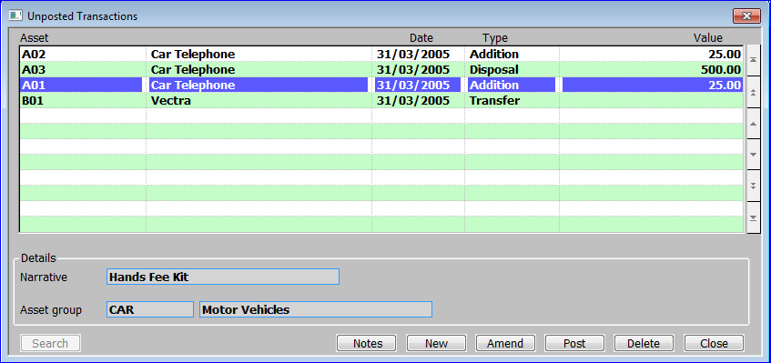

**Figure 1:** **Unposted Transactions Window**

|  |  |
| --- | --- |
|  | This window is displayed when you select Transaction Processing from the Asset Register Main Menu. |
| Purpose | This window displays all unposted transactions. It enables you to add, amend and post transactions to the Asset Register, as well as adding individual transaction specific notes. |
|  | If integration with General Ledger is selected in System Parameters, postings to General Ledger are automatically created when the transaction is posted, for transactions for owned assets, and those on a finance lease. |
| Note | For asset transfers, postings are only made to General Ledger, if the asset is transferred between profit centres, or the General Ledger accounts for the new asset group are different from those of the original group. |
|  | This window is divided into two sections with application buttons:   * Unposted Transactions. * Details. |
|  |  |

*Unposted Transactions*

|  |  |
| --- | --- |
| **Asset** | The Asset number and its description. |
| **Date** | *(Display Only)* The transaction date. |
| **Type** | *(Display Only)* The transaction type. |
| **Value** | *(Display Only)* The value of the transaction. |
|  |  |

*Details*

|  |  |
| --- | --- |
| **Narrative** | *(Display Only)* The transaction Narrative. |
| **Asset Group** | *(Display Only)* The asset group that the asset belongs to. |

*Application Buttons*

|  |  |
| --- | --- |
| **Notes** | *(Only available when a transaction is selected and the extension database is enabled).* ⇒ The standard ‘Asset Transactions Notes window’ *(See Page 144).* |
| **New** | *(Only available when adding a new transaction).* Create a new asset register transaction. ⇒ The standard ‘Select Asset Search window’ *(See Page 136).* |
| Note | You can also create a new transaction by entering an asset code on a blank line. |
| **Amend** | *(Only for Addition and Depreciation Transactions).* This enables you to amend the selected transaction.   * If the transaction type is addition  Asset Addition window *(See page 23).* * If you selected Adjust Depreciation  Adjust Depreciation window *(See page 27).* |
|  |
|  |
|  |
|  |
| **Post** | *(Only available when a transaction is selected).* ⇒ You are asked to confirm that you wish to continue. The transaction is then posted and where appropriate postings made to the General Ledger. The transaction is then cleared and the window refreshed. |
| **Delete** | *(Only for Addition and Depreciation Transactions).* This enables you to delete the selected transaction. You are asked to confirm that you wish to delete the transaction. |
| **Close** | Close the window and return to the Asset Register Main Menu. |

#### Select Transaction Type

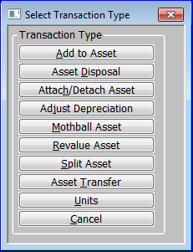

**Figure 2: Transaction Type Menu**

|  |  |
| --- | --- |
|  | This menu is displayed when you add or insert a new asset number at the Unposted Transactions window *(See page 20).* |

The options are:

|  |  |
| --- | --- |
| Add to Asset | Add to an asset or reverse a previous addition. For pooled assets, you can add additional quantities of the pooled item. For individual assets, you can record any extensions made to the asset, for example the addition of a new disk drive to a computer. ⇒ Add to Asset window *(See page 23).* |
| Note | This is not used for adding new assets; you normally add assets via Asset Maintenance *(see page 65),* although when you initially set up Asset Register, you enter them via the Asset Data Load option *(See page 106).* |
| Asset Disposal | Record the sale or disposal of an asset or part of a pooled asset. When you dispose of the whole of an asset, it acquires the ‘disposed’ status. This means it is ignored by all future depreciation and group revaluation runs, and you cannot enter further transactions for it.   * If another asset is attached to this asset ⇒ Assets Disposal – Attachments window *(See page 24).* * Otherwise ⇒ Asset Disposal window *(See page 24).* |
| Attach/Detach Asset | Attach an asset to, or detach it from, another asset. You use this option to link one asset to another; for example to attach a car phone to the car it belongs to. The assets retain their individual identities and can be depreciated in different ways. ⇒ Asset Attachment window *(See Page 24).* |
| Note | You can only attach an asset to another asset in the same profit centre. |
| Adjust Depreciation | Adjust the depreciation of an asset. ⇒ Adjust Depreciation window *(See Page 27).* |
| Mothball Asset | *(Only if asset is currently not mothballed).* Place an asset into mothballs, or reinstate an asset, which has been mothballed. Mothballed assets are ignored by depreciation runs, however they are included in group revaluations, and you can enter transactions (including depreciation adjustments) for them via Transaction Entry A confirmation is requested.  Unposted Transactions window *(See page 20).* |
| Remove from Mothball | *(Only if asset is currently mothballed).* Reinstate an asset, which has been mothballed.. ⇒ Remove from Mothball window *(See page 30).* |
| *Note* | Mothballed assets are ignored by depreciation runs, however they are included in group revaluations, and you can enter transactions (including depreciation adjustments) for them via Transaction Entry. |
| Revalue asset | Revalue an existing asset. ⇒ Asset Revaluation window *(See page 31).* |
| Note | You can revalue groups of assets via the Group Revaluation option on the System Maintenance Menu. |
| Split Asset | Split an existing asset into two assets, or move part of the value of an asset to another asset ⇒ Split Asset window *(See page 32).* |
| Asset transfer | Transfer an asset to another profit centre or asset group.   * If the asset has an attachment(s) ⇒ Asset Transfer – Attachments window *(See page 34).* * Otherwise ⇒ Asset Transfer window *(See page 35).* |
| Units | Enter the number of units used for assets, which use the ‘usage’ depreciation method ⇒ Units Used window *(See page 36).* |
| Cancel | ⇒ Unposted Transactions window *(See page20).* |

#### Add to Asset

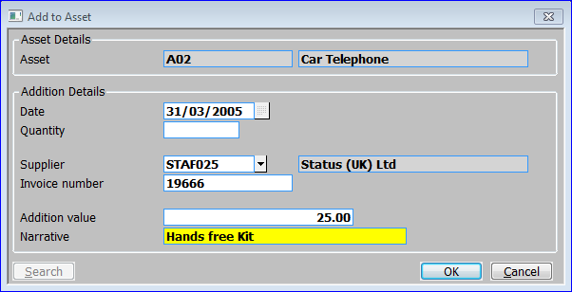

**Figure 3: Asset Addition Window**

|  |  |
| --- | --- |
|  | This window is displayed when you select ‘Add to Asset’ in the Select Transaction Type Menu *(See page 22)* when adding a transaction or select ‘Amend’ for an ‘Addition’ type transaction in the Unposted Transaction Window. |
| Purpose | This window enables you to add to the selected asset or to reverse a previous addition. For pooled assets, you can add additional quantities of the pooled item. For individual assets, you can record any extensions made to the asset, for example the addition of a new disk drive to a computer.  This window is divided into two sections:   * Asset Details. * Addition Details. |

*Asset Details*

|  |  |
| --- | --- |
| Asset | *(Display Only).* The asset number and description of the asset being added to. |

Addition Details

|  |  |
| --- | --- |
| Date | The date the addition was made. The default is the last day of the current period. |
| Quantity | *(Pooled assets only.)* Enter the quantity of the addition. |
| Supplier | The code of the supplier from whom the addition was purchased.  If Creditors Ledger is in use, you can [Search] from a list of valid accounts. The suppliers account name is also displayed.  If this addition has been created in-house (e.g. manufactured) you could set this field to an appropriate reference (e.g. In-house, Internal etc.). |
| Invoice number | The invoice reference associated with the purchase. This can be left blank. |
| Addition value | The value of the addition. |
| Narrative | Up to 30 characters to describe the addition. |
| On confirmation | ⇒ Unposted transactions window, *(See page 20).* |

#### Asset Disposal - Attachments

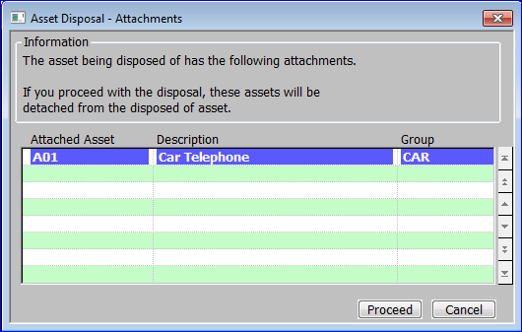

**Figure 4: Asset Disposal – Attachments Window**

|  |  |
| --- | --- |
|  | This window is displayed when you select ‘Asset Disposal’ in the Select Transaction Type Menu *(See page 22)* when adding a transaction for an asset with an attachment. |
| Purpose | This window displays the selected asset’s attachments. If you go ahead with the disposal, the attachments will be detached. |

Assets:

|  |  |
| --- | --- |
| Asset Number | *(Display Only).* The asset number of the attached asset. |
| Description | *(Display Only).* The description of the attached asset. |
| Group | *(Display Only).* The asset group of the attached asset. |

Application Buttons:

|  |  |
| --- | --- |
| Proceed | Continue with the transfer  Asset Disposal window *(See page 25).* |
| Cancel | Abandon transfer  Unposted transactions window *(See page 20).* |

#### Asset Disposal

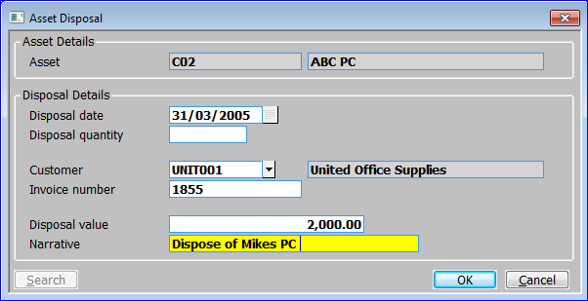

**Figure 5: Asset Disposal Window**

|  |  |
| --- | --- |
|  | This window is displayed when you:   * Select ‘Asset Disposal’ in the Select Transaction Type Menu *(See page 22)* when adding a transaction. * Select ‘Proceed’ in the Asset Disposal - Attachments window *(See page 24).* |
| Purpose | This window enables you to record the sale or disposal of an asset or part of a pooled asset. When you dispose of the whole of an asset, it acquires the ‘disposed’ status. This means it is ignored by all future depreciation and group revaluation runs, and you cannot enter further transactions for it.  This window is divided into two sections:   * Asset Details. * Disposal Details. |

*Asset Details*

|  |  |
| --- | --- |
| Asset | *(Display Only).* The asset number and description of the asset being disposed of. |

Disposal Details

|  |  |
| --- | --- |
| Disposal date | The date of disposal of the asset. |
| Disposal quantity | *(Pooled assets only.)* The quantity of the asset being sold or scrapped. |
| Customer | The code of the customer to whom the asset was sold. This can be left blank.  If Debtors Ledger is in use, you can [Search] to select from a list of valid customer accounts. The Customer account name is then displayed. |
| Invoice number | The invoice reference associated with the sale. This can be left blank. |
| Disposal value | The value of the disposal. |
| Narrative | Up to 30 characters to describe the disposal. |
| On confirmation | ⇒ Unposted transactions window *(See page 20)* |

#### Asset Attachment

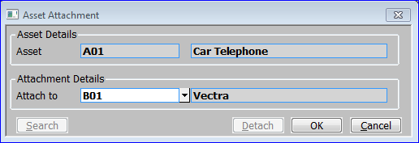

**Figure 6: Asset Attachment Window**

|  |  |
| --- | --- |
|  | This window is displayed when you select ‘Attach Asset’ in the Select Transaction Type Menu *(See page 22)* when adding a transaction. |
| Purpose | This window enables you to attach the selected asset to another asset. You use this feature to link one asset to another; for example to attach a car phone to the car it belongs to. The assets retain their individual identities and can be depreciated in different ways. |
|  | If the selected asset is already attached, this window enables you to detach it, or to transfer the attachment to a different asset. |
| Note | You cannot attach an asset, which has attachments, and you cannot attach an asset to another asset, which is itself, an attachment. For example, you can attach a car phone to a car, and you can attach a car stereo to the same car. However, once these attachments are made, you cannot attach the car stereo to the car phone. Nor can you attach the car to any other asset. |
|  | This window is divided into two sections with application buttons:   * Asset Details. * Attachment Details. |

*Asset Details*

|  |  |
| --- | --- |
| Asset | *(Display Only).* The asset number and description of the asset being attached to/unattached from another asset. |

Attachment Details

|  |  |
| --- | --- |
| Attach to | If the asset is not already attached, enter the code of the asset you want to attach it to. A Search is available which calls the Standard Asset Number search *(See page 136).* |
|  | If it is already attached, the number and description of its ‘host’ asset is displayed; enter blank to detach it or enter the code of another asset to transfer its attachment. |
| Note | Both assets must be in the same profit centre. |

*Application Buttons*

|  |  |
| --- | --- |
| **Detach** | Detach the asset from the asset shown in the Attachment Details. |
| On confirmation | ⇒ Unposted transactions window *(See page 20).* |

#### Adjust Depreciation

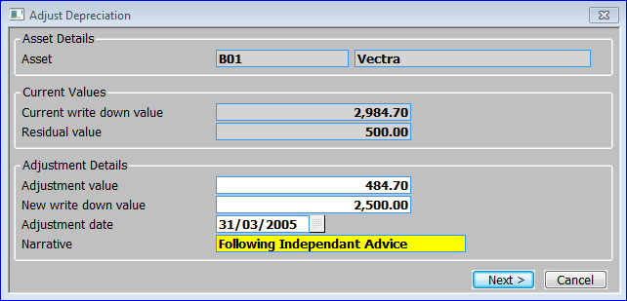

**Figure 7: Adjust Depreciation Window**

|  |  |
| --- | --- |
|  | This window is displayed when you select ‘Adjust Depreciation’ in the Select Transaction Type Menu *(See page 22)* when adding a transaction or select ‘Amend’ for an ‘Adjustment’ type transaction in the Unposted Transaction Window. |
| Purpose | This window enables you to adjust the depreciation charged against the selected asset. |
|  | This window is divided into three sections:   * Asset Details. * Current Values. * Adjustment Details. |

*Asset Details*

|  |  |
| --- | --- |
| Asset | *(Display Only).* The asset number and description of the asset having its depreciation details adjusted. |

Current Values

|  |  |
| --- | --- |
| Current write down value | *(Display only.)* The current write down value of the selected asset. |
| Residual Value | *(Display only.)* The residual value of the asset. Adjustments are not allowed that would cause the new write down value to be reduced below the asset's residual value. |

*Adjustment Details*

|  |  |
| --- | --- |
| Adjustment value | The value of the depreciation adjustment. |
| New write down value | *(Display only.)* The new write down value. This is automatically calculated and displayed when you enter the adjustment. |
| Adjustment date | The date of the adjustment. |
| Narrative | Up to 30 characters to describe the transaction. |
| On confirmation | *If tax depreciation is selected in System Parameters*  Adjust Tax Depreciation window *(See page 28).*  *Otherwise*  Unposted Transactions window *(See page 20).* |

#### Adjust Tax Depreciation

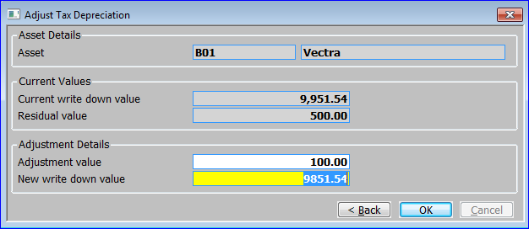

Figure 8: Adjust Tax Depreciation Window

|  |  |
| --- | --- |
|  | This window is displayed when you confirm your replies in the Adjust Depreciation Window if tax depreciation is in use. |
| Purpose | This window enables you to adjust the tax depreciation charged against an asset. |
|  | This window is divided into three sections:   * Asset Details. * Current Values. * Adjustment Details. |
| Asset | *(Display Only).* The asset number and description of the asset having its tax depreciation details adjusted. |

Current Values

|  |  |
| --- | --- |
| Current write down value | *(Display only.)* The current write down value for tax purposes of the selected asset. |
| Residual Value | *(Display only.)* The residual value for tax purposes of the selected asset. Adjustments are not allowed that would cause the new write down value to be reduced below the asset's residual value. |

*Adjustment Details*

|  |  |
| --- | --- |
| Adjustment value | The value of the tax depreciation adjustment. |
| New write down value | *(Display only.)* The new write down value for tax purposes. This is automatically calculated and displayed when you enter the adjustment. |
| On confirmation | ⇒ Unposted transactions window *(See page 20).* |

#### Asset Mothball

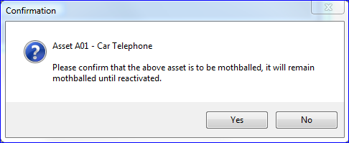

Figure 9: Asset Mothball Window

|  |  |
| --- | --- |
|  | This confirmation message is displayed when you select ‘Mothball Asset’ in the Select Transaction Type Menu *(See page 22)* when adding a transaction. |
| Purpose | This message enables you to confirm that you wish to change the status of the asset to ‘mothballed’. This suspends it from all depreciation runs until you remove it from mothballs. However, mothballed assets are included in group revaluations, and you can enter transactions (including depreciation adjustments) for them via Transaction Entry. |

Buttons

|  |  |
| --- | --- |
| Yes | Confirm that you want to suspend depreciation for this asset. |
| No | You do not want to suspend depreciation for this asset. |
| On responding | ⇒ Unposted transactions window *(See page 20).* |

|  |  |
| --- | --- |
|  |  |

#### Remove from Mothball

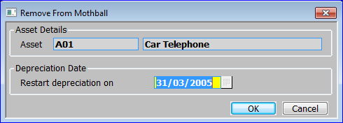

Figure 10: Remove from Mothball Window

|  |  |
| --- | --- |
|  | This window is displayed when you select ‘Remove form Mothball’ in the Select Transaction Type Menu *(See page 22)* when adding a transaction. |
| Purpose | This window enables you to take a mothballed asset out of mothballs; i.e. to change the asset’s status from ‘mothballed’ to ‘active’. |
| Note | Straight line and table depreciation do not take account of time an asset has spent in mothballs; i.e. a mothballed asset does not have its life automatically extended on removal from mothballs. However, the asset can be revalued, or the depreciation adjusted if required. |
|  | This window is divided into two sections:   * Asset Details. * Depreciation Date. |

*Asset Details*

|  |  |
| --- | --- |
| Asset | *(Display Only).* The asset number and description of the asset being reinstated from having been mothballed. |

Depreciation Date

|  |  |
| --- | --- |
| Restart depreciation on | Enter the date when depreciation is to restart. |
| On confirmation | ⇒ Unposted transactions window, *(See page 20).* |

#### Asset Revaluation

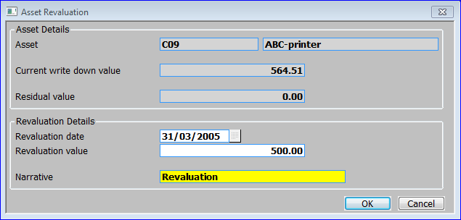

Figure 11: Asset Revaluation Window

|  |  |
| --- | --- |
|  | This window is displayed when you select ‘Revalue asset’ in the Select Transaction Type Menu *(See page 22)* when adding a transaction. |
| Purpose | This window enables you to revalue the selected asset. |
| Note | You can revalue groups of asset via the Group Revaluation option on the System Maintenance Menu. |
|  | This window is divided into two sections:   * Asset Details. * Revaluation Details. |

*Asset Details*

|  |  |
| --- | --- |
| Asset | *(Display Only).* The asset number and description of the asset being reinstated from having been mothballed. |
| Current write down value | *(Display only.)* The current write down value of the selected asset. |
| Residual value | *(Display only.)* The residual value of the asset. Revaluations are not allowed that would cause the new write down value to be reduced below the asset's residual value. |

Revaluation Details

|  |  |
| --- | --- |
| Revaluation date | The date of the revaluation. The default is the last day of the current period. |
| Revaluation value | The new value of the asset. |
| Narrative | Up to 30 characters to describe the transaction. |
| On confirmation | ⇒ Unposted transactions window *(See page 20).* |

#### Split Asset

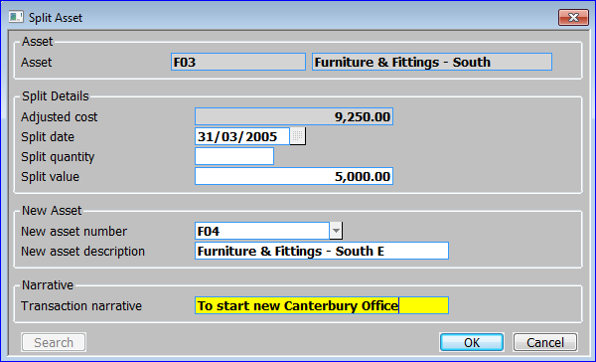

Figure 12: Split Asset Window

|  |  |
| --- | --- |
|  | This window is displayed when you select ‘Split asset’ in the Select Transaction Type Menu *(See page 22)* when adding a transaction. |
| Purpose | This window enables you to split an asset into two assets, or to move part of the value of an asset to another asset. |
|  | This window is divided into four sections:   * Asset Details. * Split Details. * New asset. * Narrative. |

*Asset Details*

|  |  |
| --- | --- |
| Asset | *(Display Only).* The asset number and description of the asset being split. |

Split Details:

|  |  |
| --- | --- |
| Adjusted cost | *(Display only.)* The adjusted cost of the asset. |
| Split date | Enter the date for the asset split. The default is the last day of the current period. |
| Split quantity | *(Pooled assets only.)* Enter the quantity to be split from the original asset. |
| Split value | *(Not pooled assets.)* Enter the value of the part to be split from the original asset. |
|  | For pooled assets, the value of the quantity split is automatically calculated and displayed. |

*New Asset*

|  |  |
| --- | --- |
| New asset number | If you are creating a new asset from the split, enter a code of up to 15 characters to uniquely identify the asset. |
|  | If you are transferring the split to an existing asset, enter its code. This asset must have the same ownership type as the original asset. You are warned that this is an existing asset and prompted to confirm your request.  A Search is available which calls the Standard Asset Number search *(See page 136).* |
| New asset description | If you are creating a new asset from the split, enter up to 30 characters to describe the new asset. |
|  | If you are transferring the split to an existing asset, its description is displayed. |

*Narrative*

|  |  |
| --- | --- |
| Narrative | Up to 30 characters to describe the transaction. |
| On confirmation | ⇒ Unposted transactions window *(See page 20).* |

#### Attached Asset Transfer

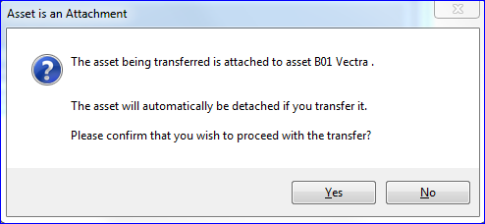

**Figure 13: Attached Asset Transfer Message**

|  |  |
| --- | --- |
|  | This window is displayed when you select ‘Asset Transfer’ for an attached asset in the Select Transaction Type Menu *(See page 22)* when adding a transaction. |
| **Purpose** | This window warns you that proceeding with the transfer will cause the selected asset to be detached, and enables you to confirm whether you want to continue. |

Buttons:

|  |  |
| --- | --- |
| Yes | Continue with the transfer  Asset Transfer Window *(See page 35).* |
| No | Abandon transfer  Unposted transactions window *(See page 20).* |

#### Asset Transfer - Attachments

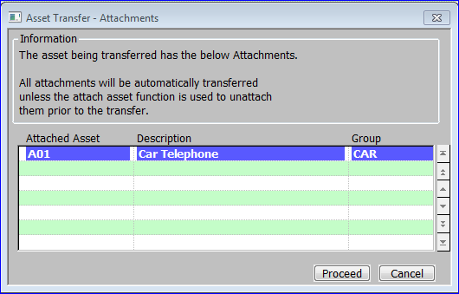

Figure 14: Asset Transfer - Attachments Window

|  |  |
| --- | --- |
|  | This window is displayed when you select ‘Asset Transfer’ for an asset with attachments in the Select Transaction Type Menu *(See page 22)* when adding a transaction. |
| Purpose | This window displays the selected asset’s attachments. If you go ahead with the transfer, the attachments are transferred to the new profit centre, but not to the new asset group. |
| Note | If you do not want to transfer the attachments to the new profit centre, you can use the Attach Asset option to detach the attachments first. |

Assets:

|  |  |
| --- | --- |
| Asset Number | *(Display Only).* The asset number of the attached asset. |
| Description | *(Display Only).* The description of the attached asset. |
| Group | *(Display Only).* The asset group of the attached asset. |

Application Buttons:

|  |  |
| --- | --- |
| Proceed | Continue with the transfer  Asset Transfer Window *(See page 35).* |
| Cancel | Abandon transfer  Unposted transactions window *(See page 20).* |

#### Asset Transfer

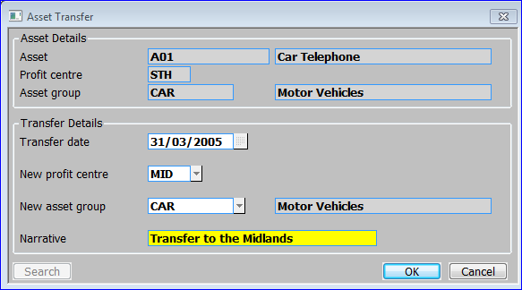

Figure 15: Asset Transfer Window

|  |  |
| --- | --- |
|  | This window is displayed when you:   * Select ‘Asset Transfer’ for an unattached asset with attachments in the Select Transaction Type Menu *(See page 22)* when adding a transaction. * Select ‘Yes’ at the Attached Asset Transfer Message *(See page 33).* * Select ‘Proceed’ at the Asset Transfer - Attachments window *(See page 34)*. |
| Purpose | This window enables you to transfer an asset to another profit centre or asset group. |
|  | This window is divided into two sections:   * Asset Details. * Transfer Details. |

*Asset Details (Display Only)*

|  |  |
| --- | --- |
| Asset | The asset number and description of the asset being split. |
| Profit centre | The selected asset’s current profit centre. |
| Asset group | The selected asset’s current asset group and description. |

*Transfer Details*

|  |  |
| --- | --- |
| Transfer date | The date of the transfer. The default is the last day of the current period. |
| New profit centre | The code of the profit centre to which the asset is to be transferred. A [Search] is available. *(See page 137).* |
| New asset group | The code of the group to which the asset is to be transferred. A [Search] is available. *(See page 137).* |
| Narrative | Up to 30 characters to describe the transaction. |
| On confirmation | ⇒ Unposted transactions window *(See page 20).* |

#### Units Used

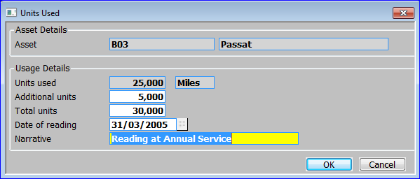

Figure 16: Units Used Window

|  |  |
| --- | --- |
|  | This window is displayed when you select ‘Units’ in the Select Transaction Type Menu *(See page 22)* when adding a transaction. |
| Purpose | This window enables you to enter the units used for assets, which use the ‘usage’ depreciation method. In this depreciation method, assets are depreciated as a proportion of the units used to the units in the life of the asset. |

*Asset Details*

|  |  |
| --- | --- |
| Asset | *(Display Only).* The asset number and description of the asset having its usage updated. |

Usage Details:

|  |  |
| --- | --- |
| Units used | *(Display only.)* The number of units used so far. |
| Additional units | Enter the additional units used. Alternatively, you can leave this blank and enter the total number of units at the next prompt. |
| Total units | *(Only if you left the ‘Additional units’ prompt blank.)* Enter the total number of units used. |
| *Note* | If you entered a value at the ‘Additional units’ prompt, the total units are automatically calculated and displayed. |
| Date of reading | Enter the date on which the new unit amount was read or measured. |
| Narrative | Enter a narrative in up to 30 characters. |
| On confirmation | ⇒ Unposted transactions window *(See page 20)* |

Section Three:

## End of Period Processing



Contents

38 Depreciation Run

This program automatically calculates the depreciation of all assets up to the end of the current period. For each asset, the depreciation is calculated according to the method defined for the asset. If tax depreciation details have been recorded for an asset, the tax depreciation is also calculated

39 Print GL Analysis Report

This report is designed for use in systems that post to General Ledger. It lists outstanding General Ledger analysis details for the current period...

40 Close Period

This program closes the current period in Asset Register, and opens the next period as the new current period. In the last period in the financial year, closing the period also transfers the year to date figures for each asset to the brought forward figures, and clears the year to date figures for the new year.

42 Purge Transactions

This program purges old transactions, disposed assets and budgets. You should run this program after closing the last period of a financial year to remove historical details that you do not want to keep.

44 Integrity Check

This program checks the integrity of the Asset Register data.

### Depreciation Run

|  |  |
| --- | --- |
| Introduction | This program automatically calculates the depreciation of all assets with an active status up to the end of the current period. For each asset, the depreciation is calculated according to its defined method. If tax depreciation details have been recorded for the asset, the tax depreciation is also calculated. |
|  | You can run the program in ‘create transactions’ mode, which creates the necessary depreciation transactions, and prints the Depreciation Report. Alternatively, you can run the program to just calculate the expected depreciation and print the Expected Depreciation Report. |
| Further information | For further information about the various calculation methods, see page 14 of the Overview. |

|  |  |
| --- | --- |
| Printed example | For a printed example of the Depreciation Report, see page 148 of the Sample Reports Section. |

#### Asset Register Depreciation Run

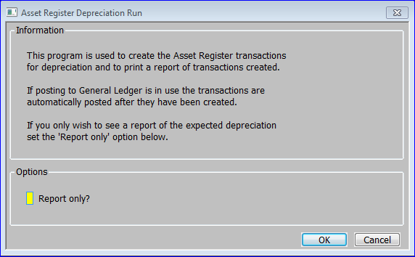

**Figure 17: Asset Register Depreciation Run Window**

|  |  |
| --- | --- |
|  | This window is displayed when you select Depreciation Run from the End of Period Processing Menu. |
| Purpose | This window enables you to enter the options for the run. | |

Options

|  |  |
| --- | --- |
| Report only? | Leave blank (default) to create the depreciation transactions and to print the Depreciation Report. ✓ to simply print a report showing the expected depreciation, without actually creating the transactions. |
| On confirmation | On confirmation of your replies, the processing begins. On completion  End of Period Processing Menu. |

### Print GL Analysis Report

|  |  |
| --- | --- |
| Introduction | This report is designed for use in systems that post to General Ledger. It lists General Ledger analysis details for the current period. |
| Note | This report is for information only, as postings are made directly to the General Ledger as they occur.  Non-capitalised assets, and those held on an operating lease, do not generate General Ledger postings and therefore do not appear on the GL Analysis Report. |
| Printed example | For a printed example of the Postings Proof List, see page 149 of the Sample Reports Section. |

#### GL Analysis Report Window

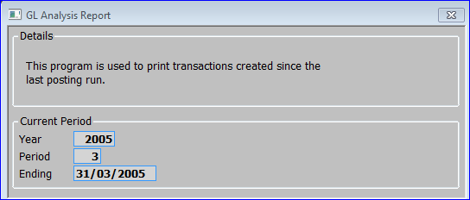

**Figure 18: GL Analysis Report Window**

|  |  |
| --- | --- |
|  | This window appears when you select Print GL Analysis Report from the End of Period Processing Menu. |
| Note | The print options window is also displayed. |
| Purpose | This window displays the details of the report to be printed. | |

Current Period (Display Only)

|  |  |
| --- | --- |
| Year | The current year. |
| Period | The current period no. |
| Ending | The current period end date. |
| On confirmation | On confirmation, the processing begins. On completion  End of Period Processing Menu. |

### Close Period

|  |  |  |  |
| --- | --- | --- | --- |
| Introduction | | The Close Period program closes the current period in Asset Register, and opens the next period as the new current period. | |
|  | | In the last period in the financial year, closing the period also transfers the year to date figures for each asset to the brought forward figures, and clears the year to date figures for the new year. | |
|  | | **Before you close the period**, you should ensure the following procedures are carried out: | |
|  | | * The depreciation run for the period. | |
|  | | * Print the GL Analysis Report (optional). | |
|  | | * Back up your data. | |
| Note | | You define the financial calendar for use in all modules via Calendar Maintenance in Administration Parameters. | |

#### Close Period Window

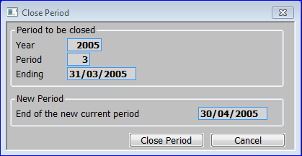

Figure 19: Close Period Window

|  |  |
| --- | --- |
|  | This window is displayed when you select Close Period from the End of Period Processing Menu. |
| Purpose | This window enables you to initiate the closing of the current period. |
| Warning | Closing the period is irreversible so you should take a backup before you run the program. |
|  | The window is divided into two sections with application buttons:   * Period to be closed. * New Period. |

Period to be closed (Display Only):

|  |  |  |  |  |  |  |  |  |  |  |
| --- | --- | --- | --- | --- | --- | --- | --- | --- | --- | --- |
| |  |  | | --- | --- | | Year | The current year. | | Period | The current period no. | | Ending | The current period end date. | | |  | | --- | | The current year. | | The current period no. | | The current period end date. | |

New Period (Display Only):

|  |  |
| --- | --- |
| End of the New current period | The last day of the new period as defined in the calendar in Administration Parameters. |

Application Buttons:

|  |  |
| --- | --- |
| Close | Close the period. The period is closed. When the processing finishes you are returned to the End of Period Processing Menu. |
| Cancel | Return to the End of Period Processing Menu without closing the period. |

### Purge Transactions

|  |  |
| --- | --- |
| Introduction | This program purges old transactions, disposed assets and budgets. You should run this program after closing the last period of a financial year to remove historical details that you do not want to keep. |
| Note | Purge Transactions requires exclusive access to the Asset Register database. You need to ask all users to exit from Asset Register while the purge is being run. |

|  |  |
| --- | --- |
| Warning | The purge procedure is irreversible, so take a backup before proceeding. |

#### Purge Transactions Window

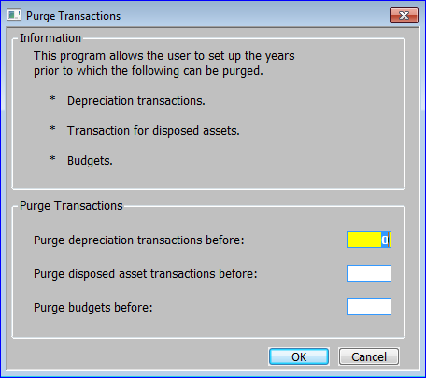

Figure 20: Purge Transactions Window

|  |  |
| --- | --- |
|  | This window is displayed when you select Purge Transactions from the End of Period Processing Menu. |
| Purpose | This window enables you to enter the criteria for the purge. |

Purge Transactions

|  |  |
| --- | --- |
| Purge depreciation transactions before | Enter the year up to the beginning of which you want to purge depreciation transactions. |
| Purge disposed asset transactions before | Enter the year up to the beginning of which you want to purge disposed asset transactions. |
| Purge budgets before | Enter the year up to the beginning of which you want to purge budgets. |
| On confirmation | The purge begins. On completion  End of Period Processing Menu. |

### Integrity Check

|  |  |
| --- | --- |
| Introduction | This program checks the integrity of the Asset Register data. It can check that:   * An asset master record exists for each transaction. |
|  | * An asset group record exists for each asset group. |
|  | * An asset master record exists for each attached asset. |
|  | * A depreciation table record exists for each asset group. |
|  | * A GL/profit centre code exists for each asset group. |
|  | * The asset master total equals the accumulated transactions total. |
|  | * Write down value / residual value check. |
|  | We suggest you run this procedure at regular intervals, for example after closing the period. |

#### Integrity Check Window

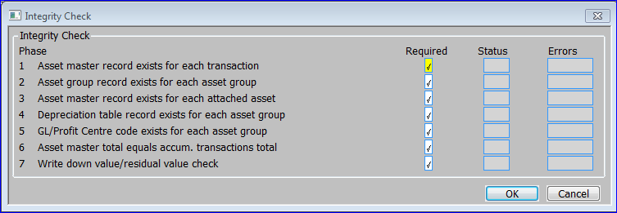

Figure 21: Integrity Check Window

|  |  |
| --- | --- |
|  | This window is displayed when you select Integrity Check from the End of Period Processing Menu. |
| Purpose | This window enables you to specify which phases of the integrity check you want to run. This window also functions as a progress window during the check, and as each phase is completed it shows its status and how many errors were found. |

The prompts for each phase are:

|  |  |
| --- | --- |
| Required | ✓ if you want to run this phase of the integrity check. Enter N to omit this phase. |
| Status | *(Display only.)* OK indicates that this phase of the integrity check has completed successfully. |
| Errors | *(Display only.)* A count of the errors encountered. |
| Note | The sixth phase always reports an error for assets created via the Asset Data Load option, because transactions were not created to reflect the initial value of the assets. These errors can be ignored. |
|  | The sixth phase may also show errors if the integrity check is run before transactions are posted at the end of period. This is because the posting year on the transaction record does not match the financial year defined in the system parameters. |
| On confirmation | You are asked for confirmation before the checks start. On completion you are returned to the End of Period Processing Menu. |

*This page is deliberately left blank*

Section Four:

## Reports



Contents

48 Asset Ledger Report

This report prints details of selected assets, including the asset code, description, profit centre, asset group, period of purchase, expected end of life, analysis codes, total of cost and any additions made to it, the depreciation and written down value.

52 Additions and Disposals Report

This report prints either a summary of movements in asset value or a summary of profit and loss on disposal. If tax depreciation is selected in System Parameters, the report shows both book and tax values.

55 Selective Transactions Report

This report enables you to print transactions selected by a wide range of criteria. The report shows for each transaction, the asset, group, profit centre, type and value.

59 Asset Print by Date

This report prints all assets for which a particular date is within a range you specify. You can use this, for example, to identify assets approaching the end of their life, or, if a date field has been used to record the next maintenance date, assets with maintenance due.

62 Asset Label Print

This option prints labels for all assets added since a specified date, or for a specified asset. The details printed on the labels are: the asset code and description, the asset’s profit centre, and the group to which the asset belongs. The labels are formatted to print on standard, one column, 1.5 inch labels.

### Asset Ledger Report

|  |  |
| --- | --- |
| Introduction | This report prints details of selected assets. For each asset, the details printed include the asset code, description, profit centre, asset group, period of purchase, expected end of life, analysis codes, value of its cost and any additions made to it, its depreciation, and written down value. This report can be printed in detail or summary form, and can optionally include comments, and lists of any attached assets. |
|  | You can select the range of assets to be printed by asset code, group, profit centre, analysis code, ownership type, status, or a combination of these methods. |
|  | You can run this report at any time. |
| Printed example | For a printed example of this report, see page 149 of the Sample Reports Section. |

#### Asset Register Print Window

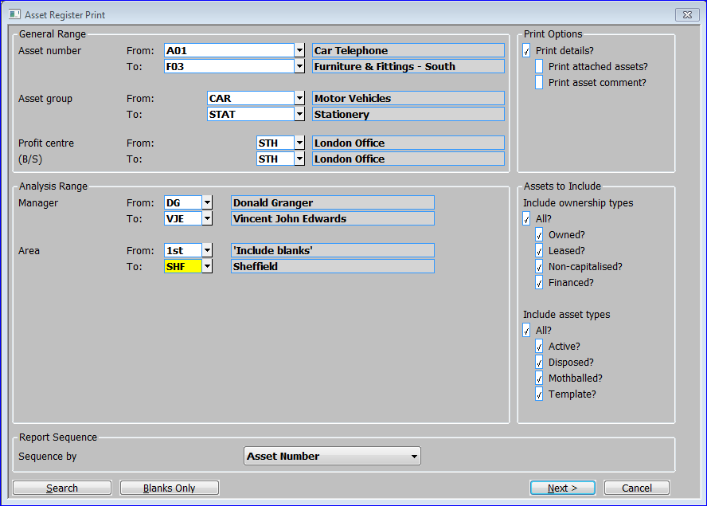

Figure 22: Asset Register Print Window

|  |  |
| --- | --- |
|  | This window is displayed when you select Asset Ledger Print from the Reports Menu. |
| Purpose | This window enables you to enter selection criteria for the report. |
|  | This window is divided into five sections:   * General Range. * Analysis Range. * Print Options. * Assets to Include. * Report Sequence. |

General Range

|  |  |
| --- | --- |
| Asset number From: | If you want to restrict the report to a range of assets, enter the code of the first asset in the range. A [Search] is available. ⇒ Asset Search window *(See Page 136)*. The description of the selected asset follows. |
| To: | If you want to restrict the report to a range of assets, enter the code of the last asset in the range. A [Search] is available. ⇒ Asset Search window *(See Page 136).* The description of the selected asset follows. |
| *Note* | The defaults are the first and last on file. |
| Note | If you use right-justified alphanumeric asset codes, the default asset code range may not include all your assets. |
| Asset group From: | If you want to restrict the report to assets in a range of asset groups, enter the code of the first asset group in the range. A [Search] is available. ⇒ Asset Group Search window *(See Page 137).* The description of the selected asset group follows. |
| To | If you want to restrict the report to assets in a range of asset groups, enter the code of the last asset group in the range. A [Search] is available. ⇒ Asset Group Search window *(See Page 137)*. The description of the selected asset group follows. |
| *Note* | The defaults are the first and last on file. |
| Profit centre From: | If you want to restrict the report to assets in a range of profit centres, enter the code of the first profit centre in the range. A [Search] is available. ⇒ Profit Centre Search window *(See Page 137)*. The description of the selected profit centre follows. |
| To: | If you want to restrict the report to assets in a range of profit centres, enter the code of the last profit centre in the range. A [Search] is available. ⇒ Profit Centre Search window. *(See Page 137)*. The description of the selected profit centre follows. |
| Note | The defaults are the first and last on file. |

Analysis Range

|  |  |
| --- | --- |
|  | You are prompted for a range of codes for each set of analysis codes defined in System Parameters *(See Page 80).* |
| *Analysis code* From: | If you want to restrict the report to assets with a range of analysis codes, enter the first analysis code in the range. The defaults are the first and last on file. A [Search] is available. ⇒ Asset Register Search Code window *(See Page 140*). The description of the selected analysis code follows. |
| *Note* | Leave blank to include assets for which the analysis code has been left blank. |
| To: | If you want to restrict the report to assets with a range of analysis codes, enter the last analysis code in the range. The defaults are the first and last on file. A [Search] is available. ⇒ Asset Register Search Code window *(See Page 140*). The description of the selected analysis code follows. |
| *Note* | If you want to restrict the report to assets for which the analysis code has been left blank, leave the ‘From’ prompt blank and then press the [Blanks Only] button at the ‘To:’ prompt. |

Print Options

|  |  |
| --- | --- |
| Print details? | ✓ to print a detailed report. Blank to print a summary report. |
| Print attached assets? | *(Only if print details is selected). ✓* if you want to print details of assets attached to the assets selected for the report. Blank if you do not want to print details of attached assets. |
| Print asset comment? | *(Only if print details is selected). ✓* if you want to print any comments that have been recorded for the assets selected for the report. Blank if you do not want to print comments. |

Assets to Include

|  |  |
| --- | --- |
| Ownership type | Select the ownership type of the assets you want to print. You can select from:   * All.   *(or at least one of)*   * Owned. * Leased (i.e. on operating lease). * Non-capitalised. * Financed (i.e. on finance lease). |
| *Note* | If ‘All’ is selected the individual ownership types are automatically shown as selected and cannot be deselected.  At least one ownership must be selected. |
| Asset status | Select the Statuses of the assets you want to print. You can select:   * All.   *(or at least one of)*   * Active. * Disposed. * Mothballed. * Template. |
| *Note* | If ‘All’ is selected the individual asset statuses are automatically shown as selected and cannot be deselected.  At least one asset status must be selected. |

Report Sequence

|  |  |
| --- | --- |
| Sequence by | This drop down menu enables you to select the sequence the assets are printed in. The options are:   * **Asset number**: - Select this option to print the assets in asset code sequence. * **Group**: - Select this option to print the assets in asset group sequence. * **Profit centre**: - Select this option to print the assets in profit centre sequence. * **Profit centre and group**: - Select this option to print the assets in asset group within profit centre sequence. |
|  |
|  |
|  |
|  |
| On confirmation | When you select one of these options  Standard Print Options Window. |

### Additions and Disposals Report

|  |  |
| --- | --- |
| Introduction | This report prints either a summary of movements in asset value or a summary of profit and loss on disposal. If tax depreciation is selected in System Parameters, the report shows both book and tax values. |
|  | You can select the range of assets you want to print by asset number, group, profit centre, start date, and up to five analysis codes. You can sequence the report by asset code, group, profit centre, or by profit centre and group. |
|  | You can run this report at any time. |
| Printed example | For a printed example of this report, see page 152 of the Sample Reports Section. |

#### Additions and Disposals

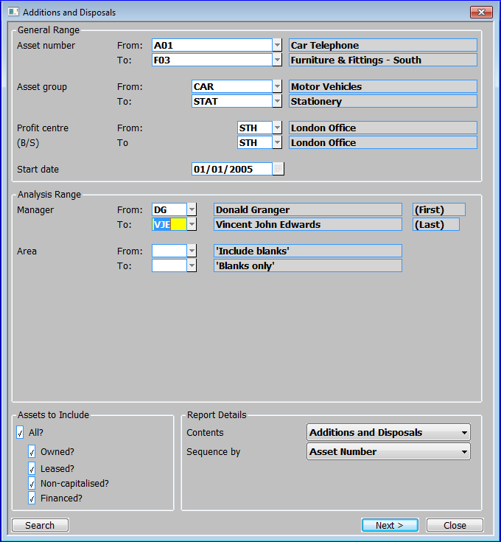

Figure 23: Addition and Disposals Window

|  |  |
| --- | --- |
|  | This window is displayed when you select Additions and Disposals from the Reports Menu. |
| Purpose | This window enables you to enter selection criteria for the report. |
|  | This window is divided into four sections:   * General Range. * Analysis Range. * Assets to Include. * Report details. |

General Range

|  |  |
| --- | --- |
| Asset number From: | If you want to restrict the report to a range of assets, enter the code of the first asset in the range. A [Search] is available. ⇒ Asset Search window *(See Page 136)*. The description of the selected asset follows. |
| To: | If you want to restrict the report to a range of assets, enter the code of the last asset in the range. A [Search] is available. ⇒ Asset Search window *(See Page 136)*. The description of the selected asset follows. |
| *Note* | The defaults are the first and last on file. |
| Note | If you use right-justified alphanumeric asset codes, the default asset code range may not include all your assets. |
| Asset group From: | If you want to restrict the report to assets in a range of asset groups, enter the code of the first asset group in the range. A [Search] is available. ⇒ Asset Group Search window *(See Page 137).* The description of the selected asset group follows. |
| To: | If you want to restrict the report to assets in a range of asset groups, enter the code of the last asset group in the range. A [Search] is available. ⇒ Asset Group Search window *(See Page 137).* The description of the selected asset group follows. |
| *Note* | The defaults are the first and last on file. |
| Profit centre From: | If you want to restrict the report to assets in a range of profit centres, enter the code of the first profit centre in the range. A [Search] is available. ⇒ Profit Centre Search window *(See Page 137)*. The description of the selected profit centre follows. |
| To: | If you want to restrict the report to assets in a range of profit centres, enter the code of the last profit centre in the range. A [Search] is available. ⇒ Profit Centre Search window *(See Page 137)*. The description of the selected profit centre follows. |
| Note | The defaults are the first and last on file. |
| Start date | If you want to exclude additions and disposals before a certain date, enter the date here. |

Analysis Range

|  |  |
| --- | --- |
|  | You are prompted for a range of codes for each set of analysis codes defined in System Parameters *(See Page 80).* |
| *Analysis code* From: | If you want to restrict the report to assets with a range of analysis codes, enter the first analysis code in the range. The defaults are the first and last on file. A [Search] is available. ⇒ Asset Register Search Code window *(See Page 140*). The description of the selected analysis code follows. |
| *Note* | Leave blank to include assets for which the analysis code has been left blank. |
| To: | If you want to restrict the report to assets with a range of analysis codes, enter the last analysis code in the range. The defaults are the first and last on file. A [Search] is available. ⇒ Asset Register Search Code window *(See Page 140*). The description of the selected analysis code follows. |
| *Note* | If you want to restrict the report to assets for which the analysis code has been left blank, leave both the ‘From’ and ‘To’ prompts blank. |

Assets to Include

|  |  |
| --- | --- |
|  | Select the ownership type of the assets you want to print. You can select:   * All.   *(or at least one of)*   * Owned. * Leased (i.e. on operating lease). * Non-capitalised. * Financed (i.e. on finance lease). |
| *Note* | If ‘All’ is selected the individual ownership types are automatically shown as selected and cannot be deselected.  At least one ownership must be selected. |

Report Details

|  |  |
| --- | --- |
| Contents | Select from a drop-down menu what the contents of the report should be.   * **Additions and Disposals**: Select this option if you want to report on the movements in asset values for additions and disposals. * **P & L Value on Disposals**: Select this option if you want to report on disposals only. * **Additions Only**: Select this option if you want to report on additions only. |
| Note | The names of the next prompts are determined by the titles given to the analysis codes in System Parameters. In Figure 23: Addition and Disposals Window the prompts are ‘Manager’ and ‘Area’. |
| Sequence by | This drop down menu enables you to select the sequence the assets are printed in. The options are:   * **Asset number**: Select this option to print the assets in asset code sequence. * **Group**: Select this option to print the assets in asset group sequence. * **Profit centre:** Select this option to print the assets in profit centre sequence. * **Profit centre and group:** Select this option to print the assets in asset group within profit centre sequence. |
| On completion | ⇒ Standard Print Options Window, |

### Selective Transaction Report

|  |  |
| --- | --- |
| Introduction | This report enables you to print transactions selected by a wide range of criteria. The report shows for each transaction, the asset, group, profit centre, type and value. |
|  | You can select the range of transactions that you want to print by asset code, group, profit centre, date, and up to five analysis codes. |
|  | You can run this report at any time. |
| Printed example | For a printed example of this report, see page 153 of the Sample Reports Section. |

#### Selective Transactions Print

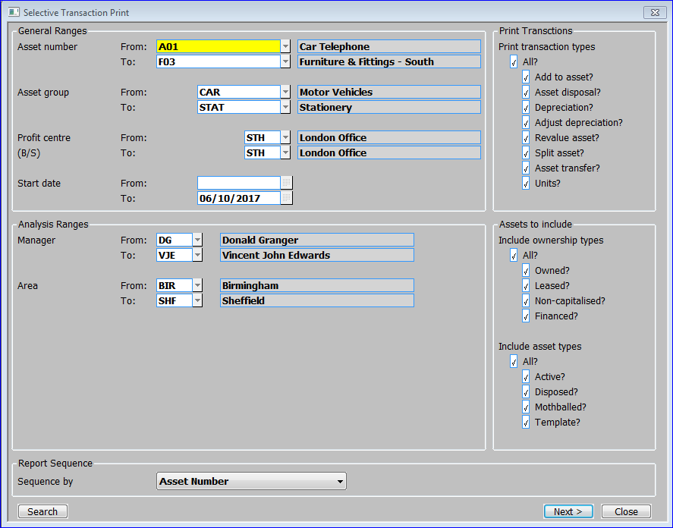

Figure 24: Selective Transactions Print Window

|  |  |
| --- | --- |
|  | This window is displayed when you choose Selective Transaction Print from the Reports Menu. |
| Purpose | This window enables you to enter selection criteria for the report.  This window is divided into 5 sections:   * General Ranges. * Analysis Ranges. * Print Transactions. * Assets to Include. * Report Sequence. |

General Range

|  |  |
| --- | --- |
| Asset number From: | If you want to restrict the report to a range of assets, enter the code of the first asset in the range. A [Search] is available. ⇒ Asset Search window *(See Page 136)*. The description of the selected asset follows. |
| To: | If you want to restrict the report to a range of assets, enter the code of the last asset in the range A [Search] is available. ⇒ Asset Search window *(See Page 136)*. The description of the selected asset follows. |
| *Note* | The defaults are the first and last on file. |
| Note | If you use right-justified alphanumeric asset codes, the default asset code range may not include all your assets. |
| Asset group From: | If you want to restrict the report to assets in a range of asset groups, enter the code of the first asset group in the range. A [Search] is available. ⇒ Asset Group Search window *(See Page 137).* The description of the selected asset group follows. |
| To: | If you want to restrict the report to assets in a range of asset groups, enter the code of the last asset group in the range. A [Search] is available. ⇒ Asset Group Search window *(See Page 137).* The description of the selected asset group follows.. |
| *Note* | The defaults are the first and last on file. |
| Profit centre From: | If you want to restrict the report to assets in a range of profit centres, enter the code of the first profit centre in the range. . A [Search] is available. ⇒ Profit Centre Search window *(See Page 137)*. The description of the selected profit centre follows. |
| To: | If you want to restrict the report to assets in a range of profit centres, enter the code of the last profit centre in the range. . A [Search] is available. ⇒ Profit Centre Search window *(See Page 137)*. The description of the selected profit centre follows. |
| Note | The defaults are the first and last on file |
| Start date From: | If you want to restrict the transactions in the report by date, enter the first date in the range. Leave blank for no restriction start date. |
| To: | If you want to restrict the transactions in the report by date, enter the first date in the range. Leave blank for no restriction end date. |
| Note | Leave both fields blank for no restriction by date. |

Analysis Range

|  |  |
| --- | --- |
|  | You are prompted for a range of codes for each set of analysis codes defined in System Parameters *(See Page 80).* |
| *Analysis code* From: | If you want to restrict the report to assets with a range of analysis codes, enter the first analysis code in the range. The defaults are the first and last on file. A [Search] is available. ⇒ Asset Register Search Code window *(See Page 140*). The description of the selected analysis code follows. |
| *Note* | Leave blank to include assets for which the analysis code has been left blank. |
| To: | If you want to restrict the report to assets with a range of analysis codes, enter the last analysis code in the range. The defaults are the first and last on file. A [Search] is available. ⇒ Asset Register Search Code window *(See Page 140*). The description of the selected analysis code follows. |

Print Transactions

|  |  |
| --- | --- |
| Print transaction types | Select the transaction types of the selected assets you want to print. You can select:   * All.   *(or at least one of)*   * Add to asset. * Asset disposal. * Depreciation. * Adjust depreciation. * Revalue asset. * Split asset. * Asset transfer. * Units. |
| *Note* | If ‘All’ is selected the transaction types are automatically shown as selected and cannot be deselected.  At least one transaction type must be selected. |

Assets to Include

|  |  |
| --- | --- |
| Include ownership types | Select the ownership type of the assets you want to print. You can select:   * All.   *(or at least one of)*   * Owned. * Leased (i.e. on operating lease). * Non-capitalised. * Financed (i.e. on finance lease). |
| *Note* | If ‘All’ is selected the individual ownership types are automatically shown as selected and cannot be deselected.  At least one ownership type must be selected. |
| Include Asset status | Select the Statuses of the assets you want to print. You can select:   * All.   *(or at least one of)*   * Active. * Disposed. * Mothballed. * Template. |
| *Note* | If ‘All’ is selected the individual asset statuses are automatically shown as selected and cannot be deselected.  At least one asset status must be selected. |

|  |  |
| --- | --- |
| Transaction type | When the cursor moves on to this prompt, the Transaction Types menu appears. This enables you to select the status of the assets you want to print. You can select all, or one or more of: add to asset, asset disposal, depreciation, adjust depreciation, revalue asset, split asset, asset transfer, or units. Select ‘Exit’ to exit from the menu. |

*Report Sequence*

|  |  |
| --- | --- |
| Sequence by | This drop down menu enables you to select the sequence the assets are printed in. The options are:   * **Asset number**: Select this option to print the assets in asset code sequence. * **Group**: Select this option to print the assets in asset group sequence. * **Profit centre**: Select this option to print the assets in profit centre sequence. * **Profit centre and group**: Select this option to print the assets in asset group within profit centre sequence. |
| On completion | ⇒ Standard Print Options Window. |

### Asset Print by Date

|  |  |
| --- | --- |
| Introduction | This report prints all assets for which a particular date is within a range you specify. You can use this, for example, to identify assets approaching the end of their life, or, if a user-defined date field has been used to record next maintenance dates, assets that are due for maintenance. |
|  | You can select the range of assets you want to print by group, profit centre, and analysis code. You can sequence the report by group, profit centre, or by group and profit centre. |
|  | You can run this report at any time. |
| Printed example | For a printed example of this report, see page 154 of the Sample Reports Section. |

#### Asset Register Print by Date Window

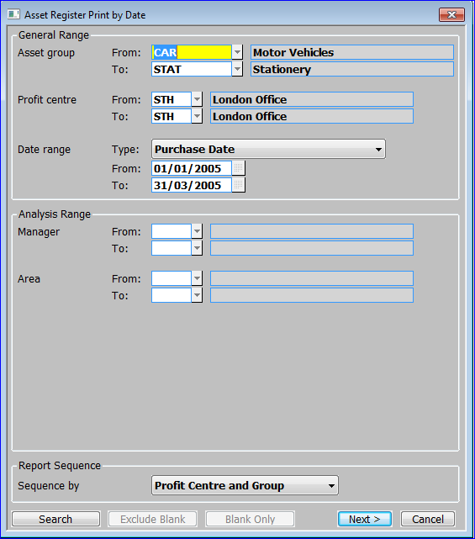

Figure 25: Asset Register Print by Date Window

|  |  |
| --- | --- |
|  | This window is displayed when you select Asset Print by Date from the Reports Menu. |
| Purpose | This window enables you to enter selection criteria for the report. |

General range

|  |  |
| --- | --- |
| Asset group From: | If you want to restrict the report to assets in a range of asset groups, enter the code of the first asset group in the range. A [Search] is available. ⇒ Asset Group Search window *(See Page 137).* The description of the selected asset group follows. |
| To | If you want to restrict the report to assets in a range of asset groups, enter the code of the last asset group in the range. A [Search] is available. ⇒ Asset Group Search window *(See Page 137).* The description of the selected asset group follows. |
| *Note* | The defaults are the first and last on file. |
| Profit centre From: | If you want to restrict the report to assets in a range of profit centres, enter the code of the first profit centre in the range. A [Search] is available. ⇒ Profit Centre Search window *(See Page 137)*. The description of the selected profit centre follows. |
| To: | If you want to restrict the report to assets in a range of profit centres, enter the code of the last profit centre in the range. A [Search] is available. ⇒ Profit Centre Search window *(See Page 137)*. The description of the selected profit centre follows. |
| Note | The defaults are the first and last on file |
| Date range Type: | Select from a drop down menu. Select from:   * The titles given to a maximum of 5 analysis codes in System Parameters – User Defined Dates window *(See page 91).* * Purchase Date. * Book End of Life. * Tax End of Life. * Last Calculated Book. * Last Calculated Tax. * Last Recorded Units. |
| From: | If you want to restrict the transactions in the report by date, enter the first date in the range. Leave blank for no restriction start date. |
| To: | If you want to restrict the transactions in the report by date, enter the first date in the range. Leave blank for no restriction end date. |
| Note | Leave both fields blank for no restriction by date. |

Analysis Range

|  |  |
| --- | --- |
|  | You are prompted for a range of codes for each set of analysis codes defined in System Parameters *(See Page 80).* |
| *Analysis code* From: | If you want to restrict the report to assets with a range of analysis codes, enter the first analysis code in the range. The defaults are the first and last on file. A [Search] is available. ⇒ Asset Register Search Code window *(See Page 140*). The description of the selected analysis code follows. |
| *Note* | Leave blank to include assets for which the analysis code has been left blank. |
| To: | If you want to restrict the report to assets with a range of analysis codes, enter the last analysis code in the range. The defaults are the first and last on file A [Search] is available. ⇒ Asset Register Search Code window *(See Page 140*). The description of the selected analysis code follows. |

Report Sequence

|  |  |
| --- | --- |
| Sequence by | This drop down menu enables you to select the sequence the assets are printed in. The options are:   * **Group**: Select this option to print the assets in asset group sequence. * **Profit centre**: Select this option to print the assets in profit centre sequence. * **Profit centre and group**: Select this option to print the assets in asset group within profit centre sequence. |
| On completion | ⇒ Report Sequence Menu. |

### Asset Label Print

|  |  |
| --- | --- |
| Introduction | This option prints labels for all assets added since a specified date, or for a specified asset. The details printed on the labels are: the asset code and description, the asset’s profit centre, and the group to which the asset belongs. The labels are formatted to print on standard, one column, 1.5 inch labels. |
|  | You can print labels at any time. |
| Printed example | For a printed example, see page 155 of the Sample Reports Section. |

#### Asset Register Print Labels Window

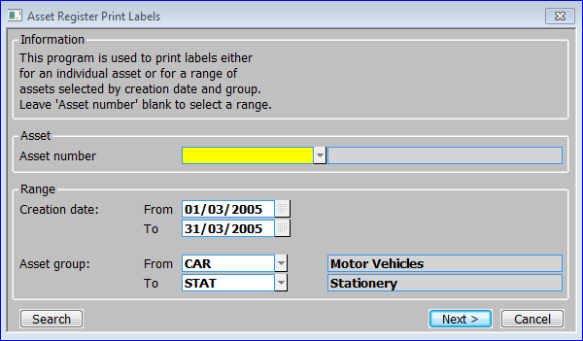

Figure 26: Asset Register Print Labels Window

|  |  |
| --- | --- |
|  | This window is displayed when you select Asset Label Print from the Reports Menu. |
| Purpose | This window enables you to enter selection criteria for the label print run. |
| Note | You can either enter the code of a single asset to print labels for, or a range of dates and/or asset groups. |
|  | This window is divided into two sections:   * Asset. * Range. |

Asset

|  |  |
| --- | --- |
| Asset number | Enter the code of the asset you want to print labels for. . A [Search] is available. ⇒ Asset Search window *(See Page 136)*. The description of the selected asset follows. |
| Creation date From: | *(Only if you left the ‘Asset number’ prompt blank.)* If you just want to print labels for assets created within a particular period, enter a start date for a range of dates here. |
| To | *(Only if you left the ‘Asset number’ prompt blank.)* If you just want to print labels for assets created within a particular period, enter a finish date for a range of dates here. |
| *Note* | The defaults are the first and last dates in the current period. |
| Asset group From: : | *(Only if you left the ‘Asset number’ prompt blank.)* If you want to restrict the print to labels for assets in a range of asset groups, enter the code of the first asset group in the range. A [Search] is available. ⇒ Asset Group Search window *(See Page 137).* The description of the selected asset group follows. |
| To: | *(Only if you left the ‘Asset number’ prompt blank.)* If you want to restrict the print to labels for assets in a range of asset groups, enter the code of the last asset group in the range. A [Search] is available. ⇒ Asset Group Search window *(See Page 137).* The description of the selected asset group follows. |
| *Note* | The defaults are the first and last groups on file. |
| On completion | ⇒ Standard Print Options Window. |

*This page is deliberately left blank*

Section Five:

## Asset Maintenance



Contents

66 Asset Maintenance

The Asset Maintenance option enables you to set up new assets and to make amendments to existing assets after Asset Register is operational.

### Asset Maintenance

|  |  |
| --- | --- |
| Introduction | The Asset Maintenance option enables you to set up new assets and to make amendments to existing assets. |
|  | When you create a new asset through this program, Asset Register generates a transaction for the asset’s value. This transaction can be viewed in Asset Register Enquiries, and can be printed on the Selective Transactions Report, etc. |
|  | If integration with General Ledger is selected in System Parameters, direct postings to General Ledger are created for additions of owned assets, and those on a finance lease. |
| Note | All values you enter must be compatible with the decimal precision specified for your company base. |

|  |  |
| --- | --- |
| Warning | Do not use this option for the initial input of assets when you are setting up the system: use the Asset Data Load option on the System Maintenance Menu instead. The Asset Data Load program does not generate transactions, and hence postings to General Ledger, and it enables you to record budget and year to date expenditure figures. |

#### General Details

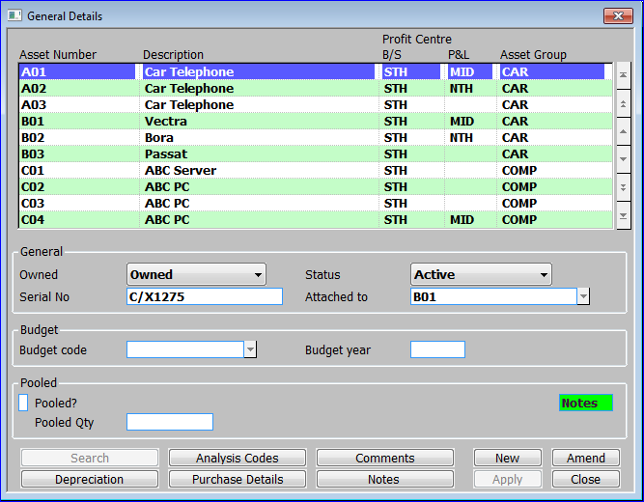

**Figure 27: General Details Window**

|  |  |
| --- | --- |
|  | This window is displayed when you select Asset Maintenance from the Asset Register main menu. |
| Purpose | This window lists existing assets, and it enables you to enter new assets, and to select assets for amendment and deletion. |
|  | This window is divided into four sections with application buttons:   * Assets. * General. * Budget. * Pooled. |

Assets:

|  |  |
| --- | --- |
| Asset number | If you are creating a new asset, enter a unique code for the asset in up to 15 characters.  Select Template Asset window *(See page 69).* |
|  | Else, enter the code of the asset you want to amend. A [Search] is available. ⇒ Asset Search window *(See Page 136)*. The description of the selected asset follows. |
| Note | If you are creating a new asset with a template, the remaining items in this and the other Asset Maintenance windows default to the values on the asset used as a template.  If you are creating a new asset without a template, many items in this and the other Asset Maintenance windows default to the values held for the asset group. |
| Description | Enter a description of the asset in up to 30 characters. |
| Profit Centre B/S | *(Only when creating a new asset.)* Enter the code of the profit centre in the balance sheet against which the asset value is recorded. A [Search] is available. ⇒ Profit Centre Search window *(See Page 137)*. The description of the selected profit centre follows. |
| P&L | Enter the code of the profit centre used when posting GL journals for asset transactions that impact on the profit and loss statement. Leave blank to use the same profit centre as balance sheet postings. A [Search] is available. ⇒ Profit Centre Search window *(See Page 137)*. The description of the selected profit centre follows. |
| Asset group | *(Only when creating a new asset.)* Enter the code of the asset group to which this asset belongs A [Search] is available. ⇒ Asset Group Search window *(See Page 137).* The description of the selected asset group follows. If the specified asset group is password-protected, you are prompted for the password. |
| Note | You can transfer assets between profit centres and asset groups using the Asset Transfer option of Transaction Entry *(See page 35).* |

General:

|  |  |
| --- | --- |
| Owned | *(Only when creating a new asset.)* This prompt records the ownership of the asset. Select from a drop down menu.   * Finance Lease. * Lease. * Non-capitalised. * Owned. |
| Note | The ownership of an asset does not affect the way it is treated for depreciation and the generation of transactions within Asset Register. However only owned assets and those on finance lease generate postings to General Ledger. |
| Status | *(Only when creating a new asset.)* This prompt records the status of the asset. Select from a drop down menu:   * **Active**: These assets are included in depreciation runs and group revaluations and there is no restriction on entering transactions for them. * **Disposed**: These assets have been disposed of, but are retained for historical purposes. They are excluded from all depreciation runs and group revaluations, and you cannot enter transactions for them via Transaction Entry. * **Mothballed**: These assets are excluded from all depreciation runs, until they are removed from mothballs via Transaction Entry. However, they are included in group revaluations and you can enter transactions (including depreciation adjustments) for them via Transaction Entry. * **Template**: These assets are only used as templates when setting up new assets. They are ignored by the depreciation run and group revaluation programs, and you cannot enter transactions for them via Transaction Entry. |
| *Reference field 1* | Enter a reference in up to 20 characters. This is the first of up to 5 reference fields established in the Asset Register Parameters - Reference Fields window *(See page 88).* |
| Note | If you are using this reference field for transaction analysis in General Ledger, it is the first eight characters that are passed to General Ledger as the transaction analysis code. |
| Attached to | This prompt enables you to attach the selected asset to another asset. You use this feature to link one asset to another; for example to attach a car phone to the car it belongs to. The assets retain their individual identities and can be depreciated in different ways. |
|  | Enter the number of the asset to which this asset is attached. Both assets must belong to the same profit centre. A [Search] is available. ⇒ Asset Search window *(See page 136).*  Leave blank if this is not an attached asset. |
| Note | You cannot attach an asset, which has attachments, and you cannot attach an asset to another asset, which is itself, an attachment. For example, you can attach a car phone to a car, and you can attach a car stereo to the same car. But once these attachments are made, you cannot attach the car stereo to the car phone. Nor can you attach the car to any other asset. |

Budget:

|  |  |
| --- | --- |
| Budget code | Enter the code of the budget to which this asset applies. A [Search] is available. ⇒ Budget Code Search window *(See page 140).* If this asset is not associated with a budget, leave this prompt blank. |
| Budget year | *(Only if a budget code was entered at the previous prompt.)* Enter the budget year to which the asset applies. |

Pooled:

|  |  |
| --- | --- |
| Pooled? | *✓* if the asset is a pooled asset; i.e. a collection of a number of identical items such as desks or chairs. Otherwise leave blank. |
| Pooled Qty | *(Only for pooled assets.)* Enter the number of pooled items that make up this asset. |

Application Buttons

|  |  |
| --- | --- |
| Analysis Codes | Enter and amend the details held for the asset in the user-defined analysis code, date, value and reference fields.  Analysis Codes window *(See page 74).* |
| Comments | Enter and amend free-form comments for the asset.  Comments window *(See page 75).* |
| Depreciation | Amend the asset’s depreciation details.  Depreciation Details window *(See page 70*). |
| Note | *If tax depreciation is selected in* *Asset Parameters – Tax Depreciation* *(See page 88) this window is followed by the* *Tax Depreciation Details window* *(See page 90).* |
| Purchase Details | Enter and amend the asset’s purchase details.  Purchase Details window *(See page 70).* |
| Notes | *(Only if the extension database is enabled)* Enter and amend free-form notes for the asset.  Asset Notes window *(See page 145).* |
| On completion | *If you are creating a new asset*  Purchase Details window *(See page 70).* |

#### Select Template Asset

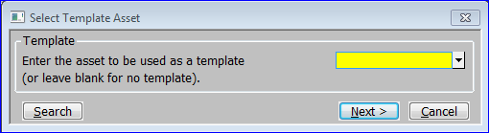

**Figure 28: Select Template Asset Window**

|  |  |
| --- | --- |
|  | This window is displayed when you enter a new asset code in the General Details window *(See page 66).* |
| Purpose | This window enables you to specify the code of an existing asset to use as a template for the new asset. You can then tailor the details by stepping through the prompts in the Asset Maintenance windows amending items as necessary. This can save time when adding a series of similar assets. |
| Note | You can create assets to just use as templates when creating other assets. You do this by setting the status to ‘template’. |

The prompt is:

|  |  |
| --- | --- |
| Template asset | Enter the code of a similar asset to use as a template. A [Search] is available. *(See page 136).* |
|  | Leave blank if you do not want to use a template. |

#### Purchase Details

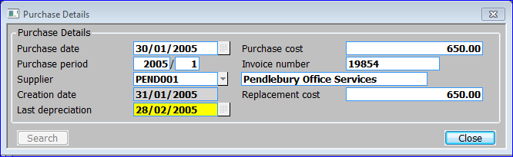

Figure 29: Purchase Details Window

|  |  |
| --- | --- |
|  | This window is displayed when you do one of the following:   * Complete your replies in the General Details window (See page 66) when creating a new asset. * *Select [Purchase Details] from the* *General Details window* *(See page 66).* |
| Purpose | This window enables you to enter and amend the asset’s purchase details. |

The prompts are:

|  |  |
| --- | --- |
| Purchase date | Enter the date the asset was purchased. Asset Register uses this date to determine the date depreciation is to start from. |
| Note | How Asset Register determines the depreciation start date varies according to the settings in the Depreciation Date window of System Parameters. *(See page 84).* |
| Purchase cost | Enter the purchase cost of the asset. This can be zero on a template asset or when the zero purchase costs for assets parameter flag is set to “Yes” or “Prompt” in System Parameters, Operating Options *(See page 93).* |
| Purchase period | *(Display only.)* The financial period in which the asset was purchased. |
| Invoice number | Enter the invoice reference associated with the purchase. This can be left blank. |
| Supplier | Enter up to 10 characters to identify the supplier from whom the asset was purchased. If Creditors Ledger is in use, a [Search] is available giving a full list of suppliers. The supplier’s description is then also displayed. |
| Creation date | *(Display only.)* The date the asset was created in Asset Register. |
| Replacement cost | Enter the cost of replacing this asset. |
| Date of last depreciation | The date the asset was last depreciated. When creating a new asset, the default is the last day of the period prior to the date of purchase. |
| On completion | If you are creating a new asset  Depreciation Details window *(See page 70).*  Otherwise  the General Details window *(See page 66).* |

#### Depreciation Details

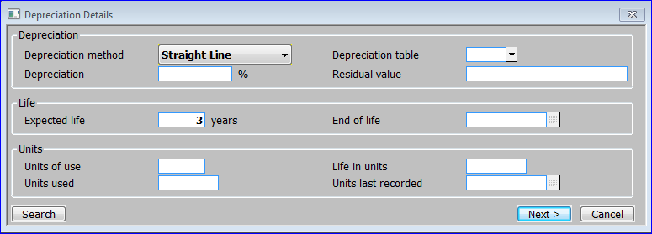

**Figure 30: Depreciation Details Window**

|  |  |
| --- | --- |
|  | This window is displayed when you do one of the following:   * Complete your replies in the Purchase Details window (See page 70) when creating a new asset. * Select [Depreciation Details] from the General Details window (See page 66). |
| Purpose | This window enables you to enter and amend the asset’s depreciation details.  This window is divided into 3 sections:   * Depreciation. * Life. * Units. |

Depreciation

|  |  |
| --- | --- |
| Depreciation method | Enter the method of calculating depreciation to be used for this asset. A drop down menu is available. |
|  | * **Period Reducing**. The depreciation is calculated by reducing the current written down value by the depreciation percentage divided by the number of periods in the year. |
|  | * **Straight Line**. The depreciation of the asset is calculated by taking the current written down value and depreciating it evenly over the remaining life of the asset. |
|  | * **Table**. The cumulative depreciation percentage for each period in the life of the asset is defined in a table. This method provides considerable flexibility as you can vary the rates of depreciation for different years. |
|  | * **Usage**. The asset is depreciated in line with the proportion of units used to those in the full life of the asset. Units may be expressed in hours, miles etc. In this method the user is required to enter the number of units used in each period. |
|  | * **Year Reducing.** This is similar to the period reducing balance, but the depreciation percentage is applied to the written down value at the start of the year. As a result the depreciation amounts are constant throughout the year. |
| Further information | For further information about depreciation methods, see page 14 of the Overview. |
| Depreciation table | *(Only if the depreciation method is* ***table****.)* Enter the code of the depreciation table to be used for calculating the depreciation of this asset. A [Search] is available. ⇒ Depreciation Table Search window *(See page 71).* |
| Note | You define depreciation tables via Depreciation Table Maintenance. For further information, see page 94. |
| Depreciation % | *(Only if the depreciation method is* ***period*** *or* ***year reducing******balance****.)* Enter the percentage depreciation to be applied to this asset each year. A zero percentage indicates that the asset is not depreciated. |
| Residual value | The residual value of the asset. Depreciation calculations do not allow the written down value to be reduced below the asset’s residual value. |

Life

|  |  |
| --- | --- |
| Expected life (years) | Enter the number of years that the asset is expected to be used for, before disposal. Asset Register uses this to calculate the end of life date. |
| End of life | The date you expect the asset’s life to end. This defaults to the purchase date plus the ‘expected life’. |

Units

|  |  |
| --- | --- |
| Units of use | *(Only if the* *depreciation method is* ***usage****.)* Enter the unit of measure used in depreciation calculations for this asset, e.g. years, hours, miles, etc. |
| Life in units | *(Only if the* *depreciation method is* ***usage****.)* Enter the expected number of units in the life of this asset. |
| Units used | *(Only if the* *depreciation method is* ***usage****.)* Enter the number of units used so far. |
| Units last recorded | The date the number of units used was last recorded. When entering an asset, this defaults to today’s date. |
| On completion | *If tax depreciation is selected in System Parameters (*Tax Depreciation window *(See page 90)*)  Tax Depreciation Details window *(See page 72)*  *Otherwise*:   * If you are creating a new asset  Analysis Codes window *(See page 74).* * If you are amending an existing asset  General Details window *(See page 66).* |

#### Tax Depreciation Details

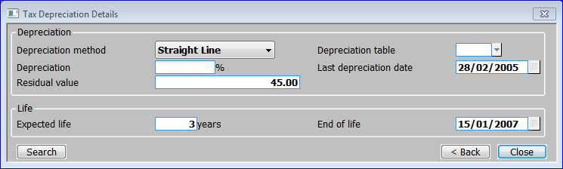

**Figure 31: Tax Depreciation Details Window**

|  |  |
| --- | --- |
|  | This window is displayed when you complete your replies in the Depreciation Details window (See page 71). |
| Note | This window is only available If tax depreciation is selected in System Parameters  Tax Depreciation window *(See page 90).* |
| Purpose | This window enables you to enter and amend the depreciation details for the asset for tax purposes.  This window is divided into two sections:   * Depreciation. * Life. |

Depreciation:

|  |  |
| --- | --- |
| Depreciation method | Enter the tax depreciation method for this asset. A drop down menu is available. These are the same as those used for the ‘Depreciation method’ prompt in the Depreciation Details window *(See page 71).* The options are:   * Period Reducing. * Straight Line. * Table. * Usage. * Year Reducing. |
| Depreciation table | *(Only if the tax depreciation method is* ***table****.)* Enter the code of the depreciation table for calculating the depreciation of this asset for tax purposes. A [Search] is available. *(See page 71).* |
| Depreciation % | *(Only if the tax depreciation method is* ***period*** *or* ***year reducing******balance****.)* Enter the percentage depreciation to be applied to this asset each year when calculating depreciation for tax purposes. A zero percentage indicates that the asset is not depreciated. |
| Last depreciation date | The date the asset was last depreciated. |
| Residual value | The residual value of the asset. Depreciation calculations do not allow the written down value to be reduced below the asset’s residual value. |

Life:

|  |  |
| --- | --- |
| Expected life | Enter the asset’s expected life span for tax purposes in years. |
| End of life | Enter the date you expect the life of the asset to end for tax purposes. This defaults to the purchase date plus the ‘expected life’ entered above. |
| On completion | *If you are creating a new asset*  Analysis Codes window *(See page 74).*  *Otherwise*  General Details window *(See page 66).* |

#### Analysis Codes

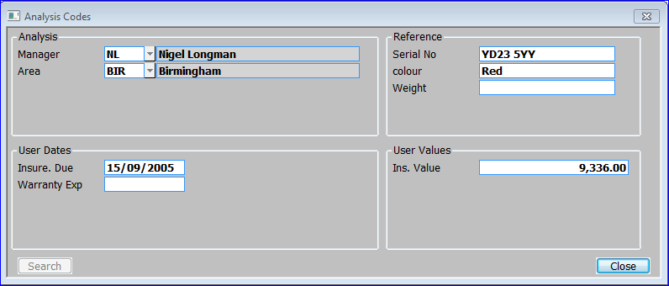

**Figure 32: Analysis Codes Window**

|  |  |
| --- | --- |
|  | This window is displayed when you do one of the following:   * If you are creating a new asset, complete your replies in the Depreciation Details window (See page 71) / complete your replies in the Tax Depreciation Details window (See page 72), If tax depreciation is selected in System Parameters  Tax Depreciation window (See page 90). * Select [Analysis Codes] from the General Details window (See page 66). |
| Purpose | This window enables you to enter and amend the details held for the asset in the user-defined analysis code, date, value and reference fields. These codes and values are used primarily for grouping assets together for enquiries and reports.  This window is divided into four sections:   * Analysis. * Reference. * User Dates. * User Values. |

Analysis:

|  |  |
| --- | --- |
|  | There are up to five prompts for analysis codes. The names of these prompts are determined by the titles entered for the five sets of analysis codes in System Parameters – Analysis Codes *(See page 80)* In Figure 32 the prompts are ‘Manager’, and ‘Area’; the third, fourth and fifth sets of analysis codes not being used. The description of that code is also displayed. |

Reference

|  |  |
| --- | --- |
|  | There are up to five prompts for reference fields. The names of these prompts are determined by the titles entered for the five sets of user-defined reference fields in System Parameters – Reference Fields *(See page 88)* In Figure 32 the prompts are ‘Serial No.’, ‘colour’ and ‘Weight’; the fourth and fifth reference fields not being used. |
| Note | If you are using any of the reference fields for transaction analysis in General Ledger, it is the first eight characters in the relevant prompt that are passed to General Ledger as the transaction analysis code. For further information, see page 87. |

User Dates

|  |  |
| --- | --- |
|  | There are up to five prompts for dates. The names of these prompts are determined by the titles entered for the five sets of user-*defined* dates in System Parameters – User Defined Dates *(See page 91*).In Figure 32 the prompts are ‘Insure. Due’, and ‘Warranty Exp’; the third, fourth and fifth dates not being used. |

User Values:

|  |  |
| --- | --- |
|  | There are up to five prompts for values. The names of these prompts are determined by the titles entered for the five sets of user-defined values in System Parameters – User Defined Values *(See page 92).* In Figure 32, only one value prompt is used, it is ‘Ins. Value’. |
| On completion | If you are creating a new asset ⇒ Comments window *(See page 75).*  Otherwise ⇒ General Details window *(See page 66).* |

#### Comments

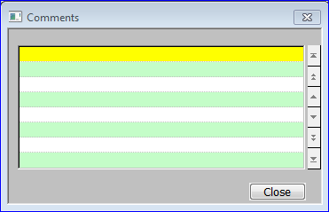

**Figure 33: Comments Window**

|  |  |
| --- | --- |
|  | This window is displayed when you do one of the following:   * Complete your replies in the Analysis Codes window (See page 74) when creating a new asset. * Select [Comments] from the General Details window (See page 66). |
| Purpose | This window enables you to view and record free-form comments for the asset. |
|  | You can enter an unlimited number of lines of up to 40 characters each. |
| On exit | ⇒ General Details window *(See page 66).* |

Section Six:

## System Maintenance



Contents

78 System Parameters

System Parameters enable you to configure your system to your specific requirements. The Asset Register-specific system parameters are described in detail here.

94 Depreciation Table Maintenance

Depreciation tables are used to determine the depreciation percentage to be applied to assets, which use the ‘table’ depreciation method. Up to five different rates can be specified for each table. For each rate you define a depreciation percentage and the number of periods for which it is to apply.

96 Asset Group Maintenance

Asset groups are used to collate assets of the same type for enquiries and reports, and to provide default depreciation details during asset entry. Asset groups also determine the General Ledger account codes to which postings for assets in the group are made.

102 Budget Maintenance

Budgets are used to accumulate the costs of new assets and additions to assets. When you create an asset, you can define the code of its budget. The value of the asset, and any additions made to it in the budget’s financial year, are then added to an expenditure total on the budget record.

106 Asset Data Load

The Asset Data Load option is used for the initial input and amendment of asset details when setting up a new system. This option enables the brought forward and year to date figures to be set up for each asset.

118 Group Revaluation

This program enables the whole of a group of assets to be revalued by a percentage. Only active and mothballed assets in the group are revalued. This option is typically used to allow for currency variations in countries where such revaluations are permitted.

### System Parameters

|  |  |  |  |
| --- | --- | --- | --- |
| Introduction | | System Parameters enable you to configure your system to your specific requirements. You should set them up very carefully, as some of the settings are difficult to change after your system is operational. | |
|  | | System parameters fall into the following groups:   * **Administration Parameters**, which are shared by all the accounting and distribution modules. | |
|  | | * **Company Parameters**, which are shared by all the accounting and distribution modules and deal mainly with company information. | |
|  | | * **Distribution Parameters**, which deal with information that is relevant only to the distribution modules. | |
|  | | * **Module-specific parameters** (e.g. SOP parameters, Asset Register parameters etc.). | |
|  | | The system cannot function without the parameters being set, so the first time you use Asset Register, you are automatically taken through the Asset Register Parameters. After the system is up and running, you can access the Asset Register Parameters via the System Maintenance Menu. | |
|  | | The Asset Register-specific system parameters are described below. | |

#### Asset Register Parameters

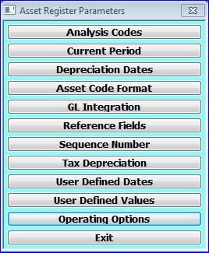

Figure 34: Asset Register Parameters Menu

|  |  |
| --- | --- |
|  | This menu is displayed when you select Asset Register from the System Parameters Menu. |

The options are:

|  |  |
| --- | --- |
| Analysis Codes | Define titles for the five sets of optional analysis codes.  Analysis Codes window *(See page 80)* |
| Current Period | Set the current financial period during initial set up, and view it after the system is active.  Current Accounting Period window *(See page* *83).* |
| Depreciation Dates | Specify how depreciation is to be calculated and when it is to start.  Depreciation Date window *(See page 84).* |
| Asset Code Format | Define the format of asset codes.  Asset Code Format window *(See page 85).* |
| GL Integration | Specify whether you want to automatically integrate Asset Register with General Ledger, and various General Ledger-related details.  GL Integration window *(See page 86).* |
| Reference Fields | Define titles for the five reference fields that are available for recording additional information about assets; for example, serial numbers, car registration numbers, etc.  Reference Fields window *(See page 88).* |
| Sequence Number | The sequence number is an internal asset reference number. This option enables you to set up the sequence during initial set-up, and to view it after the system is active.  Sequence Number window *(See page 89).* |
| Tax Depreciation | Define whether separate tax depreciation figures are required.  Tax Depreciation window *(See page 90).* |
| User Defined Dates | Define titles for the five date fields that are available for recording additional dates for assets; for example, maintenance due dates, warranty expiry dates, etc.  User Defined Dates window *(See page 91).* |
| User Defined Values | Define titles for the five user-defined value fields that can be used for recording additional values for each asset; for example, insurance values.  User Defined Values window *(See page 92).* |
| Operating Options | This flag is used to determine if zero purchase costs for assets are allowed. ⇒ Operating Options window *(see page 93).* |
| Exit | ⇒ System Parameters Menu. |

#### Analysis Codes

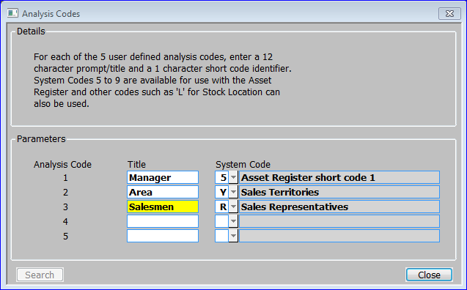

Figure 35: Analysis Codes Window

|  |  |
| --- | --- |
|  | This window is displayed when you select Analysis Codes from the Asset Register Parameters menu (See page 78). |
| Purpose | This window enables you to define a title and identifier for each of the five sets of analysis codes that are available in Asset Register. You can use the analysis codes to record additional information about assets; for example you can use one set of the codes to record the manager responsible for each asset, another set to record the area code, etc. |
|  | You can choose to validate the analysis codes. This means you can set up a table of valid codes, for example a table of manager ids. Then when you are prompted for the analysis code when entering an asset in Asset Maintenance you can only enter a code if it is in the corresponding table. |
|  | You can optionally set up tables of valid codes specifically for use in Asset Register via the System Codes option in Administration Parameters. Alternatively you can validate the codes against one of the other sets of System Codes used in the Global system; for example stock location codes, sales representative codes, sales territory codes, etc. |
| Examples | To use the first set of analysis codes to record Asset Register-specific managers:   * Enter the title ‘Manager’ and the system code ‘5’, for the first analysis code in this window. * Enter the valid manager codes via the ‘Asset Register Short Code 1’ option in System Codes in Administration Parameters. |
|  | To use the second set of analysis codes to record the assets’ area codes which correspond to the sales territory codes used in Sales Order Processing, enter the title ‘Area’ and the system code ‘Y’ for the second analysis code in this window. |

Parameters

|  |  |
| --- | --- |
|  | The prompts for each of the five sets of analysis codes are: |
| Title | Enter a title for the analysis code in up to 12 characters. Leave this blank if you do not want to use this analysis code; for example leave the title of the fourth and fifth codes blank if you only want to use three sets of codes. |
| System code | If you want to validate this analysis code against one of the system codes entered in Administration Parameters, enter the number corresponding to the required system code as follows:   * **5** Asset Register short code 1. |
|  | * **6** Asset Register short code 2. |
|  | * **7** Asset Register short code 3. |
|  | * **8** Asset Register short code 4. |
|  | * **9** Asset Register short code 5. |
|  | * **1-4** Customer classification 1-4. |
|  | * **J** Asset Register profit centre codes. |
|  | * **L** Stock locations (as defined in Product Maintenance). |
|  | * **R** Sales representatives. |
|  | * **Y** Sales territories. |
|  | A [Search] of the permitted System codes is available. ⇒ Select System Code window *(See page 81).* |
| On confirmation | ⇒ Asset Register Parameters menu (See page 78). |

#### Select System Code

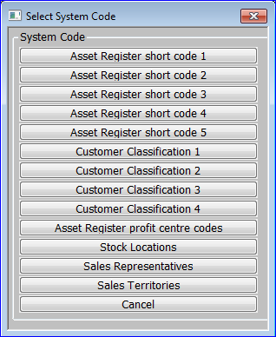

**Figure 36: Select System Code Menu**

|  |  |
| --- | --- |
|  | This menu is displayed when you do a [Search] at any of the 5 System Codes prompts in the System codes window *(See page 80).* |
| Purpose | This window enables you to select the system code to use for the Analysis code being set up. |

The options are:

|  |  |
| --- | --- |
| **Asset Register short code 1.** | Return a 5 to the selected system code prompt. |
| **Asset Register short code 2.** | Return a 6 to the selected system code prompt. |
| **Asset Register short code 3.** | Return a 7 to the selected system code prompt. |
| **Asset Register short code 4.** | Return a 8 to the selected system code prompt. |
| **Asset Register short code 5.** | Return a 9 to the selected system code prompt. |
| **Customer Classification 1.** | Return a 1 to the selected system code prompt. |
| **Customer classification 2.** | Return a 2 to the selected system code prompt. |
| **Customer Classification 3.** | Return a 3 to the selected system code prompt. |
| **Customer classification 4.** | Return a 4 to the selected system code prompt. |
| **Asset Register profit centre codes.** | Return a J to the selected system code prompt. |
| **Stock Locations.** | Return a L to the selected system code prompt. |
| **Sales Representatives.** | Return a R to the selected system code prompt. |
| **Sales territories.** | Return a Y to the selected system code prompt. |
|  |  |

#### Current Accounting Period

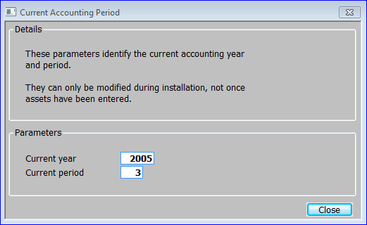

Figure 37: Current Accounting Period Window

|  |  |
| --- | --- |
|  | This window is displayed when you select Current Period from the Asset Register Parameters menu *(See page 78).* |
| Purpose | This window enables you to set the current financial period during initial set up, and subsequently to view it. |

Parameters

|  |  |
| --- | --- |
| Current year | *(Only during initial set up of Asset Register.)* Enter the current financial year, as defined in Calendar Maintenance in Administration Parameters. |
| Current period | *(Only during initial set up of Asset Register.)* Enter the current financial period, as defined in Calendar Maintenance in Administration Parameters. |
|  | After this is set, the current period is automatically updated every time you close the period. |
| On confirmation | ⇒ Asset Register Parameters menu (See page 78). |

#### Depreciation Date

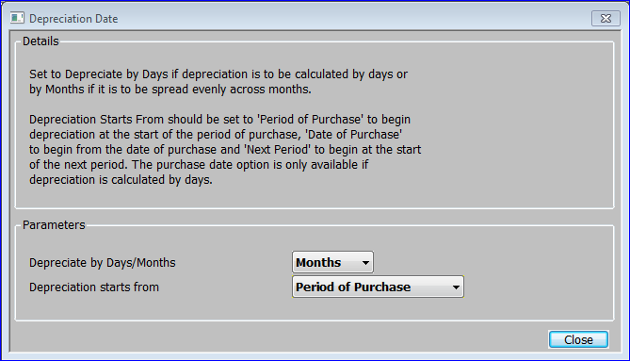

Figure 38: Depreciation Date Window

|  |  |
| --- | --- |
|  | This window is displayed when you select Depreciation Dates from the Asset Register Parameters menu *(See page 78).* |
| Purpose | This window enables you to specify how depreciation is to be calculated and when it is to start. |

Parameters

|  |  |
| --- | --- |
| Depreciate by Days/Months | Select one of the following from a drop down menu:   * **Days** - Depreciation is calculated by **days**. This is mainly for use with ‘4 4 5’ periods, so that a larger amount of depreciation is taken in the 5 week period. |
|  | * **Months** - Depreciation is spread evenly across **months**; i.e. financial periods. |
| Depreciation starts from | Select one of the following from a drop down menu:   * **Period of Purchase** - Depreciation begins at the start of the **period** of purchase. |
|  | * **Date of Purchase -** Depreciation begins on the **date** of purchase. This is only available if depreciation by days is selected above. |
|  | * **Next Period -** Depreciation begins at the start of the period after purchase; i.e. the **next** period. |
| On confirmation | ⇒ Asset Register Parameters menu (See page 78). |

#### Asset Code Format

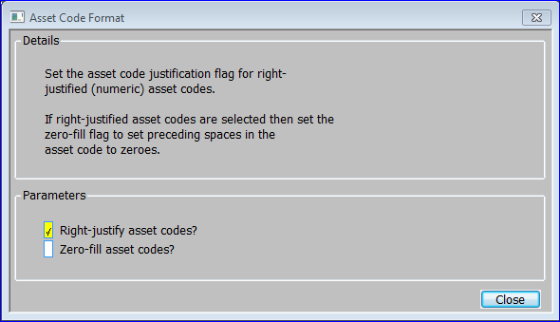

Figure 39: Asset Code Format Window

|  |  |
| --- | --- |
|  | This window is displayed when you select Asset Code Format from the Asset Register Parameters menu *(See page 78).* |
| Purpose | This window enables you to specify whether asset codes are to be right justified. If asset codes are numeric, they should be right justified. If they are right justified, leading zeroes can be shown as blanks or as zeroes. |

|  |  |
| --- | --- |
| Warning | You cannot change the asset code format after any assets have been created. |

Parameters

|  |  |
| --- | --- |
| Right-justify asset codes | ✓ if asset codes are to be right justified. This is recommended for numeric asset codes. |
|  | Leave blank if asset codes are to be left justified. This is recommended for alphanumeric codes. |
| Zero-fill asset codes | *(Only if asset codes are right justified.)* |
|  | ✓ if leading zeroes in numeric asset codes are to be shown; e.g. asset code 12345678 is shown as‘000000012345678’. |
|  | Leave blank if you are using alphanumeric codes or if leading zeroes in numeric asset codes are to be shown as blank; e.g. asset code 12345678 is shown as ‘ 12345678’. |
| On confirmation | *⇒* *Asset Register Parameters menu* *(See page 78).* |

#### General Ledger Integration

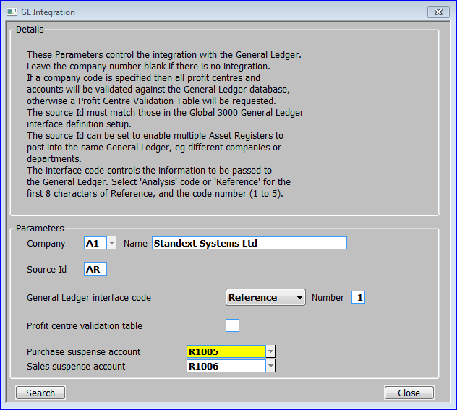

Figure 40: GL Integration Window

|  |  |
| --- | --- |
|  | This window is displayed when you select GL Integration from the Asset Register Parameters menu *(See page 78).* |
| Purpose | This window enables you to specify whether you want to automatically integrate Asset Register with General Ledger, and to enter various General Ledger related details. |

Parameters

|  |  |
| --- | --- |
| Company number | If you want Asset Register to automatically integrate with General Ledger, enter the code of the company to be used. A [Search] is available. ⇒ Select Company window *(See page 143).* |
|  | If you do not want Asset Register to integrate with General Ledger, leave this code blank. |
| Warning | Once integration with General Ledger has been set, you cannot switch it off. |
| Name | Enter the name of the company. If you entered a company code at the previous prompt, this defaults to the name defined for the company in Company Parameters, but it can be changed specifically for use in Asset Register. |
| Source id | Enter a two-character code to identify the Asset Register within General Ledger. This is normally AR and should match the source ID in the General Ledger Interface Definitions.. If you run multiple Asset Registers, give each a different source id. This enables you to identify the Asset Register each transfer file originated in. |
| General Ledger interface code | *(Only if integration with General Ledger is selected.)* Up to two analysis categories can be associated with each account in General Ledger. Transactions for these accounts can then have an analysis code recorded for each category. These analysis codes can be used in General Ledger to select transactions in enquiries or for additional customised reports created via Global Reporter. |
|  | When posting transactions to General Ledger for an account, which has an analysis category, defined, Asset Register automatically passes analysis codes for the **first** analysis category defined for the account. This prompt controls which codes are passed. Select one of the following from a drop down menu:   * **Analysis**: One of the Asset Register analysis codes (if defined) is to be passed to General Ledger is. You define which set of analysis codes is to be used via the next prompt. |
|  | * **Reference**:The first eight characters of one of the five user-defined **reference** **fields** are to be used as the General Ledger analysis code. You define which reference field is to be used via the next prompt. |
| General Ledger interface number | *(Only if integration with General Ledger is selected.)* If you entered Analysis at the previous prompt, enter the number (1-5) of the set of Asset Register analysis codes you want to use. If you entered Reference enter the number (1-5) of the reference field you want to use. |
| Note | To make use of this feature, you also need to:   * Define the corresponding set of analysis codes or reference fields as an analysis category in General Ledger System Parameters. |
|  | * Define this analysis category as the **first** analysis category for each account to which postings are made from Asset Register, in Chart of Accounts Maintenance in General Ledger. |
| Profit centre validation table | *(Not if integration with General Ledger is selected.)* This prompt controls the validation of profit centres when integration with General Ledger is not in use. Generally you set up a list of profit centre codes and descriptions via the Profit Centres option (option J) of the Asset Register Codes Menu in the System Codes option of Administration Parameters. Alternatively you can define profit centre codes via one of the five sets of Asset Register analysis codes, which are available on the same menu. |
|  | This prompt defines which option on the Asset Register Codes Menu is used to define profit centres. Enter one of the following:   * **J** if you are using the standard Profit Centres option (option J). |
|  | * **1-5** according to which of the five sets of Asset Register analysis codes you are using. |
|  | If integration with General Ledger is in use, profit centre codes are validated via the profit centre definitions in General Ledger. |
| Purchase suspense account | Enter the code of the General Ledger purchase suspense account to be used when posting to the purchase suspense account. If integration with General Ledger is selected, a [Search] is available. ⇒ GL Accounts Search window *(See page 139 ).* |
| Sales suspense account | Enter the code of the General Ledger sales suspense account to be used when posting to the sales suspense account. If integration with General Ledger is selected, a [Search] is available. ⇒ GL Accounts Search window *(See page 139 )*. |
| *On confirmation* | *⇒* *Asset Register Parameters menu*(See page 77)*.* |

#### Reference Fields

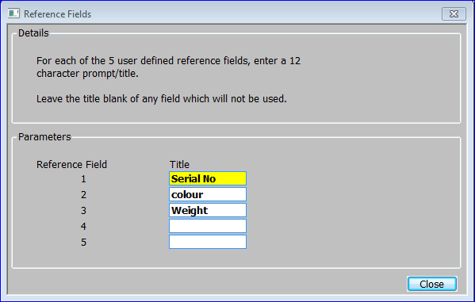

Figure 41: Reference Fields Window

|  |  |
| --- | --- |
|  | This window is displayed when you select Reference Fields from the Asset Register Parameters menu *(See page 78).* |
| Purpose | This window enables you to define titles for each of the five user-defined reference fields that are available in Asset Register. You can use the reference fields to record additional information about each asset; for example, serial numbers, car registration numbers, etc. |
| Note | The first reference field can be used as a search sequence in Asset Maintenance, Enquiries, etc. You should therefore assign the most significant reference to the first reference field. |

Parameters

|  |  |
| --- | --- |
| Reference field | *(Display only.)* The number of the reference field. |
| Title | Enter a title for the reference field in up to 12 characters. This is used as a prompt in data entry windows. If you do not want to use the reference field, leave the title blank. |
| On confirmation | *⇒* *Asset Register Parameters menu* *(See page 78).* |

#### Sequence Number

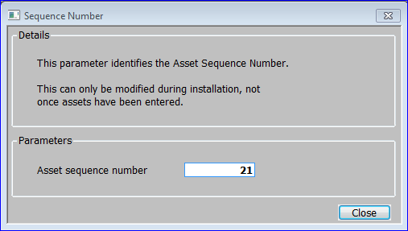

Figure 42: Sequence Number Window

|  |  |
| --- | --- |
|  | This window is displayed when you select Sequence Number from the Asset Register Parameters menu *(See page 78).* |
| Purpose | Whenever an asset is created, it is assigned a unique internal reference number. The next number to be assigned is displayed in this window, and can be altered during the initial set up of Asset Register. |
|  | Once the system is operational this number is automatically updated every time an asset is created and cannot be changed. |

Parameters

|  |  |
| --- | --- |
| Asset sequence number | *(Only during initial set-up of Asset Register.)* This is the next number to be assigned. When setting up Asset Register, this defaults to one. |
| On confirmation | *⇒* *Asset Register Parameters menu* *(See page 78).* |

#### Tax Depreciation

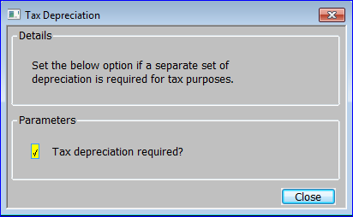

Figure 43: Tax Depreciation Window

|  |  |
| --- | --- |
|  | This window is displayed when you select Tax Depreciation from the Asset Register Parameters menu *(See page 78).* |
| Purpose | This window enables you to define whether a separate set of depreciation figures are required for tax purposes. |

Parameters

|  |  |
| --- | --- |
| Tax depreciation flag | *✓* if you require a separate set of depreciation figures for tax purposes. Leave blank if you do not. |
| On confirmation | *⇒* *Asset Register Parameters menu* *(See page 78).* |

#### User Defined Dates

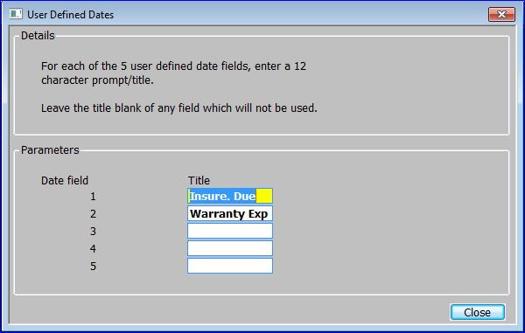

Figure 44: User Defined Dates Window

|  |  |
| --- | --- |
|  | This window is displayed when you select User Defined Dates from the Asset Register Parameters menu *(See page 78).* |
| Purpose | This window enables you to define titles for each of the five user-defined date fields that are available in Asset Register. You can use these date fields to record additional dates for each asset; for example the maintenance due date, warranty expiry date, etc. |

Parameters

|  |  |
| --- | --- |
| Date field | *(Display only.)* The number of the date field. |
| Title | Enter a title for the date in up to 12 characters. This is used as a prompt in data entry windows. If you do not want to use the date field, leave the title blank. |
| On confirmation | *⇒* *Asset Register Parameters menu* *(See page 78).* |

#### User Defined Values

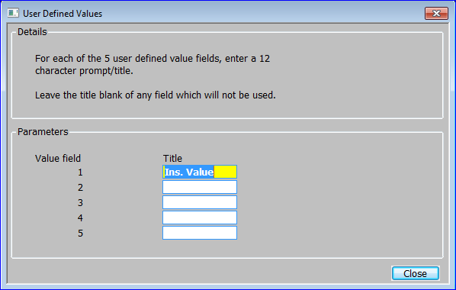

Figure 45: User Defined Values Window

|  |  |
| --- | --- |
|  | This window is displayed when you select User Defined Values from the Asset Register Parameters menu *(See page 78).* |
| Purpose | This window enables you to define titles for each of the five user-defined value fields that are available in Asset Register. You can use these value fields to record additional values for each asset, for example the insurance value. |

Parameters

|  |  |
| --- | --- |
| Value field | *(Display only.)* The number of the value field. |
| Title | Enter a title for the value in up to 12 characters. This is used as a prompt in data entry windows. If you do not want to use the value field, leave the title blank. |
| On confirmation | *⇒* *Asset Register Parameters menu* *(See page 78).* |

#### Operating Options

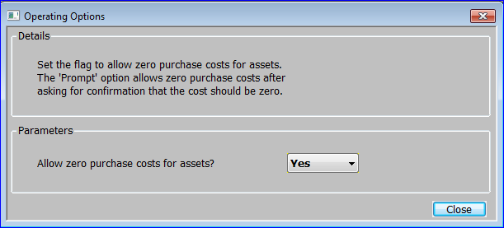

Figure 46: Operating Options

|  |  |
| --- | --- |
|  | This window is displayed when you select Operating Options from the Asset Register Parameters menu *(See page 78).* |
| Purpose | This window is used to set the parameter flag to allow zero purchase costs for assets. |

Parameters

|  |  |
| --- | --- |
| Allow zero purchase costs for Assets | This flag is used to control zero purchase costs for assets.  Select from a drop down menu.   * **Yes.** *(Default)* - Assets may have zero purchase costs. * **No.** - Only assets with template status may have zero purchase costs. * **Prompt**. - The user will be warned if the purchase cost is zero for a non-template asset and asked to confirm that they wish to continue. |
| On confirmation | *⇒* *Asset Register Parameters menu* *(See page 78).* |

### Depreciation Table Maintenance

|  |  |
| --- | --- |
| Introduction | Depreciation tables are used to determine the depreciation percentage to be applied to assets, which use the ‘table’ depreciation method. |
|  | Up to five different rates can be specified for each table. For each rate you define a depreciation percentage and the number of periods for which it is to apply. When the first rate expires, the second rate comes into use; when the second rate expires, the third rate comes into use; etc. |
|  | The last percentage in the table is used until the end of the asset’s life if necessary. |
| Further information | For details of the calculations used, see page 14 of the Overview. |

#### Depreciation Table Maintenance

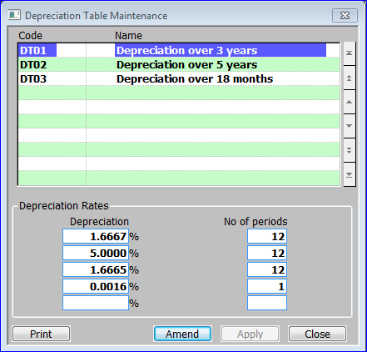

Figure 47: Depreciation Table Maintenance Window

|  |  |
| --- | --- |
|  | This window is displayed when you select Depreciation Table Maintenance from the System Maintenance Menu. |
| Purpose | This window lists depreciation tables that have already been defined, and it enables you to add new depreciation tables, and to amend, print and delete existing ones. |
|  | For each table you can define up to five depreciation percentages. For each percentage you can define the number of periods for which it is to apply.  This window is divided into two sections with application buttons:   * Codes *(Scrolled section)*. * Depreciation Rates. |

Codes

|  |  |
| --- | --- |
| Code | Enter a code for the depreciation table in up to four characters. |
| Name | Enter a description for the table in up to 30 characters. |

Depreciation Rates

|  |  |
| --- | --- |
| Depreciation % | Enter the depreciation percentage to be applied. |
| No of periods | Enter the number of periods for which this percentage is to apply. The default is the number of periods, which are required to make the total depreciation percentage up to 100%. |

*Application Buttons*

|  |  |
| --- | --- |
| **Name** | Print details of a range of Depreciation Tables ⇒ Print Depreciation Table window *(See page 95).* |

#### Print Depreciation Table

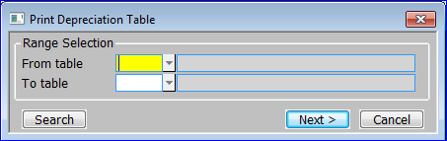

Figure 48: Print Depreciation Table Window

|  |  |
| --- | --- |
|  | This window is displayed when you select ‘Print’ from the Depreciation Table Maintenance window *(See page 94).* |
| Purpose | This window enables you to select a range of depreciation tables to print. |

The prompts are:

|  |  |
| --- | --- |
| From table | Enter the code of the first table you want to print. A [Search] is available ⇒ Select Depreciation Table window *(See page 142).* |
| To table | Enter the code of the last table you want to print. A [Search] is available ⇒ Select Depreciation Table window *(See page 142).* |
| On confirmation | ⇒ Standard Print Options Window. |

### Asset Group Maintenance

|  |  |
| --- | --- |
| Introduction | Asset groups are used to collate assets of the same type for enquiries and reports, and to provide default depreciation details during asset entry. |
|  | Asset groups also determine the General Ledger account codes to which postings for assets in the group are made. This enables groups to be separately identified in the General Ledger. If separate groups are required for reporting purposes in Asset Register, but not in General Ledger, they can be combined for General Ledger purposes by quoting the same accounts on each of the groups. |

#### Maintain Asset Groups

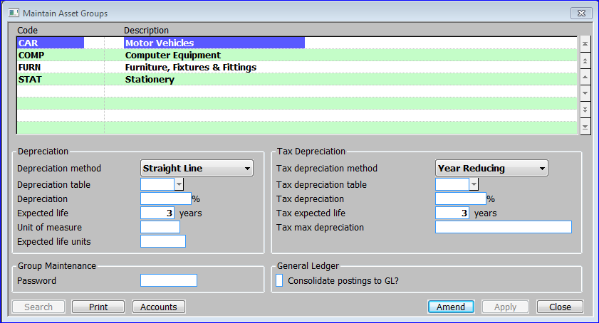

Figure 49: Maintain Asset Groups Window

|  |  |
| --- | --- |
|  | This window is displayed when you select Asset Group Maintenance from the System Maintenance Menu. |
| Purpose | This window lists asset groups that have already been defined, and it enables you to add new asset groups, and to amend and delete existing ones.  The window is divided into five sections with application buttons:   * Asset Groups. (Scrolled Section). * Depreciation. * Group Maintenance. * Tax Depreciation. * General Ledger. |

Asset Groups

|  |  |
| --- | --- |
| Code | *If you are creating a new asset group*, enter a unique code for the asset group in up to 10 characters. ⇒ Template Group window *(See page 98).* |
| Note | If you are creating a new asset group with a template, the remaining items in this window, and the items in the GL Account Codes Window default to the values on the asset group used as a template. |
| Description | Enter a description for the asset group in up to 30 characters. |

Depreciation

|  |  |
| --- | --- |
| Depreciation method | Enter the default depreciation method for assets in this group. Select from a drop down menu: |
|  | * **Period Reducing**: The depreciation is calculated by reducing the current written down value by the depreciation percentage divided by the number of periods in the year. |
|  | * **Straight Line**: The depreciation of the asset is calculated by taking the current written down value and depreciating it evenly over the remaining life of the asset. |
|  | * **Table**: The cumulative depreciation percentage for each period in the life of the asset is defined in a table. This method provides considerable flexibility as you can vary the rates of depreciation for different years. |
|  | * **Usage**: The asset is depreciated in line with the proportion of units used to those in the full life of an asset. Units may be expressed in hours, miles etc. In this method the user is required to enter the number of units used each period. |
|  | * **Year Reducing**: This is similar to the period reducing balance, but the depreciation percentage is applied to the written down value at the start of the year. As a result the depreciation amounts are constant throughout the year. |
| Further information | For further information about depreciation methods, see page 14 of the Overview. |
| Depreciation table | *(Only if the Depreciation method is* ***Table****.)* Enter the code of the default depreciation table to be used for assets in this group. A [Search] is available ⇒ Select Depreciation Table window *(See page 142).* |
| Note | You define depreciation tables via Depreciation Table Maintenance. For further information, see page 94. |
| Depreciation % | *(Only if the depreciation method is P****eriod Reducing*** *or* ***Year Reducing****)* Enter the default annual percentage depreciation for assets in this group. A zero percentage indicates that assets are not depreciated. |
| Expected life years | Enter the default number of years that an asset in this group is expected to be used for, before disposal. |
| Unit of measure | *(Only if the* *depreciation method is* ***usage****.)* Enter the default unit of measure for assets in this group, e.g. hours, miles, etc. |
| Expected life units | *(Only if the* *depreciation method is* ***usage****.)* Enter the default unit life expectancy for assets in this group. |

*Group Maintenance*

|  |  |
| --- | --- |
| Password | If you want to restrict access to this asset group, you can enter a password of up to eight characters. Operators must then supply the correct password before they can add an asset to this group or process an asset in this group via Transaction Entry, Asset Maintenance or Asset Data Load. |
|  | Leave this prompt blank for no password protection. |

Tax Depreciation

|  |  |
| --- | --- |
| *Note* | This section is only available if tax depreciation is selected in System Parameters – Asset Register – Tax Depreciation *(See page 90).* Otherwise the area is blank. |
| Tax depreciation method | Enter the default tax depreciation method for assets in the group. Valid responses parallel those described above for the ‘Depreciation method’ prompt. |
| Tax depreciation table | *(Only if the tax depreciation method is* ***table****.)* Enter the code of the default depreciation table to be used for the tax depreciation of assets in this group. A [Search] is available ⇒ Select Depreciation Table window *(See page 142).* |
| Tax depreciation % | *(Only if the tax depreciation method is P****eriod Reducing*** *or* ***Year Reducing****.)* Enter the default annual percentage tax depreciation for assets in this group. A zero percentage indicates that assets are not depreciated. |
| Tax expected life years | Enter the default number of years that an asset in this group is expected (for tax purposes) to be used for, before disposal. |
| Tax max depreciation | The maximum cost value, which may be used for the tax depreciation of assets in the group; for example, company cars in the UK have a limit on the value, which may be depreciated. Where no limit applies, enter zero. |

*General Ledger*

|  |  |
| --- | --- |
| Consolidate postings to gl? | ✓ if you want postings to General Ledger for assets in this group to be consolidated by profit centre and asset group.  Leave blank for postings at individual asset level for assets in this group. |

Application Buttons

|  |  |
| --- | --- |
| Print | Print asset group details.  Asset Group Report window *(See page 100).* |
| Account | Amend the General Ledger control accounts for this asset group. ⇒ GL Account Codes window *(See page 99).* |
| On completion | *If adding or inserting a new Asset* Group ⇒ GL Account Codes window *(See page 99)* |

#### Template Group

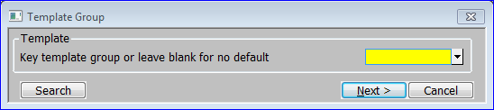

**Figure 50: Template Group Window**

|  |  |
| --- | --- |
|  | This window is displayed when you enter a new asset group code in the Maintain Asset Groups window (See page 96). |
| Purpose | This window enables you to specify the code of an existing asset group to use as a template for the new asset group. You can then tailor the details by stepping through the prompts in the Maintain Asset Groups and GL Account Codes windows amending items as necessary. This can save time when adding a series of similar asset groups. |

Template

|  |  |
| --- | --- |
| Key template group or leave blank for no default | Enter the code of a similar asset group to use as a template A [Search] of existing Asset Groups is available. ⇒ Select Group window *(See page 137).* |
|  | Leave blank if you do not want to use a template. |
| On completion | ⇒ Description prompt in the Maintain Asset Groups window *(See page 96).* |

#### GL Account Codes

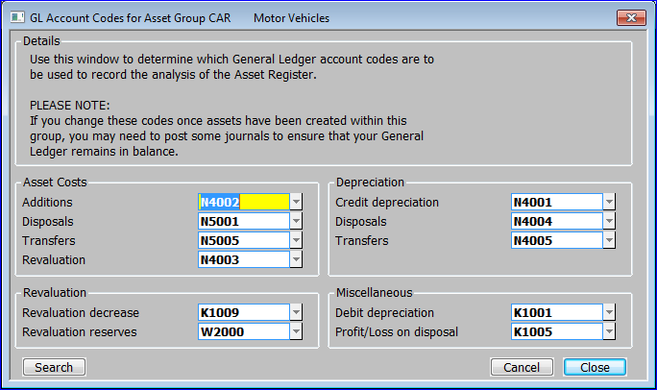

**Figure 51: GL Account Codes Window**

|  |  |
| --- | --- |
|  | This window is displayed when you do one of the following:   * Complete your replies in the Maintain Asset Groups window (See page 96) when creating a new asset group. * Select [Accounts] from the Maintain Asset Groups window (See page 96). |
| Purpose | This window enables you to define the General Ledger accounts to which postings are made for assets in this group. |
|  | You can enter the same account codes at different prompts, and for different account groups, if you want to amalgamate the postings in General Ledger. |
| Warning | If you change an asset group’s General Ledger account codes after assets have been created in the group, you may need to post adjustment journals to maintain the correct balances in General Ledger. |
|  | This window is divided into four sections:   * Asset Costs. * Depreciation. * Revaluation. * Miscellaneous |
| Note | If integration with General Ledger is selected in System Parameters, you can do a [Search] for valid codes. ⇒ GL Accounts window *(See page 139).* |

*Asset Costs*

|  |  |
| --- | --- |
|  | Enter the codes of the General Ledger accounts to which postings are to be made for: |
|  | * Additions. |
|  | * Disposals. |
|  | * Transfers. |
|  | * Revaluations. |

*Depreciation*

|  |  |
| --- | --- |
|  | Enter the codes of the General Ledger accounts to which postings are to be made for: |
|  | * Credit depreciation. |
|  | * Disposals. |
|  | * Transfers. |

*Revaluation*

|  |  |
| --- | --- |
|  | Enter the codes of the General Ledger accounts to which postings are to be made for: |
|  | * Revaluation decrease. |
|  | * Revaluation reserves. |

*Miscellaneous*

|  |  |
| --- | --- |
|  | Enter the codes of the General Ledger accounts to which postings are to be made for:   * Debit depreciation. |
|  | * Profit and loss on disposal. |
| On completion | ⇒ Maintain Asset Groups window *(See page 96).* |

#### Asset Group Report

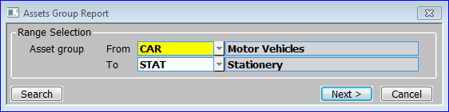

Figure 52: Asset Group Report Window

|  |  |
| --- | --- |
|  | This window is displayed when you select [Accounts] from the Maintain Asset Groups window (See page 96). |
| Purpose | This window enables you to specify the range of asset groups you want to print. |
| Printed example | For a printed example of this report, see page 157 of the Sample Reports Section. |

Range Selection:

|  |  |
| --- | --- |
| From asset group | Enter the code of the first asset group you want to print. A [Search] is available ⇒ Select Group window *(See page 137).* |
| To asset group | Enter the code of the last asset group you want to print. A [Search] is available ⇒ Select Group window *(See page 137).* |
| On confirmation | ⇒ Standard Print Options Window. |

### Budget Maintenance

|  |  |
| --- | --- |
| Introduction | Budgets are used to accumulate the costs of new assets and additions to assets. When you create an asset, you can enter the code of its budget. The value of the asset, and any additions made to it, in the budget’s financial year are then added to the budget’s expenditure total. |
| Note | Budgets for previous years can be purged via Purge Transactions. |

#### Budget Maintenance

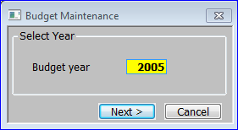

Figure 53: Budget Maintenance Window

|  |  |
| --- | --- |
|  | This window is displayed when you:   * Select Budget Maintenance from the System Maintenance Menu. * Select [Change year] from the Budgets for Year window *(See page 103).* |
| Purpose | This window enables you to enter the year whose budgets you want to enter or amend. |

Select Year

|  |  |
| --- | --- |
| Budget year | Enter the year whose budgets you want to enter or amend. |
| On completion | ⇒ Budgets for Year window *(See page 103).* |

|  |  |
| --- | --- |
|  |  |

#### Budgets for Year

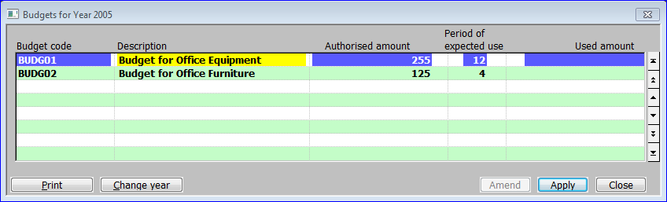

Figure 54: Budgets for Year Window

|  |  |
| --- | --- |
|  | This window is displayed when you enter a year in the Budget Maintenance window *(See page 102).* |
| Purpose | This window lists budgets that have already been defined for the selected year, and it enables you to add new budgets for the year, and to amend and delete existing ones. |

The prompts are:

|  |  |
| --- | --- |
| Budget code | Enter up to 15 characters to uniquely identify the budget within the year. |
| Description | Enter a description in up to 30 characters. |
| Authorised amount | Enter the budget value. |
| Period of expected use | Enter one of the following:   * The period in the selected year in which you expect the budget to be used. |
|  | * The number of periods in the financial year in which you expect the budget to be used. You cannot enter a number greater than the number of periods in the financial year. |
|  | * Leave blank. |
| Note | The ‘periods of expected use’ are entered for information only. |
| Used amount | *(Display only.)* Asset Register automatically increases this figure by the value of any assets with this budget code, which are added in the selected year, and by the value of any subsequent additions to these assets in the selected year. |
| On completion | ⇒ Next line in window. |

*Application Buttons*

|  |  |
| --- | --- |
| Print | Print details of a range of budgets.  Print Budgets for Year window *(See page 104).* |
| Change year | Change the year whose budgets you want to enter or amend. ⇒ Budget Maintenance window *(See page 102).* |

#### Print Budgets for Year

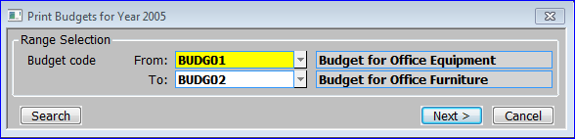

Figure 55: Print Budgets for Year Window

|  |  |
| --- | --- |
|  | This window is displayed when you select [Print] from the Budgets for Year window *(See page 103).* |
| Purpose | This window enables you to specify a year and a range of budgets to print. |
| Printed example | For a printed example of this report, see page 158 of the Sample Reports Section. |

Range Selection

|  |  |
| --- | --- |
| Budget code From: | Enter the code of the first budget you want to print. A [Search] is available. ⇒ Select Budget for Year window *(See page 104).* |
| To: | Enter the code of the last budget you want to print. A [Search] is available. ⇒ Select Budget for Year window *(See page 104).* |
| On confirmation | ⇒ Print options window. |

#### Budget Code Search

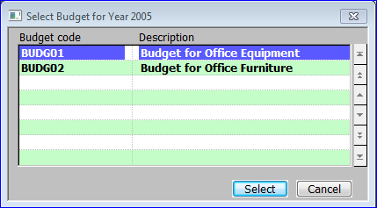

Figure 56: Select Budget Code

|  |  |
| --- | --- |
|  | This window is displayed when a [Search] is done at the Print Budgets for Year window *(See page 104).* |
| Purpose | This search window lists relevant budget codes for the selected year. |

**Budget code** *(Display Only)*

|  |  |
| --- | --- |
| **Budget code** | A unique code for the budget. |
| **Description** | A description of the budget. |

**Application Buttons**

|  |  |
| --- | --- |
| **Select** | Return the selected budget code  Print Budgets for Year window *(See page 104)*. |
| **Cancel** | Return to Print Budgets for Year window *(See page 104)*, but without returning the selected budget code. |

### Asset Data Load

|  |  |
| --- | --- |
| Introduction | The Asset Data Load option is used for the initial input and amendment of asset details when setting up a new system. This option enables the brought forward and year to date figures to be set up for each asset. |
|  | A new asset can be created by copying an existing asset. Any asset can be used as a template in this way, although assets can be defined purely for this purpose by giving them ‘template’ status. |
|  | Unlike the Asset Maintenance option, which you use to enter and amend asset details when the system is up and running, Asset Data Load does not create transactions, and hence it does not generate any postings in General Ledger. |
| Note | All values you enter must be compatible with the decimal precision specified for your company base currency. |

|  |  |
| --- | --- |
| Note | Do not use this option for the entering and amending assets after your system is up and running; use the Asset Maintenance option instead. |

#### General Details

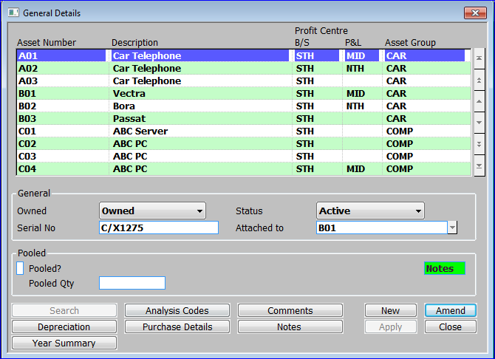

Figure 57: General Details Window

|  |  |
| --- | --- |
|  | This window is displayed when you select Asset Data Load from the Asset Register System maintenance menu. |
| Purpose | This window lists existing assets, and it enables you to enter new assets, and to select assets for amendment and deletion.  This window is divided into 3 sections with application buttons:   * Assets. * General. * Pooled. |

Assets:

|  |  |
| --- | --- |
| Asset number | If you are creating a new asset, enter a unique code for the asset in up to 15 characters.  Select Template Asset window *(See page 108).* |
| Note | If you are creating a new asset with a template, the remaining items in this and the other Asset Data Load windows default to the values on the asset used as a template.  If you are creating a new asset without a template, many items in this and the other Asset Data Load windows default to the values held for the asset group. |
| Description | Enter a description of the asset in up to 30 characters. |
| Profit Centres B/S | *(Only when creating a new asset.)* Enter the code of the profit centre in the balance sheet against which the asset value is recorded. A [Search] is available. ⇒ Profit Centre Search window *(See page 138).* |
| P&L | Enter the code of the profit centre used when posting GL journals for asset transactions that impact on the profit and loss statement. Leave blank to use the same profit centre as balance sheet postings. A [Search] is available. ⇒ Profit Centre Search window *(See page 138).* |
| Asset group | *(Only when creating a new asset.)* Enter the code of the asset group to which this asset belongs. A [Search] is available. ⇒ Asset Group Search window *(See page 137)*.  If the specified asset group is password-protected, you are prompted for the password. |
| Note | You can transfer assets between profit centres and asset groups using the Asset Transfer option of Transaction Entry. |

*General*

|  |  |
| --- | --- |
| Owned | *(Only when creating a new asset.)* This prompt records the ownership of the asset. Select from a drop down menu:   * Finance Lease. * Lease. * Non-capitalised * Owned. |
| Note | The ownership of an asset does not affect the way it is treated for depreciation and the generation of transactions within Asset Register. However only owned assets and those on finance lease generate postings to General Ledger. |
| Status | *(Only when setting up a new asset.)* This prompt records the status of the asset. Select from a drop don menu. |
|  | * **Active**: These assets are included in depreciation runs and group revaluations and there is no restriction on entering transactions for them. |
|  | * **Disposed**: These assets have been disposed of, but are retained for historical purposes. They are excluded from all depreciation runs and group revaluations, and you cannot enter transactions for them via Transaction Entry. |
|  | * **Mothballed**: These assets are excluded from all depreciation runs, until they are removed from mothballs via Transaction Entry. However, they are included in group revaluations and you can enter transactions (including depreciation adjustments) for them via Transaction Entry. |
|  | * **Template**: These assets are only used as templates when setting up new assets. They are ignored by the depreciation run and group revaluation programs, and you cannot enter transactions for them via Transaction Entry. |
| *Reference field 1* | Enter a reference in up to 20 characters. This is the first of up to 5 reference fields established in the Asset Register Parameters – Reference Fields window *(See page 88).* |
| Note | If you are using this reference field for transaction analysis in General Ledger, it is the first eight characters that are passed to General Ledger as the transaction analysis code. |
| Attached to | This prompt enables you to attach the selected asset to another asset. You use this feature to link one asset to another; for example to attach a car phone to the car it belongs to. The assets retain their individual identities and can be depreciated in different ways. |
|  | Enter the number of the asset to which this asset is attached. Both assets must belong to the same profit centre. A [Search] is available. ⇒ Asset Search window *(See page 136).*  Leave blank if this is not an attached asset. |
| Note | You cannot attach an asset, which has attachments, and you cannot attach an asset to another asset, which is itself, an attachment. For example, you can attach a car phone to a car, and you can attach a car stereo to the same car. But once these attachments are made, you cannot attach the car stereo to the car phone. Nor can you attach the car to any other asset. |

*Pooled*

|  |  |
| --- | --- |
| Pooled? | ✓ if the asset is a pooled asset; i.e. a collection of a number of identical items such as desks or chairs. Otherwise leave blank. |
| Pooled Qty | *(Only for pooled assets.)* Enter the number of pooled items that make up this asset. |

*Application Buttons*

|  |  |
| --- | --- |
| Analysis codes | Enter and amend the details held for the asset in the user-defined analysis code, date, value and reference fields.  Analysis Codes window *(See page 114).* |
| Comments | Enter and amend free-form comments for the asset.  Comments window *(See page 117).* |
| Depreciation | Enter and amend the asset’s purchase details ⇒ Depreciation Details window. *(See page 110).* |
| *Note* | *If tax depreciation is selected in System Parameters, this window is followed by the Tax Depreciation Details Window.* |
| Purchase Details | Enter and amend the asset’s purchase details. ⇒ Purchase Details window *(See page 109).* |
| Notes | *(Only if the extension database is enabled)* Enter and amend free-form notes for the asset.  Asset Notes window *(See page 145).* |
| Year Summary | Enter and amend the asset’s brought forward and year to date figures.  Brought Forward/Year to Date Values window *(See page 115).* |
| On completion | *If you are creating a new asset*  Purchase Details window *(See page 109).* |

#### Select Template Asset

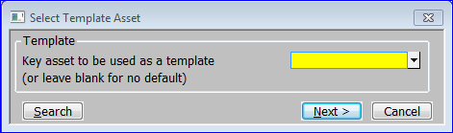

**Figure 58: Select Template Asset Window**

|  |  |
| --- | --- |
|  | This window is displayed when you enter a new asset code in the General Details window *(See page 106).* |
| Purpose | This window enables you to specify the code of an existing asset to use as a template for the new asset. You can then tailor the details by stepping through the prompts in the Asset Data Load windows amending items as necessary. This can save time when adding a series of similar assets. |
| Note | You can create assets to just use as templates when creating other assets. You do this by setting the status to ‘template’. |

Template

|  |  |
| --- | --- |
| Key asset to be used as a template | Enter the code of a similar asset to use as a template, A [Search] is available ⇒ Asset Search window *(See page 136)*. |
|  | Leave blank if you do not want to use a template. |
| On completion | ⇒ Description prompt in the General Details window *(See page 106).* |

#### Purchase Details

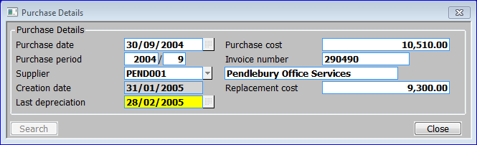

Figure 59: Purchase Details Window

|  |  |
| --- | --- |
|  | This window is displayed when you do one of the following:  Complete your replies in the General Details window (See page 106) when creating a new asset.  Select [Purchase Details] from the General Details window (See page 106). |
| Purpose | This window enables you to enter and amend the asset’s purchase details. |

Purchase Details:

|  |  |
| --- | --- |
| Purchase date | Enter the date the asset was purchased. Asset Register uses this date to determine the date depreciation is to start from. |
| Note | How Asset Register determines the depreciation start date varies according to the settings in the Depreciation Date window of System Parameters. *(See page 84).* |
| Purchase cost | Enter the purchase cost of the asset. This can be zero on a template asset or when the zero purchase costs for assets parameter flag is set to “Yes” or “Prompt” in System Parameters, Asset Register, Operating Options *(See page 93).* |
| Purchase period | *(Display only.)* The financial period in which the asset was purchased. |
| Invoice number | Enter the invoice reference associated with the purchase. This can be left blank. |
| Supplier | Enter up to 10 characters to identify the supplier from whom the asset was purchased. If Creditors Ledger is in use, a [Search] is available giving a full list of suppliers. The supplier’s description is then also displayed. |
| Creation date | *(Display only.)* The date the asset was created in Asset Register. |
| Replacement cost | Enter the cost of replacing this asset. |
| Date of last depreciation | The date the asset was last depreciated. When creating a new asset, the default is the last day of the period prior to the date of purchase. |
| On completion | If you are creating a new asset  Depreciation Details Window *(See page 110)*.  Otherwise  General Details window *(See page 106).* |

#### Depreciation Details

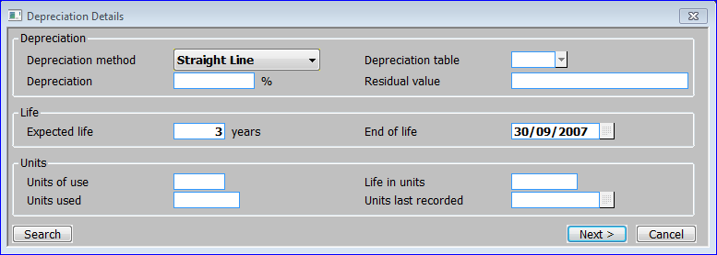

**Figure 60: Depreciation Details Window**

|  |  |
| --- | --- |
|  | This window is displayed when you do one of the following:  Complete your replies in the Purchase Details window (See page 107) when creating a new asset.  Select [Depreciation] from the General Details window (See page 104). |
| Purpose | This window enables you to enter and amend the asset’s depreciation details.  This window is divided into three sections:   * Depreciation. * Life. * Units. |

Depreciation

|  |  |
| --- | --- |
| Depreciation method | *(Only when creating a new asset.)* Enter the method of calculating depreciation to be used for this asset. Select from a drop down menu. |
|  | * **Period Reducing**: The depreciation is calculated by reducing the current written down value by the depreciation percentage divided by the number of periods in the year. |
|  | * **Straight Line**: The depreciation of the asset is calculated by taking the current written down value and depreciating it evenly over the remaining life of the asset. |
|  | * **Table**: The cumulative depreciation percentage for each period in the life of the asset is defined in a table. This method provides considerable flexibility as you can vary the rates of depreciation for different years. |
|  | * **Usage**: The asset is depreciated in line with the proportion of units used to those in the full life of the asset. Units may be expressed in hours, miles etc. In this method the user is required to enter the number of units used in each period. |
|  | * **Year Reducing**: This is similar to the period reducing balance, but the depreciation percentage is applied to the written down value at the start of the year. As a result the depreciation amounts are constant throughout the year. |
| Further information | For further information about depreciation methods, see page 13 of the Overview. |
| Depreciation table | *(Only if the depreciation method is* ***Table****.)* Enter the code of the depreciation table to be used for calculating the depreciation of this asset. A [Search] is available. ⇒ Depreciation Table Search window *(See page 142)*. |
| Note | You define depreciation tables via Depreciation Table Maintenance. For further information, see page 94. |
| Depreciation % | *(Only if the depreciation method is P****eriod Reducing*** *or* ***Year Reducing****.)* Enter the percentage depreciation to be applied to this asset each year. A zero percentage indicates that the asset is not depreciated. |
| Residual value | The residual value of the asset. Depreciation calculations do not allow the written down value to be reduced below the asset’s residual value. |

Life

|  |  |
| --- | --- |
| Expected life (years) | Enter the number of years the asset is expected to be used for, before disposal. |
| End of life | The date you expect the asset’s life to end. This defaults to the purchase date plus the ‘expected life’. |

*Units*

|  |  |
| --- | --- |
| Units of use | *(Only if the* *depreciation method is* ***usage****.)* Enter the unit of measure used in depreciation calculations for this asset, e.g. years, hours, miles, etc. |
| Life in units | *(Only if the* *depreciation method is* ***usage****.)* Enter the expected number of units in the life of this asset. |
| Units used | *(Only if the* *depreciation method is* ***usage****.)* Enter the number of units used so far. |
| Units last recorded | The date the number of units used was last recorded. When entering an asset, this defaults to today’s date. |
| On completion | *If tax depreciation is selected in System Parameters* (Tax Depreciation window *(See page 90*))  Tax Depreciation Details window *(See page 113).*  *Otherwise*:   * If you are creating a new asset  Analysis Codes window *(See page 114).* * If you are amending an existing asset  General Details window *(See page 106).* |

#### Tax Depreciation Details

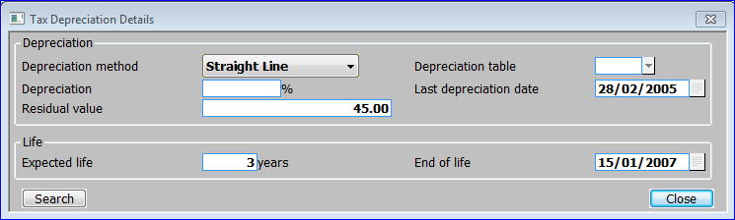

**Figure 61: Tax Depreciation Details Window**

|  |  |
| --- | --- |
|  | This window is displayed when you complete your replies in the Depreciation Details window *(See page 110).* |
| Note | This window is only available if tax depreciation is selected in System Parameters. |
| Purpose | This window enables you to enter and amend the depreciation details for the asset for tax purposes.  Tis window is divided into two sections:   * Depreciation. * Life. |

Depreciation

|  |  |
| --- | --- |
| Depreciation method | Enter the tax depreciation method for this asset. These are the same as those described on page 111 for the ‘Depreciation method’ prompt in the Depreciation Details window *(See page 110)*. Select from a drop down menu: |
|  | * Period Reducing. * Straight Line. * Table. * Usage. * Year Reducing**.** |
|  |
|  |
| Depreciation table | *(Only if the tax depreciation method is T****able****.)* Enter the code of the depreciation table for calculating the depreciation of this asset for tax purposes. A [Search] is available. ⇒ Depreciation Table Search window *(See page 142)*. |
| Depreciation % | *(Only if the tax depreciation method is* ***period*** *or* ***year reducing******balance****.)* Enter the percentage depreciation percentage to be applied to this asset each year when calculating depreciation for tax purposes. A zero percentage indicates that the asset is not depreciated. |
| Last depreciation date | The date the asset was last depreciated. |
| Residual value | The residual value of the asset. Depreciation calculations do not allow the written down value to be reduced below the asset’s residual value. |

Life

|  |  |
| --- | --- |
| Expected life | Enter the asset’s expected life span for tax purposes in years. |
| End of life | Enter the date you expect the life of the asset to end for tax purposes. This defaults to the purchase date plus the ‘expected life’ entered above. |
| On completion | * If you are creating a new asset  Analysis Codes window *(See page 114).* * If you are amending an existing asset  General Details window *(See page 106)*. |

#### Analysis Codes

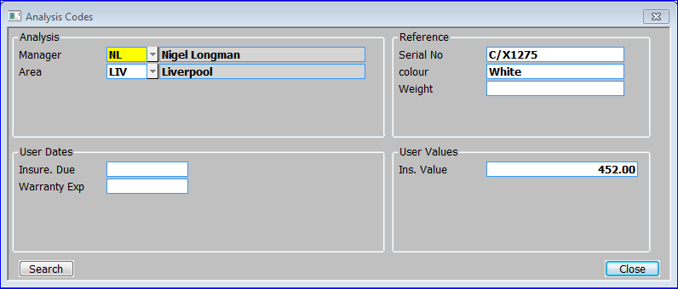

**Figure 62: Analysis Codes Window**

|  |  |
| --- | --- |
|  | This window is displayed when you do one of the following:   * Complete your replies in the Depreciation Details window (See page 109) when creating a new asset. * Select [Analysis Codes] from the General Details window (See page 106). |
| Purpose | This window enables you to enter and amend the details held for the asset in the user-defined analysis code, date, value and reference fields. These codes and values are used primarily for grouping assets together for enquiries and reports.  This window is divided into four sections:   * Analysis. * Reference. * User Dates. * User Values. |

Analysis

|  |  |
| --- | --- |
|  | There are up to five prompts for analysis codes. The names of these prompts are determined by the titles entered for the five sets of analysis codes in System Parameters – Analysis Codes *(See page 80).* In Figure62, the prompts are ‘Manager’, and ‘Area’; the third, fourth and fifth sets of analysis codes not being used. |

*Reference*

|  |  |
| --- | --- |
|  | There are up to five prompts for user-defined reference fields. The names of these prompts are determined by the titles entered for the five sets of user-defined reference fields in System Parameters – Reference Fields. In Figure 62, the prompts are ‘Serial no.’, ‘Colour’ and ‘Weight’; the fourth and fifth reference fields not being used. |
| Note | If you are using any of the reference fields for transaction analysis in General Ledger, it is the first eight characters in the relevant prompt that are passed to General Ledger as the transaction analysis code. For further information, see page 87. |

*User Dates*

|  |  |
| --- | --- |
|  | There are up to five prompts for dates. The names of these prompts are determined by the titles entered for the five sets of user-defined dates in System Parameters – User Defined Dates *(See page 91).* In Figure 62, the prompts are ‘Insure. Due’, and ‘Warranty Exp’, the third, fourth and fifth dates not being used. |

*User Values*

|  |  |
| --- | --- |
|  | There are up to five prompts for values. The names of these prompts are determined by the titles entered for the five sets of user-defined values in System Parameters – User Defined Values *(See page 92).* In Figure 62, only one value prompt is used, it is ‘Ins Value’. |
| On completion | *If you are creating a new asset*  Year to Date Summary window *(See page 115).*  *Otherwise*  General Details window *(See page 106).* |

#### Year to Date Summary

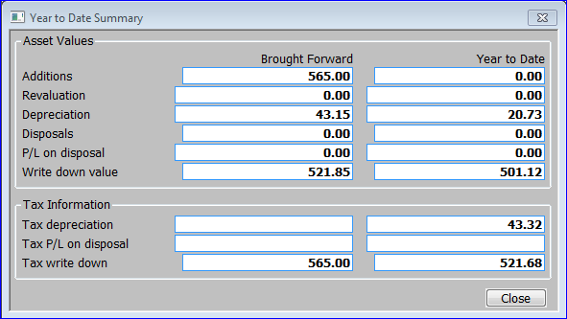

**Figure 63: Year to Date Summary Window**

|  |  |
| --- | --- |
|  | This window is displayed when you do one of the following:   * Complete your replies in the Analysis Codes window (See page 114) when creating a new asset. * Select [Year Summary] from the General Details window (See page 106). |
| Purpose | This window enables you to enter the brought forward and year to date figures for new assets during the initial set-up of Asset Register.  This window is divided into two sections:   * Asset Values. * Tax Information. |

*Asset Values*

|  |  |  |  |
| --- | --- | --- | --- |
| Brought forward | | Enter the brought forward value (i.e. the balance brought forward from the end of the last year) for each of the following: | |
|  | | * Additions. | |
|  | | * Revaluation. | |
|  | | * Depreciation. | |
|  | | * Disposals. | |
|  | | * P/L on disposal. | |
|  | | * Write down value. | |
| Year to date | | Enter the equivalent figures for the year to date; i.e. the current year’s values. | |

*Tax Information*

|  |  |
| --- | --- |
| **Brought forward** | If tax depreciation is enabled in System Parameters Tax Depreciation *(See page 90).*  Enter the brought forward value (i.e. the balance brought forward from the end of the last year) for each of the following:   * Tax depreciation. |
|  | * Tax profit and loss on disposal. |
|  | * Tax written down value. |
| Year to date | Enter the equivalent figures for the year to date; i.e. the current year’s values. |
| On completion | ⇒ General Details window *(See page 106).* |

|  |  |
| --- | --- |
|  |  |

#### Comments

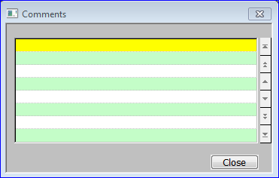

**Figure 64: Comments Window**

|  |  |
| --- | --- |
|  | This window is displayed when you select [Comments] from the General Details window (See page 106). |
| Purpose | This window enables you to view and record free-form comments for the asset. |
|  | You can enter an unlimited number of lines of up to 40 characters each. |
| On exit | ⇒ General Details window *(See page 106).* |

### Group Revaluation

|  |  |
| --- | --- |
| Introduction | This program enables the whole of a group of assets to be revalued by a percentage. Only active and mothballed assets in the group are revalued. This option is typically used to allow for currency variations in countries where such revaluations are permitted. |
| Note | Assets can be revalued individually via the Transaction Entry program. |

#### Revalue Asset Group

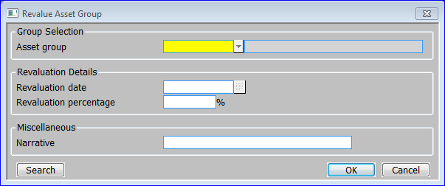

Figure 65: Revalue Asset Group Window

|  |  |
| --- | --- |
|  | This window is displayed when you select Group Revaluation from the System Maintenance Menu. |
| Purpose | This window enables you to enter criteria for the revaluation.  This window is divided into three sections:   * Group Selection. * Revaluation Details. * Miscellaneous. |

Group Selection

|  |  |
| --- | --- |
| Asset group | Enter the code of the asset group you want to revalue. A [Search] is available. ⇒ Asset Group Search window *(See page 137).* The asset group description is then displayed. |

Revaluation Details

|  |  |
| --- | --- |
| Revaluation date | The date for this revaluation. |
| Revaluation percentage | The percentage by which you want to revalue the assets in the group. If you enter a negative value, the assets are devalued. |

Miscellaneous

|  |  |
| --- | --- |
| Narrative | Enter up to 30 characters of narrative. |
| On confirmation | The asset group is revalued. On completion  System Maintenance Menu. |

Section Seven:

## Enquiries



Contents

120 Asset Enquiry

This program lists on the screen all the assets that have been defined. By selecting an asset you can view its attachments, comments, depreciation details, tax depreciation details, analysis codes and user-defined reference fields, brought forward and year to date figures, and its transaction details.

### Asset Enquiry

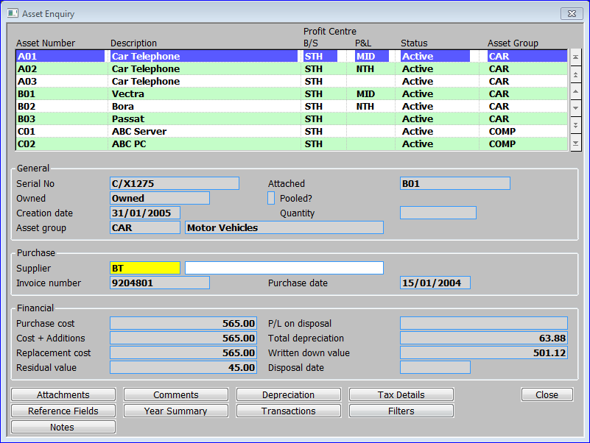

Figure 66: Asset Enquiry Window

|  |  |
| --- | --- |
|  | This window is displayed when you select Enquiries from the Asset Register Main Menu. |
| Purpose | This window lists existing assets, and it enables you to select an asset for more detailed enquiries.  This window is divided into four sections with application buttons:   * Assets. * General. * Purchase. * Financial. |

Assets:

|  |  |
| --- | --- |
| Asset Number | The unique code for the asset in up to 15 characters. |
| Description | The description of the asset in up to 30 characters. |
| Profit Centres B/S | The code of the profit centre in the balance sheet against which the asset value is recorded. |
| P&L | The code of the profit centre used when posting GL journals for asset transactions that impact on the profit and loss statement. Blank if the asset is set to use the same profit centre as balance sheet postings. |
| Status | The status of the asset. This can be one of the following: |
|  | * **Active**: These assets are included in depreciation runs and group revaluations and there is no restriction on entering transactions for them. |
|  | * **Disposed**: These assets have been disposed of, but are retained for historical purposes. They are excluded from all depreciation runs and group revaluations, and you cannot enter transactions for them via Transaction Entry. |
|  | * **Mothballed**: These assets are excluded from all depreciation runs, until they are removed from mothballs via Transaction Entry. However, they are included in group revaluations and you can enter transactions (including depreciation adjustments) for them via Transaction Entry. |
|  | * **Template**: These assets are only used as templates when setting up new assets. They are ignored by the depreciation run and group revaluation programs, and you cannot enter transactions for them via Transaction Entry. |
| **Asset Group** | The code of the asset group to which this asset belongs. |

*General*

|  |  |
| --- | --- |
| *Reference field 1* | Enter a reference in up to 20 characters. This is the first of up to 5 reference fields established in the Asset Register Parameters – Reference Fields window *(See page 88).* |
| Owned | The ownership of the asset. It can be one of the following: |
|  | * Finance Lease. |
|  | * Lease. |
|  | * Non-capitalised. |
|  | * Owned. |
| **Creation Date** | The date the asset was created in Asset Register. |
| **Asset Group** | The code of the asset group to which this asset belongs, followed by its long description. |
| **Attached** | If this asset is attached to another asset, that assets number. |
| Pooled? | ✓ed if the asset is a pooled asset; i.e. a collection of a number of identical items such as desks or chairs. |
| Quantity | *(Only for pooled assets.)* The number of pooled items that make up this asset. |

*Purchase*

|  |  |
| --- | --- |
| Supplier | 10 characters used to identify the supplier from whom the asset was purchased. If Creditors Ledger is in use, this can be the suppliers account code, in which case the suppliers account name is then also displayed. |
| Invoice number | The optional invoice reference associated with the purchase. |
| **Purchase date** | The date the asset was purchased. |

*Financial*

|  |  |
| --- | --- |
| **Purchase cost** | The purchase cost of the asset. |
| **Cost + Additions** | The purchase cost of the asset plus any additions. |
| **Replacement cost** | The cost of replacing the asset. |
| **Residual value** | The residual value of the asset. Depreciation calculations do not allow the written down value to be reduced below the asset’s residual value. |
| **P/L on disposal** | The profit/loss calculated if the asset has been disposed of. |
| **Total depreciation** | The total of the depreciation deducted from the value of the asset. |
| **Written down value** | The written down value of the asset. |
| **Disposal date** | If the asset has been disposed of the, the date entered for its disposal. |

*Application Buttons*

|  |  |
| --- | --- |
| **Attachments** | View the selected asset’s attachments. ⇒ Attachments window *(See page 122).* |
| **Comments** | View the selected asset’s extended comments. ⇒ Comments window *(See page 123).* |
| **Depreciation** | View the selected asset’s depreciation details. ⇒ Depreciation Details window *(See page 124).* |
| **Tax details** | (Only if tax depreciation is selected in System Parameters Tax Depreciation *(See page 88)*.) View the selected asset’s tax depreciation details. ⇒ Tax Details window *(See page 125).* |
| **Reference fields** | View the analysis codes, and user-defined dates, references and values associated with the selected asset. ⇒ Reference Fields window *(See page* *126).* |
| **Year Summary** | View the selected asset’s brought forward and year to date values. ⇒ Year to Date Summary window *(See page* *127).* |
| **Transactions** | View details of the selected asset’s transactions. ⇒ Transactions window *(See page 128).* |
| **Filters** | Set up Filters to determine which assets are displayed in the asset enquiries ⇒ Asset Enquiry Filters window *(See page 132).* |
| Notes | *(Only if the extension database is enabled).* Enter and amend free-form notes for the asset.  Asset Notes window *(See page 145).* |
| On exit | ⇒ Asset Register Main Menu. |

#### Attachments

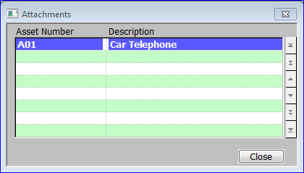

Figure 67: Attachments Window

|  |  |
| --- | --- |
|  | This window is displayed when you select [Attachments] from the Asset Enquiry window *(See page 120).* |
| Purpose | This window displays the code and description of any assets, which are attached to the asset, which is the subject of your enquiry. |
| On exit | ⇒ Asset Enquiry window *(See page 120)*. |

#### Comments

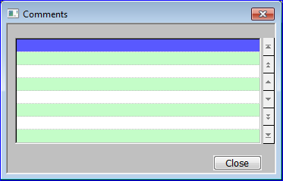

Figure 68: Comments Window

|  |  |
| --- | --- |
|  | This window is displayed when you select [Attachments] from the Asset Enquiry window *(See page 120).* |
| Purpose | This window displays any comments, which have been attached to the selected asset. |
| On exit | ⇒ Asset Enquiry window *(See page 120)*. |

|  |  |
| --- | --- |
|  |  |

#### Depreciation Details

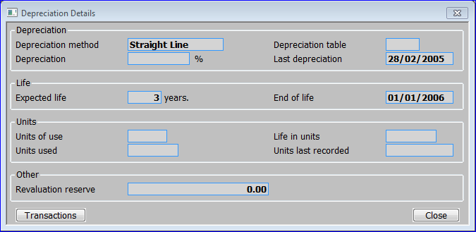

Figure 69: Depreciation Details Window

|  |  |
| --- | --- |
|  | This window is displayed when you select [Depreciation] from the Asset Enquiry window *(See page 120).* |
| Purpose | This window displays the depreciation details for the selected asset. |
|  | This window is divided into four sections with a an application button:   * Depreciation. * Life. * Units. * Other. |

*Depreciation*

|  |  |
| --- | --- |
| Depreciation method | The method of calculating depreciation selected for use by this asset. It can be one of the following. |
|  | * **Period Reducing**: The depreciation is calculated by reducing the current written down value by the depreciation percentage divided by the number of periods in the year |
|  | * **Straight Line**: The depreciation of the asset is calculated by taking the current written down value and depreciating it evenly over the remaining life of the asset. |
|  | * **Table**: The cumulative depreciation percentage for each period in the life of the asset is defined in a table. This method provides considerable flexibility as you can vary the rates of depreciation for different years. |
|  | * **Usage**: The asset is depreciated in line with the proportion of units used to those in the full life of the asset. Units may be expressed in hours, miles etc. In this method the user is required to enter the number of units used in each period |
|  | * **Year Reducing**: This is similar to the period reducing balance, but the depreciation percentage is applied to the written down value at the start of the year. As a result the depreciation amounts are constant throughout the year. |
| Depreciation table | *(Only if the depreciation method is* ***Table****.)* The code of the depreciation table to be used for calculating the depreciation of this asset. |
| Depreciation % | *(Only if the depreciation method is P****eriod Reducing*** *or* ***Year Reducing****.)* The percentage depreciation to be applied to this asset each year. A zero percentage indicates that the asset is not depreciated. |
| Last depreciation | The date of the most recent depreciation of the transaction. |

*Application button*

|  |  |
| --- | --- |
| Transactions | Display details of the selected asset’s depreciation transactions.  Depreciation Transactions window *(See page 131).* |
| On exit | ⇒ Asset Enquiry window *(See page 120)*. |

#### Tax Details

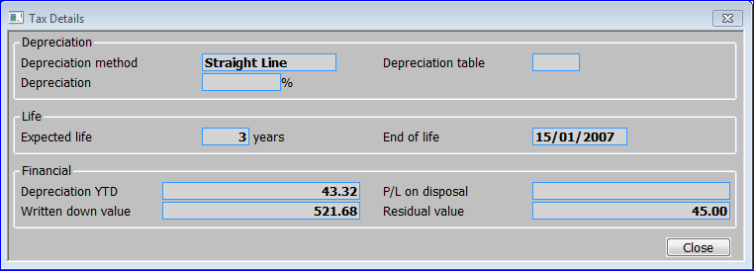

**Figure 70: Tax Details Window**

|  |  |
| --- | --- |
|  | This window is displayed when you select [Tax Details] from the Asset Enquiry window *(See page 120).* |

|  |  |
| --- | --- |
| Note | This window is only available if tax depreciation is selected in System Parameters. |
| Purpose | This window displays the tax depreciation details of the selected asset. |
|  | This window is divided into three sections:   * Depreciation. * Life. * Financial. |

*Depreciation*

|  |  |
| --- | --- |
| **Depreciation method** | The method of calculating tax depreciation selected for use by this asset. These are the same as the normal depreciation methods:   * Period Reducing. * Straight Line. * Table. * Usage. * Year Reducing. |
| **Depreciation table** | (Only if the depreciation method is Table.) The code of the depreciation table to be used for calculating the depreciation of this asset. |
| **Depreciation %** | (Only if the depreciation method is Period Reducing or Year Reducing.) The percentage depreciation to be applied to this asset each year. A zero percentage indicates that the asset is not depreciated. |
| On exit | ⇒ Asset Enquiry window *(See page 120)*. |

#### Reference Fields

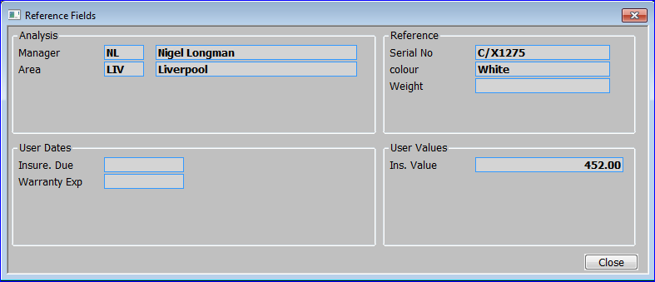

Figure 71: Reference Fields Window

|  |  |
| --- | --- |
|  | This window is displayed when you select [Reference Fields] from the Asset Enquiry window *(See page 120).* |
| Purpose | This window displays the analysis codes, and user-defined dates, references and values associated with the selected asset. These codes and values are used primarily for grouping assets together for enquiries and reports.  This window is divided into four sections:   * Analysis. * Reference. * User Dates. * User Values. |

Analysis

|  |  |
| --- | --- |
|  | There are up to five analysis codes. The names of these values are determined by the titles entered for the five sets of analysis codes in System Parameters – Analysis Codes *(See page 80).* In Figure 71: Reference Fields Window, the prompts are ‘Manager’, and ‘Area’; the third, fourth and fifth sets of analysis codes not being used. |

*Reference*

|  |  |
| --- | --- |
|  | There are up to five user-defined reference fields. The names of these values are determined by the titles entered for the five sets of user-defined reference fields in System Parameters – Reference Fields. In Figure 71: Reference Fields Window, the prompts are ‘Serial no.’, ‘Colour’ and ‘Weight’; the fourth and fifth reference fields not being used. |

*User Dates*

|  |  |
| --- | --- |
|  | There are up to five dates. The names of these dates are determined by the titles entered for the five sets of user-defined dates in System Parameters – User Defined Dates *(See page 91).* In Figure 71 Reference Fields Window, the prompts are ‘Insure. Due’, and ‘Warranty Exp’, the third, fourth and fifth dates not being used. |

*User Values*

|  |  |
| --- | --- |
|  | There are up to five values. The names of these values are determined by the titles entered for the five sets of user-defined values in System Parameters – User Defined Values *(See page 92).* In Figure 71: Reference Fields Window, only one value prompt is used, it is ‘Ins Value’. |
| On exit | ⇒ Asset Enquiry window *(See page 120)*. |

#### Year to Date Summary

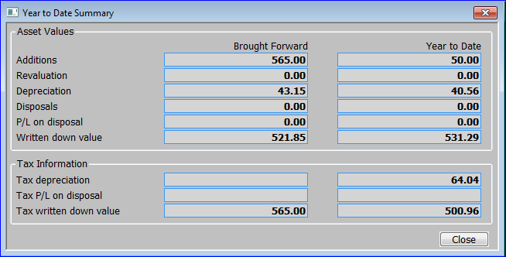

Figure 72: Year to Date Summary Window

|  |  |
| --- | --- |
|  | This window is displayed when you select [Year Summary] from the Asset Enquiry window *(See page 120).* |
| Purpose | This window displays the brought forward figures and year to date figures for the selected asset.  The window is divided into two sections:   * Asset Values. * Tax Information. |

*Asset Values*

|  |  |  |  |  |  |
| --- | --- | --- | --- | --- | --- |
| Brought forward | | | The brought forward value (i.e. the balance brought forward from the end of the last year) for each of the following: | | |
|  | | | * Additions. | | |
|  | | | * Revaluation. | | |
|  | | | * Depreciation. | | |
|  | | | * Disposals. | | |
|  | | | * P/L on disposal. | | |
|  | | | * Written down value. | | |
| Year to date | | | The equivalent figures for the year to date; i.e. the current year’s values. | | |

*Tax Information*

|  |  |
| --- | --- |
| **Brought forward** | Only if tax depreciation is enabled in System Parameters Tax Depreciation *(See page 90).*  The brought forward value (i.e. the balance brought forward from the end of the last year) for each of the following:   * Tax depreciation. |
|  | * Tax profit and loss on disposal. |
|  | * Tax written down value. |
| Year to date | Enter the equivalent figures for the year to date; i.e. the current year’s values. |
| On exit | ⇒ Asset Enquiry window *(See page 120)*. |

#### Transactions

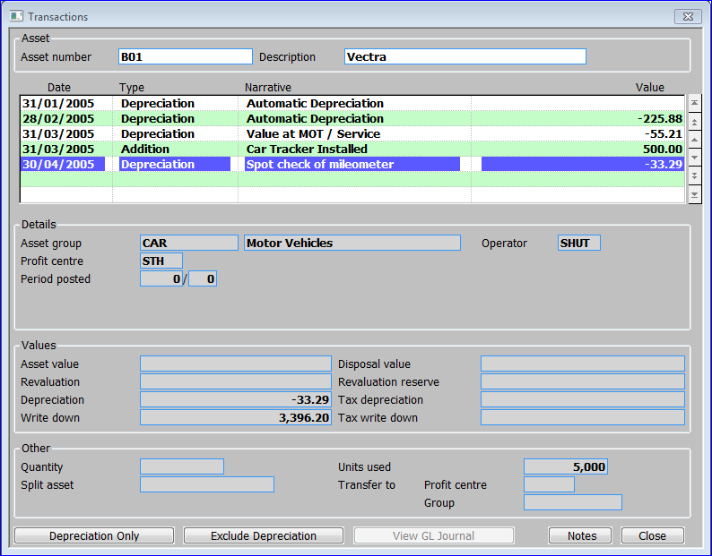

Figure 73: Transactions Window

|  |  |
| --- | --- |
|  | This window is displayed when you select [Transactions] from the Asset Enquiry window *(See page 120).* |
| Purpose | This window lists all the transactions that exist for the selected asset. The window is divided into five sections with application buttons:   * Asset. * Transactions. * Details. * Value. * Other. |

*Asset*

|  |  |
| --- | --- |
| Asset Number | The unique code for the asset in up to 15 characters. |
| Description | The description of the asset in up to 30 characters. |

*Transactions*

|  |  |
| --- | --- |
| Date | The date of the transaction. |
| Type | The transaction type.  This can be one of the following:   * Addition. * Adjustment. * Depreciation. * Disposal. * Revalue. * Split. * Transfer. * Units. |
| Narrative | The narrative entered for the transaction. |
| *Note* | For transactions generated by a Depreciation run, this is set to ‘Automatic Depreciation.’ |
| Value | The Value of the transaction. |

*Details*

|  |  |
| --- | --- |
| **Asset Group** | The code of the asset group to which this asset belongs, followed by its long description. |
| *Note* | For asset transfers this is the original asset group. See the Other section for the new asset group. |
| **Operator** | The ID of the operator who entered the transaction / ran the depreciation run. |
| **Profit centre** | The profit centre which the transaction belongs to. |
| *Note* | For asset transfers this is the originating profit centre. See the Other section for the destination. |
| **Period posted** | The financial period and year in which the transaction occurred. |
| **Customer** | *(Disposal transactions only).* The customer code. |
| *Note* | If Debtors Ledger is configured and this code matches a valid customer code, the account name is also displayed. |
| **Supplier** | *(Addition transactions only).* The supplier code. |
| *Note* | If Creditors Ledger is configured and this code matches a valid supplier code, the account name is also displayed. |
| **Invoice** | *(Addition / Disposal transactions only).* The invoice number entered. |

*Value*

|  |  |
| --- | --- |
| **Asset value** | The changes in the value of the asset. |
| **Revaluation** | *(Revaluation transactions only).* The value that the asset has been revalued by. |
| **Depreciation** | The amount the transaction was depreciated by*.* |
| **Write down** | The new written dowqn value of the transaction. |
| **Disposal value** | *(Disposal transactions only).* The amount the asset was disposed of for. |
| **Revaluation reserve** |  |
|  | The following two displays are only shown if tax depreciation is enabled in System Parameters Tax Depreciation *(See page 90).* |
| **Tax depreciation** | The amount the transaction was depreciated by for tax purposes. |
| **Tax write down** | The new written down value of the transaction for tax purposes. |

*Other*

|  |  |
| --- | --- |
| **Quantity** | The number of units for the transaction. |
| **Split asset** | (Split transactions only). The asset code that was split off. |
| **Units used** | *(Only transactions depreciated by the usage method).* The number of units by which the asset was depreciated. |
| **Transfer to** |  |
| **Profit centre** | *(Transfer transactions only).* Only if the profit centre changed. The profit centre the asset was transferred to. |
| **Group** | *(Transfer transactions only).* Only if the asset group changed. The asset group the asset was transferred to. |
| On exit | ⇒ Asset Enquiry window *(See page 120)*. |

*Application Buttons*

|  |  |
| --- | --- |
| Depreciation Only | View details of the selected asset’s depreciation transactions.  Depreciation Transactions window *(See page* *131).* |
| Exclude Depreciation | *(Only available if Depreciation transactions are currently displayed).* The window is refreshed, but with depreciation transactions excluded. |
| Include Depreciation | *(Only available if Depreciation transactions are currently not displayed).* The window is refreshed, but with depreciation transactions included. |
| View GL Journal. | *(Only for transactions that generated GL Postings).* Drill down to the General Ledger for more details of the batch in which the transaction was posted. |
| Notes | *(Only available when a transaction is selected and the extension database is enabled). ⇒ The standard* *‘Asset Transactions Notes window’* *(See Page 144).* |
| On exit | ⇒ Asset Enquiry window *(See page 120)*. |

#### Depreciation Transactions

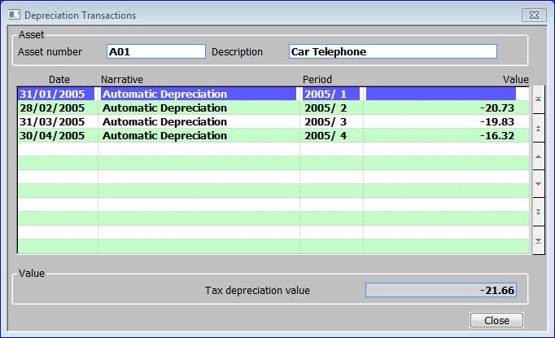

Figure 74: Depreciation Transactions Window

|  |  |
| --- | --- |
|  | This window is displayed when you select   * [Depreciation Only] from the Transaction window *(See page 128)*. * [Transactions] from the Depreciation Details window *(See page 124).* |
| Purpose | This window lists all the depreciation transactions that exist for the selected asset. This window is divided into three sections:   * Assets. * Transactions. * Value. |

*Asset*

|  |  |
| --- | --- |
| Asset Number | The unique code for the asset in up to 15 characters. |
| Description | The description of the asset in up to 30 characters. |

*Transactions*

|  |  |
| --- | --- |
| Date | The date of the transaction. |
| Narrative | The narrative entered for the transaction. |
| *Note* | For transactions generated by a Depreciation run, this is set to ‘Automatic Depreciation.’ |
| Value | The value of the depreciation. |

*Value*

|  |  |
| --- | --- |
| **Tax depreciation value** | (Only if tax depreciation is enabled in System Parameters Tax Depreciation *(See page 90)*): The value of the depreciation for tax purposes. |
| On exit | Return to calling window. |

#### Asset Enquiry Filters

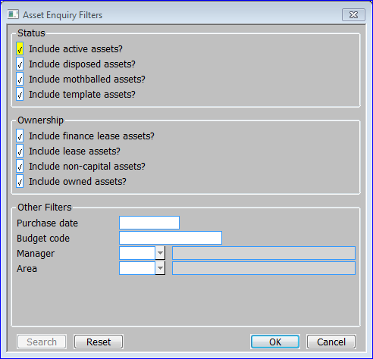

Figure 75: Asset Enquiries Filters Window

|  |  |
| --- | --- |
|  | This window is displayed when you select [Filters] from the Asset Enquiry window *(See page 120).* |

|  |  |
| --- | --- |
| Purpose | This window enables the user to select various filters which can then be applied to the Asset Enquiry window *(See page 120)*. This window is divided into three sections with application buttons: |
|  | * Status. |
|  | * Ownership. |
|  | * Other Filters. |

*Status*

|  |  |
| --- | --- |
| Include active assets? | Include assets with a status of ‘Active’ in asset enquiries. |
| **Include disposed assets?** | Include assets with a status of ‘Disposed’ in asset enquiries. |
| **Include mothballed assets?** | Include assets with a status of ‘Mothballed’ in asset enquiries. |
| **Include template assets?** | Include assets with a status of ‘Template’ in asset enquiries. |

*Ownership*

|  |  |
| --- | --- |
| **Include finance lease assets?** | Include assets with an Ownership type of ‘Finance Lease’ in asset enquiries. |
| **Include lease assets?** | Include assets with an Ownership type of ‘Lease’ in asset enquiries. |
| **Include non-capital assets?** | Include assets with an Ownership type of ‘Non-Capital’ in asset enquiries. |
| **Include owned assets?** | Include assets with an Ownership type of ‘Owned in asset enquiries. |

*Other Filters*

|  |  |
| --- | --- |
| **Purchase date** | Restrict Assets to those with the specified purchase date. Leave blank for no purchase date restriction. |
| **Budget code** | Restrict Assets to those with the specified budget code. Leave blank for no budget code restriction. |
| *Analysis Codes (1 – 5)* | There are up to five prompts for analysis codes. The names of these prompts are determined by the titles entered for the five sets of analysis codes in System Parameters – Analysis Codes *(See page 80).* In Figure 75 the prompts are ‘Manager’, and ‘Area’; the third, fourth and fifth sets of analysis codes not being used. The description of that code is also displayed. You can use these prompts to restrict enquiries to those whose values match these analysis codes. Again leave blank for no filtering by that analysis code. |

|  |  |
| --- | --- |
|  |  |

*This page is deliberately left blank*

Section Eight:

## Standard Windows



Contents

This section provides printed examples of the following reports:

136 Asset Number Search

137 Asset Group Search

138 Profit centre Search

139 GL Account Search

140 Asset Register Code Search

141 Budget Code Search

142 Depreciation Table Search

143 Company Search

144 Asset Transaction Note

145 Asset Notes

###### Asset Search

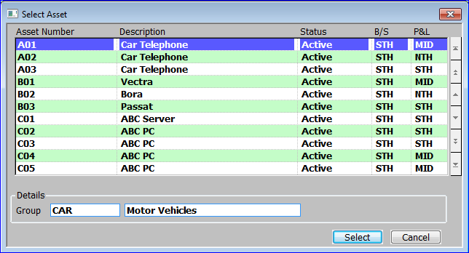

Figure 76: Select Asset

|  |  |
| --- | --- |
|  | This window is displayed when a [search] is done as an asset/asset no prompt. |
| Purpose | This standard enquiry/search window lists relevant assets for a [Search] option.  This window is divided into two sections with application buttons:   * Assets. * Details. |

**Assets**

|  |  |
| --- | --- |
| **Asset Number** | A unique code for the asset in up to 15 characters. |
| **Description** | A description of the asset in up to 30 characters. |
| **Status** | The status of the asset. This can be one of :   * Active. * Disposed. * Mothballed. * Template. |
| **B/S** | The code of the profit centre in the balance sheet against which the asset value is recorded. |
| **P&L** | The code of the profit centre used when posting GL journals for asset transactions that impact on the profit and loss statement. Leave blank to use the same profit centre as balance sheet postings. |

**Details**

|  |  |
| --- | --- |
| **Group** | The code of the asset group to which this asset belongs followed by its description. |

**Application Buttons**

|  |  |
| --- | --- |
| **Select** | Return the selected asset to the original calling window. |
| **Cancel** | Return to the calling window, but without returning the selected asset. |

###### Asset Group Search

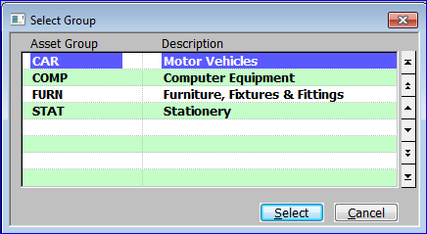

Figure 77: Select Asset Group

|  |  |
| --- | --- |
|  | This window is displayed when a [search] is done at an asset group prompt. |
| Purpose | This standard enquiry/search window lists relevant asset groups for a [Search] option. |

**Asset Group** *(Display Only)*

|  |  |
| --- | --- |
| **Asset Group** | A unique code for the asset group in up to 10 characters. |
| **Description** | A description of the asset in up to 30 characters. |

**Application Buttons**

|  |  |
| --- | --- |
| **Select** | Return the selected asset group to the original calling window. |
| **Cancel** | Return to the calling window, but without returning the selected asset group. |

###### Profit Centre Search

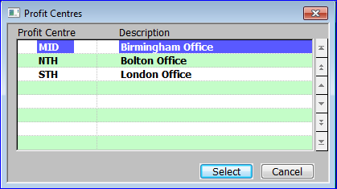

Figure 78: Profit Centres

|  |  |
| --- | --- |
|  | This window is displayed when a [search] is done at a profit centre prompt. |
| Purpose | This standard enquiry/search window lists relevant profit centre for a [Search] option. |

**Profit Centre** *(Display Only)*

|  |  |
| --- | --- |
| **Profit Centre** | A unique code for the profit centre in up to 4 characters. |
| **Description** | A description of the profit centre in up to 30 characters. |

**Application Buttons**

|  |  |
| --- | --- |
| **Select** | Return the selected profit centre to the original calling window. |
| **Cancel** | Return to the calling window, but without returning the selected profit centre. |

###### GL Accounts Search

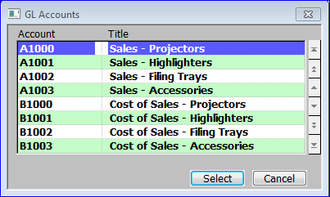

Figure 79: GL Accounts

|  |  |
| --- | --- |
|  | This window is displayed when a [search] is done at an account prompt. |
| Purpose | This standard enquiry/search window lists relevant accounts for a [Search] option. |

**GL Account** *(Display Only)*

|  |  |
| --- | --- |
| **Account** | A unique code for the Account. |
| **Title** | The title for that account. |

**Application Buttons**

|  |  |
| --- | --- |
| **Select** | Return the selected GL Account to the original calling window. |
| **Cancel** | Return to the calling window, but without returning the selected GL Account. |

###### Asset Register Code Search

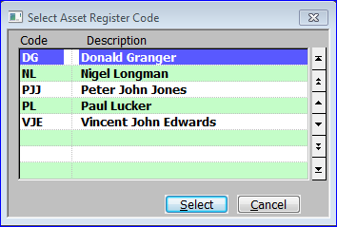

Figure 80: Select Asset Register Code

|  |  |
| --- | --- |
|  | This window is displayed when a [search] is done at an asset register analysis code prompt. |
| Purpose | This standard enquiry/search window lists relevant asset register analysis code for a [Search] option. |

**Profit Centre** *(Display Only)*

|  |  |
| --- | --- |
| **Profit Centre** | A unique code for the profit centre in up to 4 characters. |
| **Description** | A description of the profit centre in up to 30 characters. |

**Application Buttons**

|  |  |
| --- | --- |
| **Select** | Return the selected profit centre to the original calling window. |
| **Cancel** | Return to the calling window, but without returning the selected profit centre. |

###### Budget Code Search

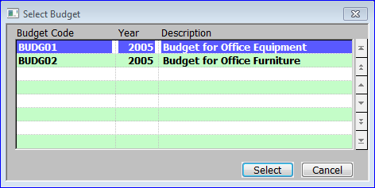

Figure 81: Select Budget

|  |  |
| --- | --- |
|  | This window is displayed when a [search] is done at a budget code prompt. |
| Purpose | This standard enquiry/search window lists relevant budget code for a [Search] option. |

**Profit Centre** *(Display Only)*

|  |  |
| --- | --- |
| **Budget** | A unique code for the profit centre. |
| **Year** | The year the budget relates to. |
| **Description** | A description of the budget. |

**Application Buttons**

|  |  |
| --- | --- |
| **Select** | Return the selected budget code to the original calling window. |
| **Cancel** | Return to the calling window, but without returning the selected budget code. |

###### Depreciation Table Search

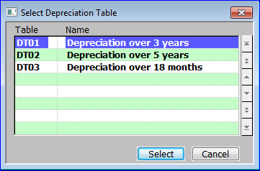

Figure 82: Select Depreciation Table

|  |  |
| --- | --- |
|  | This window is displayed when a [search] is done at a Depreciation Table prompt. |
| Purpose | This standard enquiry/search window lists Depreciation Table codes for a [Search] option. |

**Profit Centre** *(Display Only)*

|  |  |
| --- | --- |
| **Table** | The unique code for the depreciation table. |
| **Name** | The predefined description of the depreciation table. |

**Application Buttons**

|  |  |
| --- | --- |
| **Select** | Return the selected depreciation table code to the original calling window. |
| **Cancel** | Return to the calling window, but without returning the selected depreciation table code. |

###### Company Search

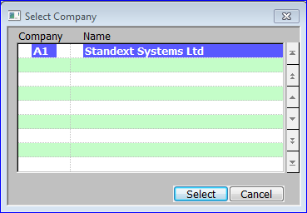

Figure 83: Select Company

|  |  |
| --- | --- |
|  | This window is displayed when a [search] is done at a Company prompt. |
| Purpose | This standard enquiry/search window lists available companies for a [Search] option. |

**Company** *(Display Only)*

|  |  |
| --- | --- |
| **Company** | The unique code for the company. |
| **Name** | The predefined description of the company. |

**Application Buttons**

|  |  |
| --- | --- |
| **Select** | Return the selected company code to the original calling window. |
| **Cancel** | Return to the calling window, but without returning the selected company code. |

###### Asset Transaction Notes

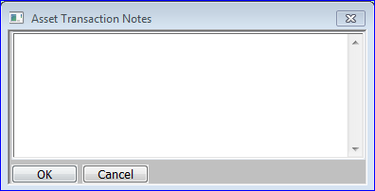

Figure 84: Asset Transaction Notes

|  |  |
| --- | --- |
| Purpose | *(Only on systems where the extension database is enabled).* This window allows the entry of free form notes relating to the selected transaction. |

**Application Buttons**

|  |  |  |  |
| --- | --- | --- | --- |
| |  |  | | --- | --- | | **OK** | Return the selected asset to the original calling window. | | Accept the changes to the notes and return to the original calling window. |
| **Cancel** | Discard the changes to the notes and return to the original calling window. |

###### Asset Notes

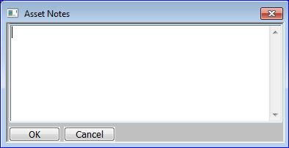

Figure 85: Asset Notes

|  |  |  |  |  |
| --- | --- | --- | --- | --- |
| Purpose | *(Only on systems where the extension database is enabled).* This window allows the entry of free form notes relating to the selected asset. |  |  | *(Only on systems where the extension database is enabled).* This window allows the entry of free form notes relating to the selected asset. |

**Application Buttons**

|  |  |  |  |
| --- | --- | --- | --- |
| |  |  | | --- | --- | | **OK** | Return the selected asset to the original calling window. | | Accept the changes to the notes and return to the original calling window. |
| **Cancel** | Discard the changes to the notes and return to the original calling window. |

|  |  |
| --- | --- |
|  |  |

*This page is deliberately left blank*

Section Nine:

## Sample Reports



Contents

This section provides printed examples of the following reports:

148 Depreciation Report

149 Postings Proof List

151 Asset Ledger Report

152 Additions and Disposals Report

153 Selective Transactions Report

154 Asset Print by Date

155 Asset Label Print

156 Depreciation Tables Listing

157 Asset Groups Listing

###### Depreciation Report

This report is produced by the Depreciation Run program. This program automatically calculates the depreciation of all assets up to the end of the current period. For each asset, the depreciation is calculated according to its defined method. If tax depreciation details have been recorded for the asset, the tax depreciation is also calculated.

You can run the program in ‘create transactions’ mode, which creates the necessary depreciation transactions, and prints a report entitled ‘Depreciation Report’. Alternatively you can run the program to just calculate the expected depreciation and print a report entitled ‘Expected Depreciation Report’. In other respects the reports have the same format.

For further information about the Depreciation Run program, see page 38.

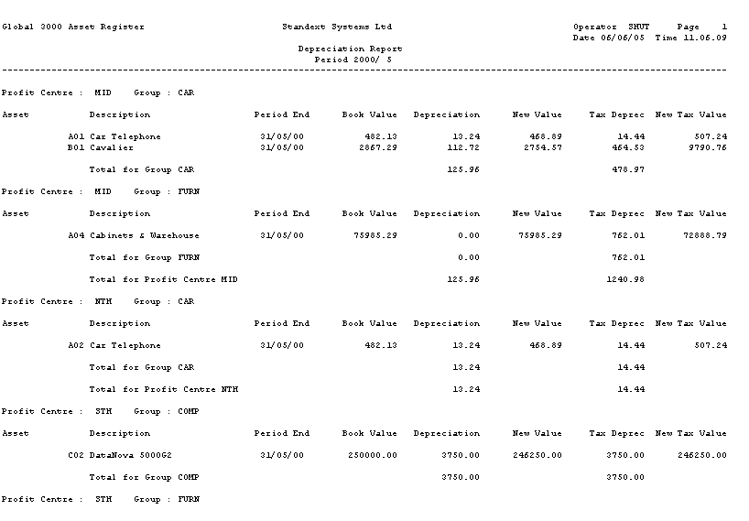

Global 3000 Asset Register Standext Systems Ltd Operator MWB Page 1

Financial Year 1998/ 1 Depreciation Report Date 06/08/98 Time 13.36.18

Profit Centre : MID Group : CAR

Asset Description Period End Book Value Depreciation New Value Tax Deprec New Tax Value

B01 Cavalier 31/01/98 3210.58 208.50 3002.08 859.23 10810.77

Total for Group CAR 208.50 859.23

Profit Centre : MID Group : COMP

Asset Description Period End Book Value Depreciation New Value Tax Deprec New Tax Value

C05 DataNova 132 Column Dot Matrix 31/01/98 14388.16 224.81 14163.35 224.81 14762.86

Total for Group COMP 224.81 224.81

Total for Profit Centre MID 433.31 1084.04

Profit Centre : NTH Group : CAR

Asset Description Period End Book Value Depreciation New Value Tax Deprec New Tax Value

A01 Car Telephone 31/01/98 521.85 19.86 501.99 21.66 543.34

A02 Car Telephone 31/01/98 521.85 19.07 502.78 20.80 544.20

Total for Group CAR 38.93 42.46

Profit Centre : NTH Group : COMP

Asset Description Period End Book Value Depreciation New Value Tax Deprec New Tax Value

C06 DataNova Laser Printer 31/01/98 7253.78 113.34 7140.44 113.34 7442.68

Total for Group COMP 113.34 113.34

Total for Profit Centre NTH 152.27 155.80

Total for Report 585.58 1239.84

*** End of Report ***

Figure 86: Depreciation Report

###### Postings Proof List

This report is printed when you run Print GL Analysis Report from the End of Period Processing Menu. The first part of the report lists the postings in profit centre/asset group sequence. Transferred assets are listed under the current profit centre. The second part of the report has summary totals with a line for each profit centre/account for which there are postings.

Note: Non-capitalised assets, and those are held on an operating lease, do not generate General Ledger postings and do not appear on the Postings Proof List.

For further information on the Transaction Posting program, see page 55.

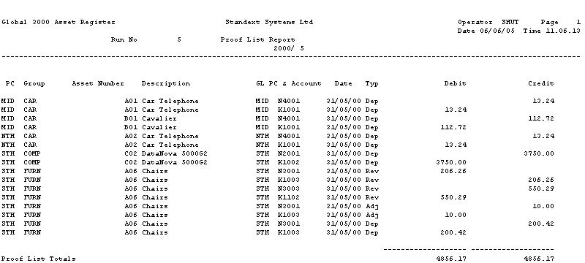

Figure 87: Postings Proof List

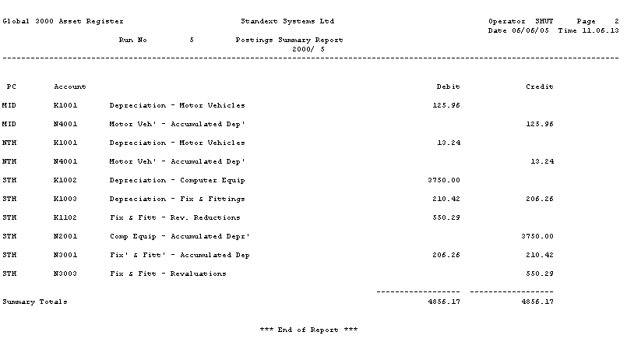

Figure 88: Postings Proof List (Summary Totals)

###### Asset Ledger Report

This report prints details of selected assets. For each asset, the details printed include the asset code, description, profit centre, asset group, period of purchase, expected end of life, analysis codes, value of its cost and any additions made to it, its depreciation and written down value. This report can be printed in detail or summary form, and can optionally include for each asset, comments, and a list of any attached assets.

You can select the range of assets to be printed by asset code, group, profit centre, analysis code, ownership type, status, or a combination of these methods. You can run this report at any time.

For further information on this report, see page 48.

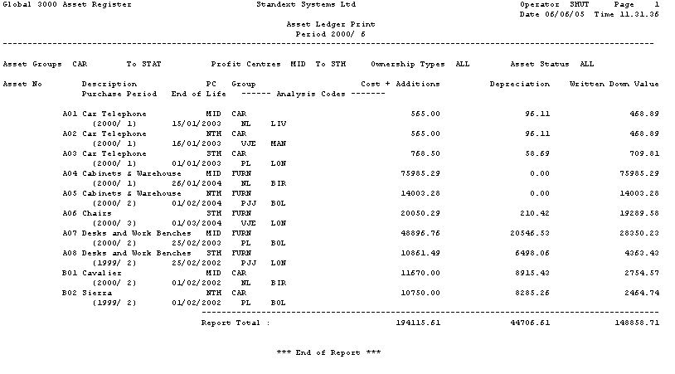

Figure 89: Asset Ledger Report

###### Additions and Disposals Report

This report prints either a summary of movements in asset value or a summary of profit and loss on disposal. If tax depreciation is selected in System Parameters, the report shows both book and tax values.

You can select the range of assets you want to print by asset number, group, profit centre, start date, and up to five analysis codes. You can sequence the report by asset code, group, profit centre, or by profit centre and group. You can run this report at any time.

For further information on this report, see page 52.

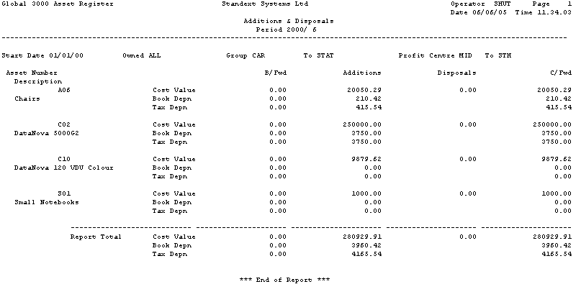

Figure 90: Additions and Disposals Report

###### Selective Transactions Report

This report enables you to print transactions selected by a wide range of criteria. The report shows for each transaction, the asset, group, profit centre, type and value.

You can select the range of transactions that you want to print by asset code, group, profit centre, date, and up to five analysis codes. You can run this report at any time.

For further information on this report, see page 55.

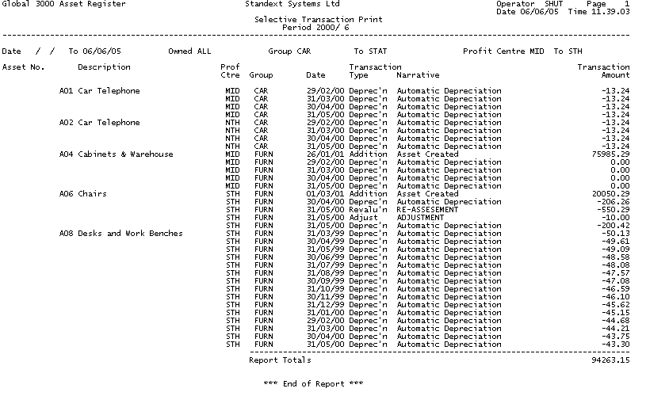

Figure 91: Selective Transactions Report

###### Asset Print by Date

This report prints all assets for which a particular date is within a range you specify. You can use this, for example, to identify assets approaching the end of their life, or, if a user-defined date field has been used to record the next maintenance date, assets which are due for maintenance.

You can select the range of assets you want to print by group, profit centre, and analysis code. You can sequence the report by group, profit centre, or by group and profit centre. You can run this report at any time.

For further information on this report, see page 59.

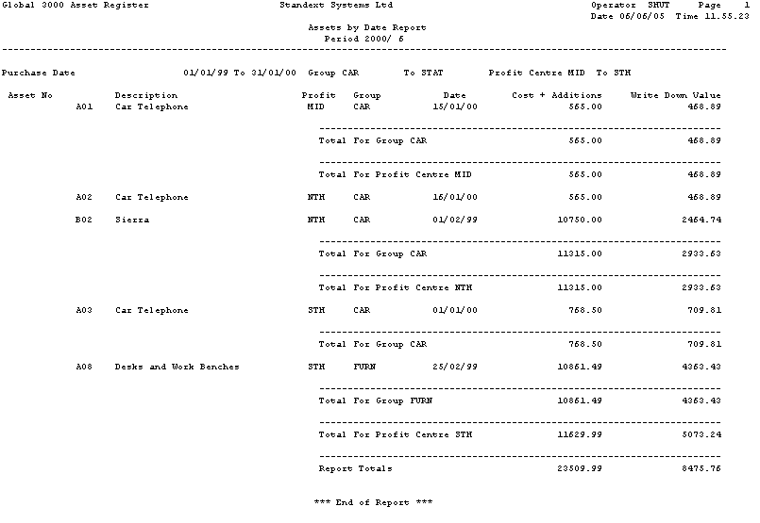

Figure 92: Asset Print by Date

###### Asset Label Print

This option prints labels for all assets added since a specified date, or for a specified asset. The details printed on the labels are: the asset code and description, the asset’s profit centre, and the group to which the asset belongs. The labels are formatted to print on standard, one column. 1.5 inch labels. You can print labels at any time.

For further information on printing labels, see page 62.

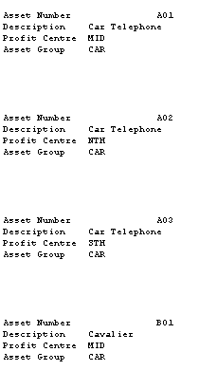

Figure 93: Asset Label Print

###### Depreciation Tables Listing

This report prints a listing of depreciation tables. Depreciation tables are used to determine the depreciation percentage to be applied to assets, which use the ‘table’ depreciation method.

Up to five different rates can be specified for each table. For each rate you define a depreciation percentage and the number of periods for which it is to apply. When the first rate expires, the second rate comes into use; when the second rate expires, the third rate comes into use; etc.

For further information about initiating this report, see page 95.

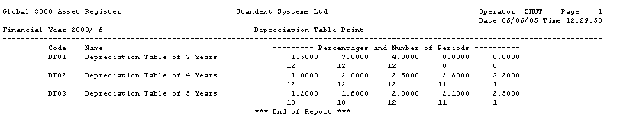

Figure 94: Depreciation Tables Listing

###### Asset Groups Listing

This report prints a listing of asset groups. Asset groups are used to collate assets of the same type for enquiries and reports, and to provide default depreciation details during asset entry.

Asset groups also determine the General Ledger account codes to which postings for assets in the group are made. This enables groups to be separately identified in the General Ledger.

For further information about initiating this report, see page 101.

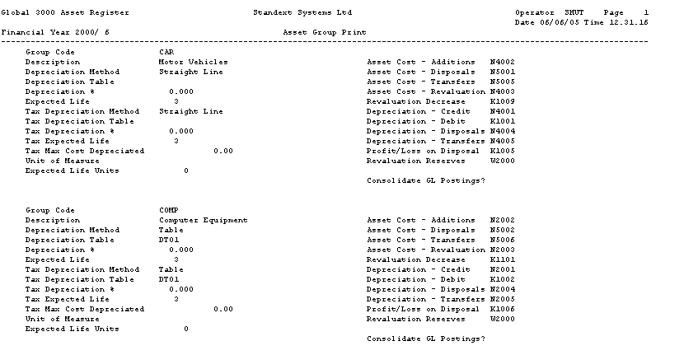

Figure 95: Asset Groups Listing

###### Budgets Listing

This report prints a listing of budgets. Budgets are used to accumulate the costs of new assets and additions to assets. When you create an asset, you can enter the code of its budget. The value of the asset, and any additions made to it, in the budget’s financial year are then added to the budget’s expenditure total.

For further information about initiating this report, see page 104.

Global 3000 Asset Register Standext Systems Ltd Operator amf Page 1

Financial Year 1998/ 3 Asset Register Budget List Date 07/08/98 Time 17.13.37

Code Year Description Period of Authorised Amount Used Amount

Expected Use

BUDG1 1998 BUDGET 1 12 50000 0

BUDG2 1998 BUDGET 2 12 350000 96035

BUDG3 1998 BUDGET 3 12 1000000 288864

BUDG4 1998 BUDGET 4 12 5000 1000

*** End of Report ***

Figure 96: Budgets Listing

## Index

A

about this manual, 4

accounts, 99

active status, 68, 108, 120

add

assets, 32, 66

add to assets, 24

addition and disposals window, 52

additional units, 36

additions, 12, 22, *See* *also* add to assets

postings, 17, 100

report, 52, 152

split asset, 33

additions and disposals report, 52–54, 53, 152

adjust depreciation window, 27

adjust tax depreciation window, 28

adjusted cost, 32

adjustments, 13, 16, 22, 27, 28

administration parameters, 78

allow zero purchase costs for Assets, 93

analysis codes, 11, 80–81

asset data load, 114

asset maintenance, 74

enquiries, 126

pass to general ledger, 87

select assets for report by, 49, 53, 56, 60

analysis codes window, 74, 80, 114

analysis details, 114

asset addition window, 23

asset attachment window, 26

asset code format window, 85

asset creation date, 121

asset data load, 106–17

analysis codes, 114

analysis details, 114

comments, 117

depreciation details, 111

general details, 107

purchase details, 110

reference fields, 115

tax depreciation details, 113

user defined dates, 115

user defined values, 115

year to date figures, 116

asset disposal – attachments window, 24

asset disposal window, 25

asset enquiries filters window, 132

asset enquiry

financial, 121

asset enquiry window, 120

asset group report window, 101

asset group revaluation, 118

asset group search, 137

asset groups, 10, 67, 96–101, 107

create using template, 98

maintenance, 96–101

print, 101, 157

revalue, 118

select assets for report by, 49, 53, 56, 60, 63

sequence report by, 51

transfer assets, 35

asset groups - maintain, 96

asset ledger report, 48, 151

asset maintenance, 65–76

analysis codes, 74

general details, 66

reference fields, 74

user defined dates, 75

user defined values, 75

asset mothball window, 29

asset notes, 145

asset number

print label, 62

asset number search, 136

asset parameters

analysis codes, 80

asset sequence numbers, 89

current period, 83

depreciation, 84

operating options, 93

reference fields, 88

sequence numbers, 89

tax depreciation, 90

user defined dates, 91

user defined reference fields, 88

user defined values, 92

zero purchase costs for Assets, 93

Asset Parameters

dates - user defined, 91

asset parametres

asset code format, 85

asset parmeters

general ledger, 86

asset print by date, 59–61, 154

asset register by date report, 60

asset register code search, 140

asset register depreciation run window, 38

asset register print by date window, 59

asset register print labels window, 62

asset register print window, 48

asset register report, 48

asset revaluation, 31

asset revaluation window, 31

asset transaction notes, 21, 144

asset transfer

profit centre, 35

asset transfer - attachments window, 34

asset transfer window, 35

asset-register-parameters menu, 78

assets, 65–76

codes, 67, 85, 107, 120, 129, 131

comments, 75

create using template, 69, 109

depreciation details, 71

enquiries, 118–32

intial set-up, 106–17

maintenance, 65–76

overview, 10

purchase details, 70

tax depreciation details, 73

user-defined codes, fields, dates, etc., 74

attach assets, 13, 22, 26

attached asset transfer message, 33

attached assets, 12, 33, 68, 108

enquiries, 123

print on report, 50

transfers, 25, 34

attachments window, 122

auditing, 14

authorised amount, 103

B

brought forward figures, 116

budget

used amount, 103

budget codes search, 141

budget definition, 103

budget maintenance window

select year, 102

budget year - select, 102

budgets, 13, 68, 102–4

print, 104, 158

budgets for year window, 103

budgets purge, 42

C

calculations for depreciation

system parameters, 84

calculations of depreciatin, 14

capital expenditure budgets, 13, 102–4

check integrity, 44–46

close period, 40

close period window, 40

codes

analysis, 80

comments, 11, 75, 117

enquiries, 123

print on report, 50

comments window, 75, 117, 123

company, 86

company parameters, 78

consolidate postings to GL?, 98

contents, 5

additions and disposals, 54

p & l value on disposals, 54

sdditions only, 54

conventions used in this manual, 4

copy

asset groups, 98

assets, 69, 109

costs

adjusted, 32

General Ledger postings, 17, 100

purchase, 70, 79

replacement, 70

creation date, 110, 121

credit depreciation, 16, 17, 100

creditors ledger, 121

currencies, 10

decimal precision, 10, 20

currency variations, 118

current accounting period window, 83

current period, 83

current written down value

depreciation adjustments, 28

revaluation of assets, 31

tax depreciation adjusments, 29

customer classifications, 81

customers, 26

cycle of operations, 14

D

date

transaction, 131

date of last depreciation, 110

dates

additions, 24

additions and disposals report, 53

adjustments, 28

disposals, 26

last depreciation, 70, 73

purchase, 70

revaluation, 31, 118

select assets for label print by, 62, 63

select transactions for report by, 56, 60

split assets, 32

transfers, 35

units last recorded, 72

units of use, 36

user-defined, 91

days, calculate depreciation by, 84

debit depreciation, 16, 100

decimal precision of currencies, 10, 20

decrease on revaluation, 100

definine budgets, 103

depreciatin calculations, 14

depreciation

adjustments, 13, 16, 22, 27, 28

asset parameters, 84

attached assets, 26

date of last, 70

details for assets, 71, 124

maximum for tax purposes, 98

methods, 71, 73, 97

postings, 16, 100

report, 38, 148

restart after mothballing, 30

run, 38

depreciation %, 73, 111, 125

tax details, 126

depreciation date window, 84

depreciation details, 111

enquiries, 124

tax, 113

depreciation details window, 71, 110, 124

depreciation method, 111, 124

*tax details*, 125

Depreciation Run, 38

depreciation table, 111, 125

*tax details*, 125

depreciation table maintenance window, 94

depreciation table search, 142

depreciation tables, 72, 73, 94–95, 94, 97

print, 95, 156

depreciation transactions, 131

depreciation transactions window, 131

depreciation units, 13

descriptions

asset groups, 97

assets, 67, 107, 120, 129, 131

budgets, 103

depreciation tables, 95

detach assets, 13, 22, 26

detailed report, 50

disposals, 12, 22, 25

postings, 16, 100

report, 52, 152

disposed

status, 121

disposed status, 108, 121

distribution parameters, 78

E

end of life, 72, 111

end of period processing, 37–46

enquiies

reference fields, 126

enquiries, 17, 118–32

analysis codes, 126

asset filters, 132

attached assets, 123

comments, 123

depreciation details, 124

depreciation details - tax, 125

depreciation transactions, 131

reference fields, 126

tax depreciation details, 125

transactions - depreciation, 131

transactions (all), 129

user defined dates, 127

user defined values, 127

year to date values, 127

expected depreciation report, 38, 148

expected life, 72, 97

expected life (years), 111

expiry dates, 91

F

filters

asset enquiries, 132

finance leases, 67, 107, 121

financial periods, 83

budgets, 103

close, 40–41

depreciation tables, 95

purchases, 70

format of asset codes, 85

G

general details

asset data load, 107

asset maintenance, 66

general details window

asset data load, 106

asset maintenance, 66

general ledger

postings

account definitions, 99

system parameters, 86

transaction analysis, 13, 87

general ledger account search, 139

general ledger postings, 16

gl account codes window, 99

gl account search, 139

gl accounts, 139

gl analysis report, 39

gl analysis report window, 39

gl integration window, 86

gl postings consolidate, 98

group revaluation, 118

groups, 10, 67, 96–101, 107

create using template, 98

maintenance, 96–101

print, 101, 157

revalue, 118

select assets for report by, 49, 53, 56, 60, 63

sequence report by, 51

transfer assets, 35

I

individual assets, 10

initial set-up of assets, 106–17

insurance values, 11

integration with general ledger, 86

integrity check, 44

integrity check window, 44

integrity checks, 44–46

interface code, 87

interface number, 87

invoice number, 24, 110, 121

invoice numbers, 26, 70

L

labels, 62–63, 155

print asset register labels, 62

last depreciation, 125

date, 110

last depreciation date, 73

leased assets, 11, 67, 107, 121

life, 72, 97

tax purposes, 73

life in units, 112

link assets. *See* attach assets

M

maintain asset groups, 96

maintain asset groups window, 96

maintenance due dates, 91

manual conventions, 4

maximum depreciation, 98

methods of depreciation, 71, 73, 97

module-specific parameters, 78

months, spread depreciation evenly across, 84

mothball assets, 13, 14, 23, 29

mothballed assets, 30

mothballed status, 108

multi-currency operation, 10

N

narrative

transaction, 131

narratives

additions, 24

adjustments, 28

disposals, 26

revaluation, 31

split assets, 33

transfers, 35

units of use, 36

new written down value

depreciation adjustments, 28

tax depreciation adjustments, 29

non-capitalised, 67

non-capitalised assets, 39, 121

notes

asset transaction, 21

assets, 11

transaction, 21

transactions, 11

number of periods, 95

O

operating leases, 39

operating options, 93

order of report, 50, 54, 58, 61

Overview, 10–9

owned, 67

owned assets, 121

ownership, 11, 67, 107, 121

select assets for report by, 50, 54, 57

P

passwords, 11, 97

percentage

revaluation, 118

percentage depreciation, 72, 97

depreciation tables, 95

period reducing balance depreciation, 15, 72

period reducing depreciation, 71, 111

periods, financial, 83

budgets, 103

close, 40–41

depreciation tables, 95

purchases, 70

pooled assets, 10, 68, 108, 121

post transactions, 21

postings proof list, 149

postings to general ledger, 16

print

additions and disposals, 53

asset groups, 101, 157

asset register, 48

asset register by date, 60

asset register labels, 62

budgets, 104, 158

depreciation tables, 95, 156

selective transactions, 55

print budgets for year window, 104

print depreciation table window, 95

print gl analysis, 39

profit and loss

postings, 16, 100

report, 52–54, 152

profit centre search, 138

profit centres, 11, 67, 81, 107, 120, 138

attaching assets, 27

select assets for report by, 49, 53, 56, 60

sequence report by, 51

transfer assets, 35

validation, 87

provisional proof list, 149

purchase cost, 110

purchase date, 110

*Purchase date*, 121

purchase details, 110

purchase details window, 70, 109

purchase period, 110

purchase suspense account, 87

purchases

details, 70

suspense account, 17

purge budgets, 42

purge budgets before, 43

purge depreciation transactions before, 42

purge disposed asset transactions before, 43

purge transactions, 42

purge transactions window, 42

Q

quantities

additions, 24

disposals, 26

pooled assets, 68, 108, 121

split assets, 32

R

reading date, 36

reducing balance depreciation, 15, 72

*reference fields*, 68, 88, 108, 121

asset data load, 115

asset maintenance, 74

enquiies, 126

enquiries, 126

pass to general ledger, 87

reference fields window, 88, 126

remove assets from mothballs, 23, 30

remove from mothball window, 30

replacement cost, 110

replacement costs, 70

reports, 47–63

overview, 18

printed examples, 133–58

reports and enquiries, 18

reserves, revaluation, 100

residual value, 16, 72, 73, 111

restart depreciation, 30

revaluation date, 118

revaluation of assets, 12, 23, 31, 118

postings, 16, 17, 100

revaluation percentage, 118

revalue asset group window, 118

revalue asset groups, 118

reverse additions, 22

right-justify asset codes, 85

S

sales. *See* disposals

suspense account, 16

sales representatives, 11, 81

sales suspense account, 87

sample reports, 133–58

search

asset group, 137

asset number, 136

asset register codes, 140

budget codes, 141

depreciation tables, 142

gl accounts, 139

general, 139

profit centre, 138

select asset, 136

select asset group, 137

select asset register code, 140

select budget, 141

select budget code, 104

select budget year, 102

select company, 143

select depreciation table, 142

select system code menu, 81

select template asset window, 69, 109

selective transactions print window, 55

selective transactions report, 55–58, 55, 153

sequence number window, 89

sequence numbers

internal, 89

sequence of report, 50, 54, 58, 61

source id, 87

split asset window, 32

split assets, 13, 23, 32

start date for report, 53

start of depreciation parameter, 84

status, 68, 107, 120

select assets for report by, 50, 57

stock locations, 11, 81

straight line depreciation, 15, 71, 111

structure of this manual, 4

summary report, 50

supplier, 70, 110

suppliers, 24, 121

suspense account

purchase, 87

sales, 87

suspense accounts, 16, 17

system codes, 80, 82

system parameters

introduction, 78

tax depreciation, 90

T

table depreciation, 15, 71, 111

tax depreciation

adjustments, 28

asset parameters, 90

details, 73, 98, 125

system parameters, 90

tax depreciation details, 113

tax depreciation details window, 72, 113

tax depreciation window, 90

tax details window, 125

template

status, 121

template group window, 98

templates, 10, 108

new asset groups, 98

new assets, 69, 109

territories, 11, 81

titles

analysis codes, 81

reference fields, 88

user-defined dates, 91

user-defined values, 92

total units, 36

transaction

assets, 11

date, 131

narrative, 131

notes, 11

transaction analysis, 13, 87

transaction entry, 21

overview, 12–13

transaction notes, 21

transaction type menu, 22

transactions, 21

addition of new assets, 66

depreciation, 38

overview, 12–13

print, 55–58, 153

purge, 42

transactions (all), 129

transactions purge, 42

transactions window, 128

transfer assets, 13, 23, 33

postings, 17, 100

transfer attachment, 27

transfer part of asset, 33

types of transactions, 22, 58

U

units, 13

units last recorded, 112

units of use, 72, 97, 112

units used, 72, 112

record, 23, 36

units used window, 36

unposted transactions, 20, 21

unposted transactions window, 20

usage depreciation, 16, 71, 72, 111

record units, 23, 36

used amount budgets, 103

user defined dates

asset data load, 115

asset maintenance, 75

enquiries, 127

user defined values

asset data load, 115

asset maintenance, 75

enquiries, 127

user-defined dates window, 91

user-defined fields, 11

dates, 91

enter for assets, 74

reference fields, 88

user-defined values window, 92

V

validation

analysis codes, 80

profit centres, 87

values

additions, 24

budgets, 103

depreciation adjustments, 28, 29

disposals, 26

residual, 16, 72, 73

revaluation, 31

split assets, 32

W

warranty expiry dates, 91

written down value (WDV), 15

depreciation adjustments, 28

revaluation of assets, 31

tax depreciation adjustments, 29

Y

year of budgets, 68, 102

year reducing balance depreciation, 15, 72

year reducing depreciation, 71, 111

year summary

enquiries, 127

year to date figures, 116

year to date summary window, 115, 127

Z

zero purchase costs for assets, 93

zero-fill asset codes, 85